

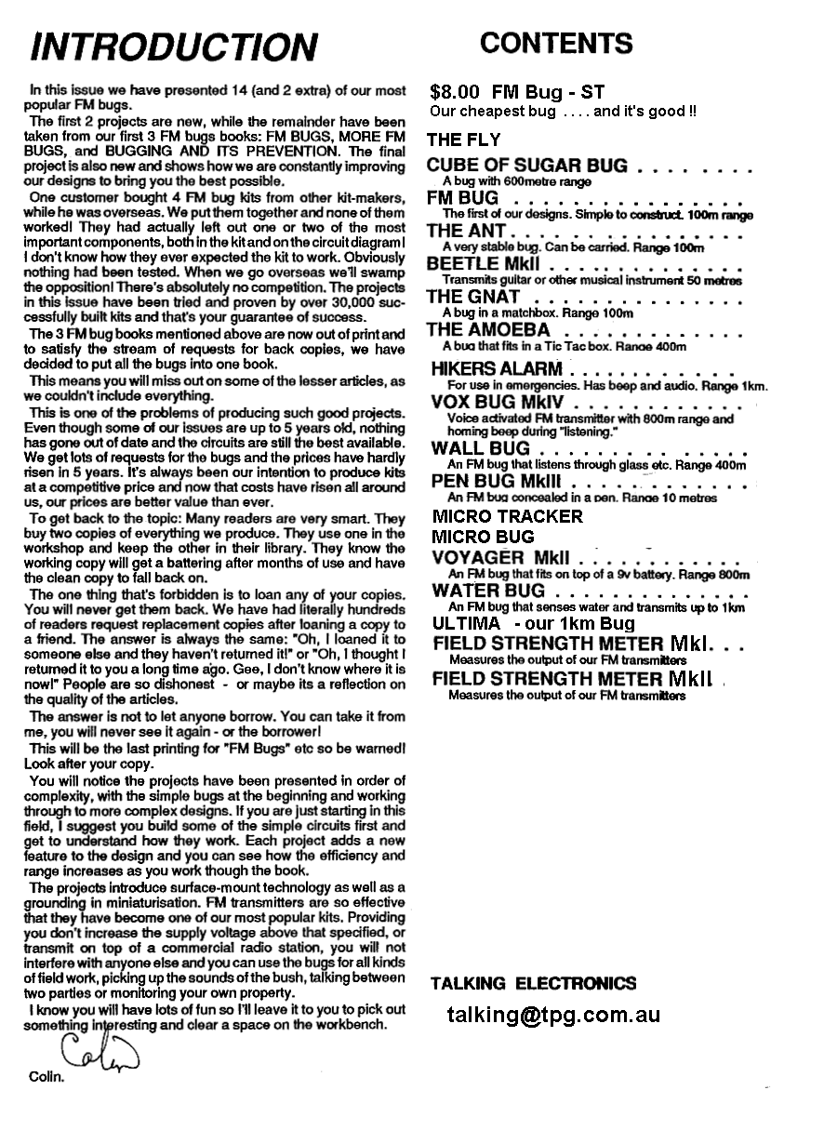

See complete PRICE LIST
at end of this eBook

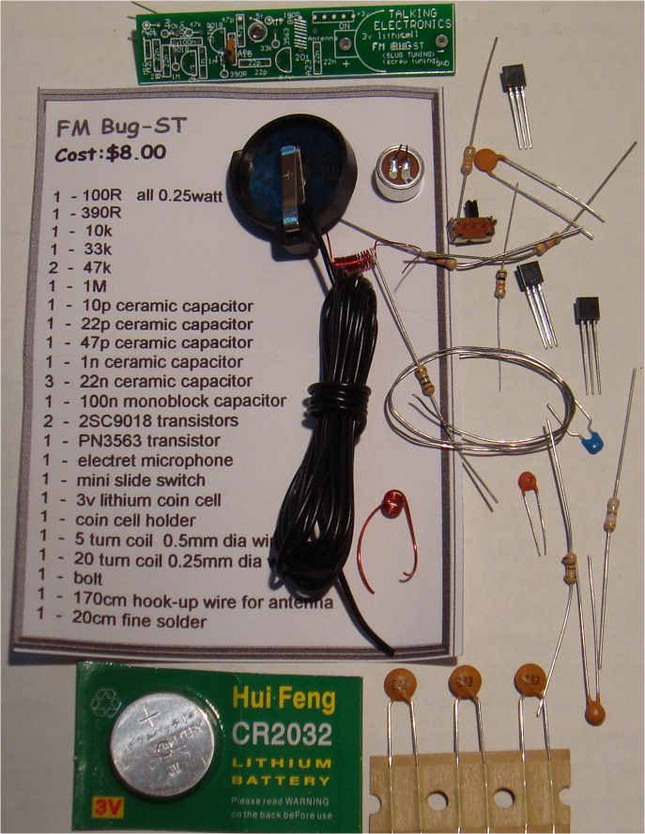
The complete kit of parts for the FM Bug-ST costs just $8.00
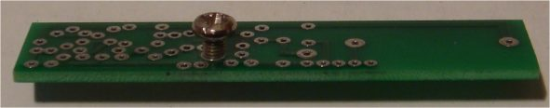
The “screw” is adjusted from the underside of the board to set the frequency.
This “screw” is called a SLUG and the bug is called “SLUG TUNED.”
FM BUG (slug tuned)
Cost: $8.00 including postage
email:
talking@tpg.com.au
and ask for details on how to pay for the kit.

This project is a great way to learn about FM transmission.
With just a few components you can create your own FM Radio Station !!!
This project has been designed to compete with the low-cost kits on the market. This kit is better than all the rest.
1 and 2 transistor kits are very poor performers and it is pointless getting a kit that does not perform.
You will be disappointed and think all FM transmitters are useless.
But that is not so.
You need 3 transistors to get reliable performance.
The first transistor amplifies the signal from the microphone so you can hear a pin drop.
The second transistor creates the frequency at which the bug transmits and
The third transistor acts as an amplifier (in the form of a BUFFER), to separate the oscillator from the antenna, so the bug does not drift when being held.
The circuit is well-designed and includes an interesting feature: "SLUG TUNING."
We have used a steel bolt or "screw" to adjust the frequency of the circuit and it is screwed through the board and into the coil.
By placing the first two turns close to the board, the end of the bolt will have an effect on changing the frequency.
This is called a SLUG TUNED COIL and is one of the oldest ways to tune a radio or transmitter.
The slug is normally ferrite but if you only insert a small portion, the frequency will shift slightly. If the bolt is fully inserted, it will freeze the oscillator as the coil will pass all its energy into the bolt and the circuit will stop oscillating. But just a small insertion will tune the bug to the frequency you want.
The approximate frequency on the 88MHz to 108MHz band is set by expanding or compressing the 5 turn coil and then the fine tuning is done by screwing the bold from the underside of the board. As you expand the turns, the frequency increases and compressing the turns takes the frequency from 88MHz to a lower frequency.
Designing a good circuit involves a number of points.
The layout of the board is important as well as the choice of actual component values.
Our is the simplest and best design and has been perfected over the past 25 years from the sales of over 100,000 kits and 20 different designs.
Talking Electronics was the first company in the world to produce a kit and attach a free PC board to the cover of the magazine.
This brought over 30,000 hobbyists into the market of building their own transmitter and experiencing the clarity of FM and the enormous range possible with only a few milliwatts of power.
These kits are very easy to build and result in an enormous achievement with just a few components.
The fun of talking and listening is like having your own radio station and you can transmit music from one location to another or use it to talk over a long distance to lots of listeners.
You can use it as a "Radio Mic" at a gathering or a stage performance.
The clarity is so perfect, you will think the person is actually in the room.
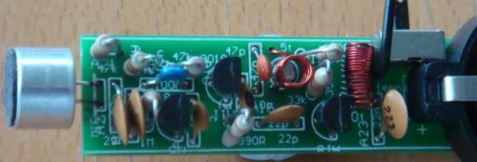
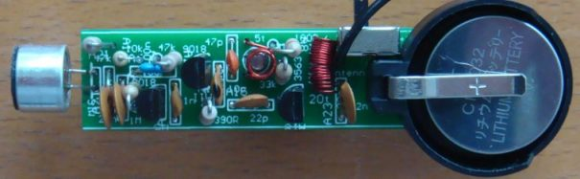
All the parts fit very neatly on the board and the only thing you have to align is the 5 turn oscillator coil. The leads need to be bet so they fit down the holes and the coil sits directly above the screw.
Make sure you tin the leads so the enamel is removed, BEFORE fitting the coil down the holes.
The 20 turn coil is also pre-wound with 0.25mm wire and it is easier to tin and fit to the board.
All the parts are in the same position as on the circuit diagram and this makes it easy to compare the two when trouble-shooting. The prototype-worked as soon as it was built and this is a testament to the designs created by Talking Electronics. Over 50,000 FM Bugs have been sold and TE has 20 different types. This is the cheapest and best and is better than any other $8.00 bug on the market.
The screw tuning is primitive but has been used since the earliest days of radio.
The input is amplified with a stage and the output is buffered with a stage.
The three stages create a very sensitive transmitter that can be handled and it will pick up the sound of a pin dropping on the floor.
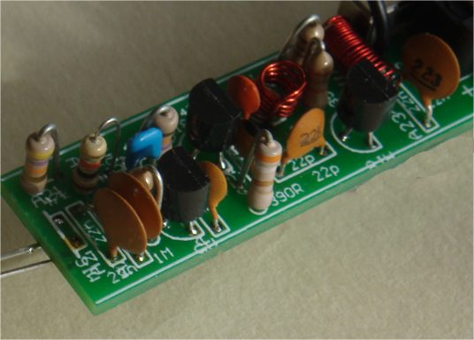
This photo shows the coil mounted above the board with the ends down the holes and the coil sitting above the screw.
The screw is screwed from the underside of the board and its end enters the coil to reduce the frequency of transmission.
The screw is called a SLUG as anything that enters a coil to change the frequency is called a SLUG.
HOW THE CIRCUIT WORKS
The circuit is very simple but you have to use the right-value components and put them in the correct part of the circuit to get the best results.
Many of the circuits on the web contain faults are not very reliable.
The first stage consists of a single component - the electret mic. This is actually a FET (Field Effect Transistor) and it has to have a very small current for it to operate correctly. This current is delivered by the 47k resistor.
The output is only a few millivolts but the signal is very clean and the microphone will pick up a pin dropping on the floor.
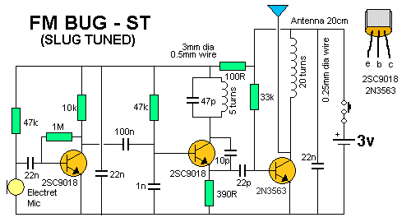
The output is connected to the next stage via a 22n capacitor.
This value is easy to obtain as a ceramic capacitor and passes about 20% of the amplitude of the signal. This is sufficient for the first transistor in the circuit.
It amplifies the signal about 70 times to get an output of between 70mV and 700mV.
The 22n across the power rails near the microphone prevents internal feedback in the circuit called "Motor-boating" or squeal and the 100R combines with the capacitor to isolates the first transistors from the third transistor.
The second transistor is the oscillator. It gets its feedback from the 10p capacitor between the collector and emitter.
The transistor turns on via the 47k base resistor and puts a little bit of energy into the coil and capacitor combination on the collector.
This is called a PARALLEL TUNED CIRCUIT and the capacitor gets charged first. The coil initially refuses to allow current to flow through it but as the capacitor charges, the coil allows current to flow.
During this time the voltage on the collector falls and this fall passes through the 10p to lower the voltage on the emitter and keep the transistor turned ON.
The 10p charges during this time and the transistor turns off slightly. This reduces the current in the coil and the magnetic field starts to collapse and produce a voltage from the coil that is in the opposite direction.
This puts a higher voltage on the collector and this voltage is passed to the emitter to turn the transistor OFF slightly more.
This continues until the transistor is completely turned off and it is similar to the transistor being removed from the circuit.
The coil continues to produce a voltage and charges the capacitor.
This voltage can be as high as 3v or more, depending on the amount of energy it contains and the amount of energy required to charge the capacitor to 3v.
The end result is a voltage that can be greater than 6v, however we are not using this voltage but tapping off the emitter, where a much smaller voltage is produced.
The emitter waveform passes through the 22p to the output stage.
This a class "A" amplifier and the signal is amplified about 50 times. It could be grater than this due to the effect of the RFC on the collector.
This is called a RADIO FREQUENCY CHOKE and it has the effect of storing energy during parts of the cycle and delivering the energy during the remainder of the cycle.
The end result is a larger output waveform.
If you connect the antenna to the collector of the oscillator transistor, it will remove some of the energy and change the frequency at which the circuit works. This is called "drift" and is very annoying as the reception will be lost.
To prevent drift, we have added the 3rd transistor.
It is called a "Buffer Stage" and is designed to separate the antenna from the oscillator.
Finally, the 22n across the power rails is deigned to tighten the rails.
This means the top rail does not move up and down when the transistor is sending audio.
It helps to maintain the frequency at which the circuit works as the oscillator is also called a voltage-controlled oscillator and a change in voltage will produce a slightly different output frequency.
TUNING
Tuning is the capability of changing the frequency of the oscillator so the bug transmits on a clear part of the band.
The FM band is completely filled with radio stations from 88MHz to 108MHz and there is almost nothing available.
The only frequency available in most large cities is 87MHz and some radios will receive as low as 86.5MHz.
The best type of FM radio for picking up our bug is a manually tuned radio.
This allows you to get right on top of the frequency of the bug and achieve the greatest range.
Many of the digitally tuned radios jump in steps of 50kHz or 100kHz and since radio stations have been allocated to these frequencies, you will be competing with a radio station.
The 5-turn coil and the 47p produces a frequency at the lower end of the band and screwing the slug (screw) into the coil will lower the frequency to below 88MHz.
You have to start with the frequency above 88MHz and then carefully reduce it without losing it below 86MHz.
The range of the transmitter is hundreds of metres with the 170cm antenna supplied in the kit and tuning with a manually-tuned radio is simple.
Use the "tuning LED" on the radio to indicate maximum reception. Move the bug further away and retune the radio.
Screwing the slug into the coil reduces the frequency of transmission.
RANGE
How far will this project transmit?
This circuit was placed at the top of a mountain and transmitted 27km to the hobbyists car-radio when he got home.
This was a line-of-sight transmission and was an ideal "set-up."
We have achieved from 200 metres to 400 metres from a house to a hand-held radio while walking down the street when there are no houses blocking the transmission.
Some of the worst conditions are through concrete walls as they contain mesh reinforcing that almost totally prevents the signal passing through.

FM Bug-ST
Parts List
Cost:$8.00 including postage

1 - 100R all 0.25watt
1 - 390R
1 - 10k
1 - 33k
2 - 47k
1 - 1M
1 - 10p ceramic capacitor
1 - 22p ceramic capacitor
1 - 47p ceramic capacitor
1 - 1n ceramic capacitor
3 - 22n ceramic capacitor
1 - 100n monoblock capacitor
2 - 2SC9018 transistors
1 - PN3563 transistor
1 - electret microphone
1 - mini slide switch
1 - 3v lithium coin cell
1 - coin cell holder
1 - 5 turn coil 0.5mm dia wire
1 - 20 turn coil 0.25mm dia wire
1 - bolt
1 - 170cm hook-up wire for antenna
1 - 20cm fine solder
1 - FM BUG - ST PCB

Why do we have so many different FM Transmitter circuits?
Each project has something different to offer.
Some use surface-mount components, some use slug tuning or air trimmer tuning while others allow you to expand the coil to increase the frequency.
By building different circuits you get an understanding of COMPARISON and how different features affect the stability of the circuit and the range.
After all, everything started off with simple, primitive designs.
The first walkie talkies were 27MHz and needed a long antenna to get just a few kilometers.
Now we have mobile phones, WITHOUT an external antenna, with a range of 10km!
Some of our bugs have reached 27km from the top of a mountain to the hobbyists house. The capability of FM transmission is amazing.
Projects start at $8.00 and they provide the best fun and the most learning you will get from such a small number of components.
All of our best projects have been included in this publication and it’s just a matter of sitting down and reading the text to learn about this area of electronics.
All the projects have different names, so you can remember them. The boards are not marked: EA-1960-34AeD-2, like our stupid electronics magazine from 50 years ago !!
Over 300,000 kits have been sold so there is a lot of interest in this area and lots of happy hobbyists have been amazed at the performance. . . . . make sure you are one of them.

THE FLY
A very stable BUG.
Can be carried and moved while in use.
Kit of parts: $10.80 USD
Postage $4.50 USD
pay by PayPal
contact Colin Mitchell
email: talking@tpg.com.au
for details on paying for kit
The LED Power Meter can be used to detect the output.
$1.25 extra
Range: 100 to 200 metres.
Frequency: 85MHz to 110MHz - refer to article to set frequency.
At first, the thought of producing a bug that would transmit 400 metres sounded far-fetched. If you consider a circle of radius 400 metres, the area enclosed is quite considerable.
To send a signal over this range is quite an achievement and when we first started designing mini transmitters we had no idea of what we would achieve. Some of the first devices went 50 metres, then 100, and then 200 metres.
We got stuck at 200 metres because, to double the range, the power must be increased four-fold. We were already at the limit of BC 547 transistors and did not want to go into high power designs.
So we let it rest for a while.
Some time later the thought arose that the output stage could include a tuned circuit to improve the performance and after some experimenting it was found it did in fact improve the output enormously.
After a few field-tests the range had passed the 300 metre mark and was approaching 400 metres. Thus the AMOEBA was born.
It is an upgraded version of the ANT and although it appears only a few components were added, it represented hundreds of hours of experimenting - working out what was needed and eliminating things that didn't work.
But the Amoeba could not be handled or moved. The circuit was "too active" and allowed the capacitance of the users hand to change the frequency of operation.
So, back to the workbench.
The output section had to be "tightened-up."
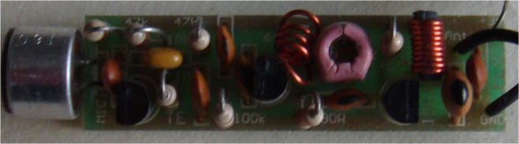
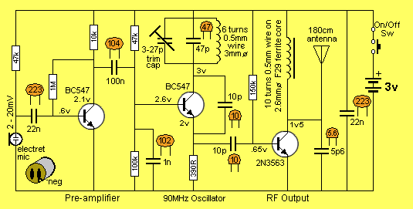
The Fly Circuit Diagram
THE OUTPUT STAGE
To tighten up the output stage we used a linear amplifier and placed an RFC (radio frequency choke - Radio Frequency Coil) in the output.
The effectiveness of this can be seen by the range we gained over the ANT. Without any increase in current or supply voltage, we have increased the range four-fold.
For the output stage to be effective, it needs a genuine RF transistor and that's why we used a 2N 3563. It's about the only suitable, low-cost, type on the market.
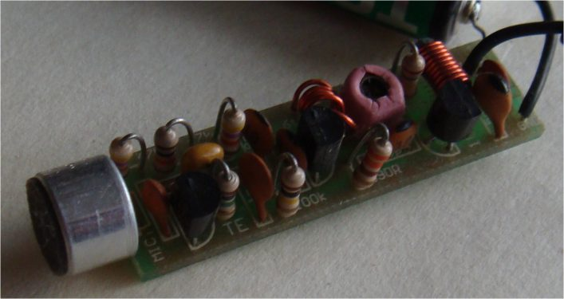

BUYING A KIT
I cannot stress too strongly, the need to purchase a kit. It is almost impossible for you to make your own PC board with tinned track-work and a fully detailed overlay for less than the price we are selling them for. This is because we get them made 1,000 at a time on an automatic 3-head drilling machine and you could never compete with mass-production.
On one of the early CAD boards we placed the RFC around the wrong way and the output was reduced enormously. The simple mistake of having the tank coil and RFC positioned so that the magnetic field of each interacted to oppose each other took quite a while to diagnose.
Also the size and spacing of the coils is critical as the wire gauge as well as coil diameter and the number of the turns.
This has all taken many hundreds of experiments to get the optimum size and shape and it all looks so obvious when it's finished.
If you want your project to work as good as the one we have described, the characteristics of everything must be identical to ours.
If you like experimenting, you should build a kit first, then you can experiment with another set of parts and make all the changes you like.
But let me stress, I think we have achieved the optimum performance and I don't think you will do any better. But don't let that deter you. Winning the lottery is near impossible and yet millions try their luck every week.
But that's getting off the track. First thing’s first.
The Amoeba is only slightly more complex than the ANT in construction, but considerably more complex in peaking. The Ant needs no peaking at all but simply an adjustment of the oscillator coil to get the desired frequency. The Amoeba requires additional skill in peaking the tank circuit to get maximum output.
This is done with the aid of a peaking meter (or peaking circuit) we call the LED Power Meter.
PARTS LIST
1 - 390R (orange-white-brown)
1 - 10k (brown-black-orange)
2 - 47k (yellow-purple-orange)
1 - 100k (brown-black-yellow)
1 - 150k (brown-green-yellow)
1 - 1M (brown-black-green)
1 - 2-10p air trimmer
1 - 5p6 ceramic
2 - 10p ceramics
1 - 47p ceramic
1 - 1n ceramic (102)
2 - 22n ceramics (223)
1 - 100n monoblock (monolithic) (104)
2 - BC 547 or 2N 2222 or similar transistors
1 - 2N 3563 transistor
1 - 6 turn 0.5mm enamelled wire (3mm dia) coil
1 - 10cm enamelled wire
1 - Ferrite core F29 material
1 - electret microphone
1 - mini slide switch
2 - AAA cells
1 - 170cm antenna wire
1 - FLY PC BOARD
CONSTRUCTION
If you follow the circuit diagram for the FLY you will see that the audio amplifying stage including the microphone starts on the left. The circuit follows through to the RF oscillator and the output stage and then the power supply.
When we design our CAD PC boards we try to keep the layout as close to how the layout of the circuit diagram is presented. This will help you follow the circuit and understand its operation in a linear fashion especially when it comes to trouble-shooting, (this is when the circuit doesn’t work as expected). It is only when you have built and tested the project and had first-hand experience that you will be able to see and understand what each part is doing.
To work on the PC board, rotate it and have the microphone end of the board to your left. Leaving the microphone until last, because it is one of the tallest components. Start with the 47k resistor, place it through the marked holes and bend the leads outwards under the board to hold it in place. Next, fit the 22n capacitor and the BC 547 transistor bending the leads to hold them in place.
When you have fitted 2 or 3 parts, turn the board over and neatly solder the leads to the lands. Snip them as close to the top of the solder joint with a pair of side-cutters. Never cut the leads before soldering.
One constructor cut the leads before soldering and one lead was cut too short. It did not make contact when soldered and it took a long time to find.
Next you can fit the BC 547 transistor, the 100n mono block and the 1M resistor.
Following what you have just done, work from left to right of the board fitting a part as you come to it by following the overlay.
Alternatively you can always fit one component at a time and solder it to the board.
The enameled air coil is pre-wound for your convenience. To tin the leads for the soldering process you can scrape the enamel off the leads with a blade close to the coil so that when the coil is placed on the PC board it is positioned one or two millimeters off the board. When you have scraped the enamel off, lightly tin the leads with some solder and solder it to the pads.
The ferrite-cored coil needs to be wound by you. A length of wire and a small ferrite core is included in the kit.
Taking the wire and coil. Place the middle of the wire on the centre of the core and wind 5 turns to the end of the core and then the other 5 turns. This method allows you to hold the core in your fingers. Make sure the coil is wound is the correct direction so the ends fit down the holes in the PC board.
Tin the leads of the coil, place it down the marked holes and solder it close to the board.
The last part to be fitted is the microphone. It is polarised so there is only one correct way to fit it. One of the leads has a fine track to the case. This is the negative lead and should match the hole on the board marked with a “—“ sign.
The batteries included in the kit have to be soldered together. The switch is prepared by feeding an off-cut of tinned copper wire lead through one end-terminal and the centre terminal. Bend to hold it in place, and solder it to the terminals.
With a piece of blu-tack stuck to your workbench stand the two batteries side by side with opposite ends at the same height. Tin the ends with solder. Take the switch and solder the two connected switch tabs to one terminal of a battery and the other tab to the other terminal. Now get another wire off-cut and feed it though the negative hole on the board and solder it in place. Line up the negative terminal and solder the wire. Use a short length of hook-up flex from the antenna to solder the positive terminal to the board.
Solder the antenna wire and the project is complete.
TESTING
You may think our method of testing a transmitter is back-to-front because we start at the output and work towards the front end. But when you look at it more closely, you will see why. Once you have the output stage working, you have a starting point and from there the procedure is fairly straight-forward.
The output of the transmitter consists of two parts. The 'carrier' is a constant frequency. If we are transmitting at 100MHz, it is a 100MHz carrier. Added to this is the audio component and this causes the carrier to increase and decrease by an amount equal to the audio picked up by the microphone.
This audio MODULATES the carrier and this gives the term FM transmission. We use this knowledge to fault-find the project. Our first concern is to be able to detect the carrier. This is picked up on an FM radio as a 'dead spot' or 'clear spot' on the dial when the transmitter is on. When the transmitter is turned off, the background noise appears.
The carrier is produced by the oscillator stage (the BC 547) and the linear amplifier (the 2N 3563) will transfer this frequency to the antenna with increased driving power. When we detect a carrier, we prove that both stages are working. if a dead spot is not heard, you should firstly assume the frequency of transmission is off the FM band.
To adjust the transmitter, all you need do is stretch the turns of the oscillator coil (making sure they do not touch each other if bare tinned copper wire is used). Tune across the entire band on the FM radio, looking for a silent spot.
The bandwidth of the transmitter will be quite narrow and it will be necessary to sweep the band fairly slowly. If nothing is heard, go over some of the simple faults such as making sure the project is ON, the radio is on the correct band (88MHz to 108MHz), the radio has an antenna connected and no metal objects are near the transmitter.
You must detect a carrier before progressing any further. This is the starting point and no other sections can be tested until this is successful. Unless you have a 100MHz CRO, there is no other way to see if the project is transmitting.
This is not exactly true as another solution is to make a second FLY. If the second project works successfully, (and I see no reason why it shouldn't), you can use it to physically check the spacing of the coil, placement of the parts and the position on the FM band, to see why things are not coming through on the first model. When a clear spot is heard, you are half-way home. In fact you are 90% home. The next step is the testing of the audio stage or stages. Although the project contains one audio stage, we can consider the microphone to be a stage since it is an active device containing a FET transistor.
If either the microphone or pre-amplifier stage does not work, you will only get a carrier output. Make sure the voltage on the microphone is at least 50mV and the collector of the preamplifier is at least .8v. If it is less, the transistor may be saturated and if it is 3v, the transistor will not be conducting. Check the base voltage also. It should be 0.65v. If this fails to locate the fault, you can use almost any CRO to pick up the waveform at a number of locations on the board, around the audio section.
You can also use our Mini Bench Amplifier and it is very handy for testing audio projects.
If you have access to a CRo, by whistling into the microphone and picking up the waveform at the output of the mic (at the point where the load resistor connects to the mic), you will be able to see the output of the microphone. Next, pickup the waveform at the other end of the coupling capacitor and note that some of the amplitude has been lost. This point is also the base of the audio transistor and you can determine the gain of the transistor by comparing the output with the input. The gain should be between 50 and 100.
The output is injected into the base of the oscillator stage via a DC blocking capacitor and this is where the CRO capability finishes. You will need a 100MHz CRO from now on. You should adjust the oscillator coil to a frequency away from a radio station and this is generally at the very bottom of the band. Once the circuit is working successfully, the final part is to peak it by adjusting the coil on the tank circuit.
This will give the range you will be expecting. This is done by connecting the LED Power Meter to the antenna land on the board (without the antenna wire connected). But first we have to build the LED Power Meter.

USING THE LED POWER METER
Connect the 5cm wander lead to the collector of the oscillator transistor on the FLY and turn the project on.
The lead of the LED Power Meter will act as an antenna, so place a radio nearby and tune it to about 88.5MHz or somewhere at the low end of the band. Move the turns of the 6 turn oscillator coil either together or stretch them apart until a feedback whistle is picked up by the radio. This is the frequency of transmission.
When the turns are pushed together the frequency decreases and when moved apart, the frequency increases. Now place the wander lead from the LED Power Meter on the antenna point on the board.
You will not be able "peak" the signal as the output stage does not have any adjustment.
The project is now ready to fit into a Tic Tac box. The ON/OFF switch can be operated by opening the lid and switching the bug on. It does not matter if the lid is open or closed, the microphone will pick up the faintest sounds in a room and transmit them to an FM radio up to 400 metres away. Of course, this will depend on the positioning of the antenna and the quality of the radio. The antenna should be stretched and placed over a high shelf etc so the signal has an opportunity to radiate effectively.
Do a bit of experimenting and you will be very impressed with the performance.

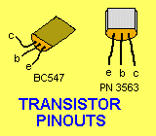

Reading these articles is certainly a starting point, but to really understand how a circuit works, you have to BUILD it.
This eBook contains more variety and information on FM transmission than anywhere else.
The best way to start is with a kit as some of the items in each kit are only available from Talking Electronics.

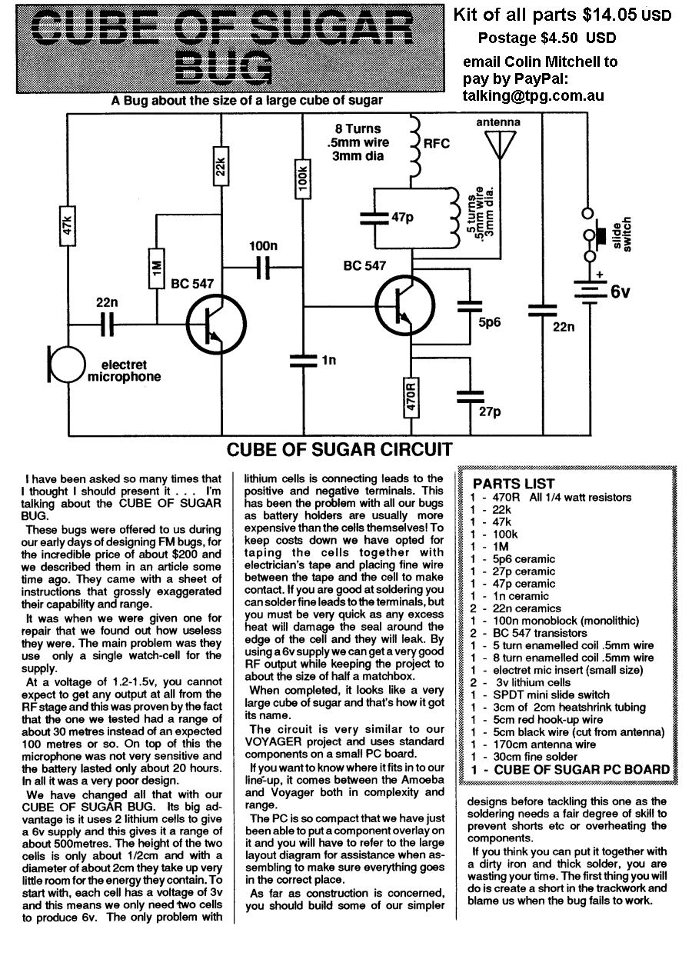

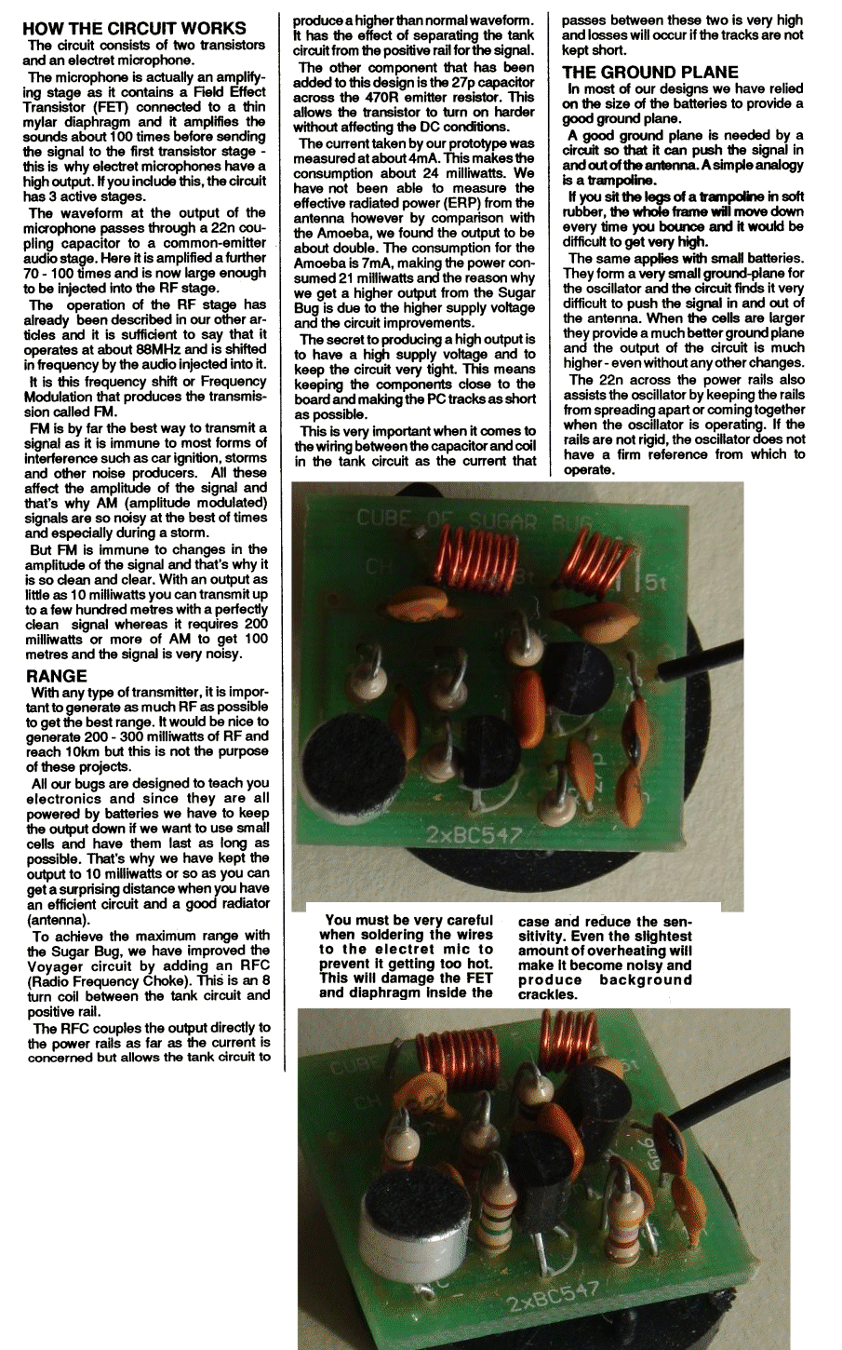

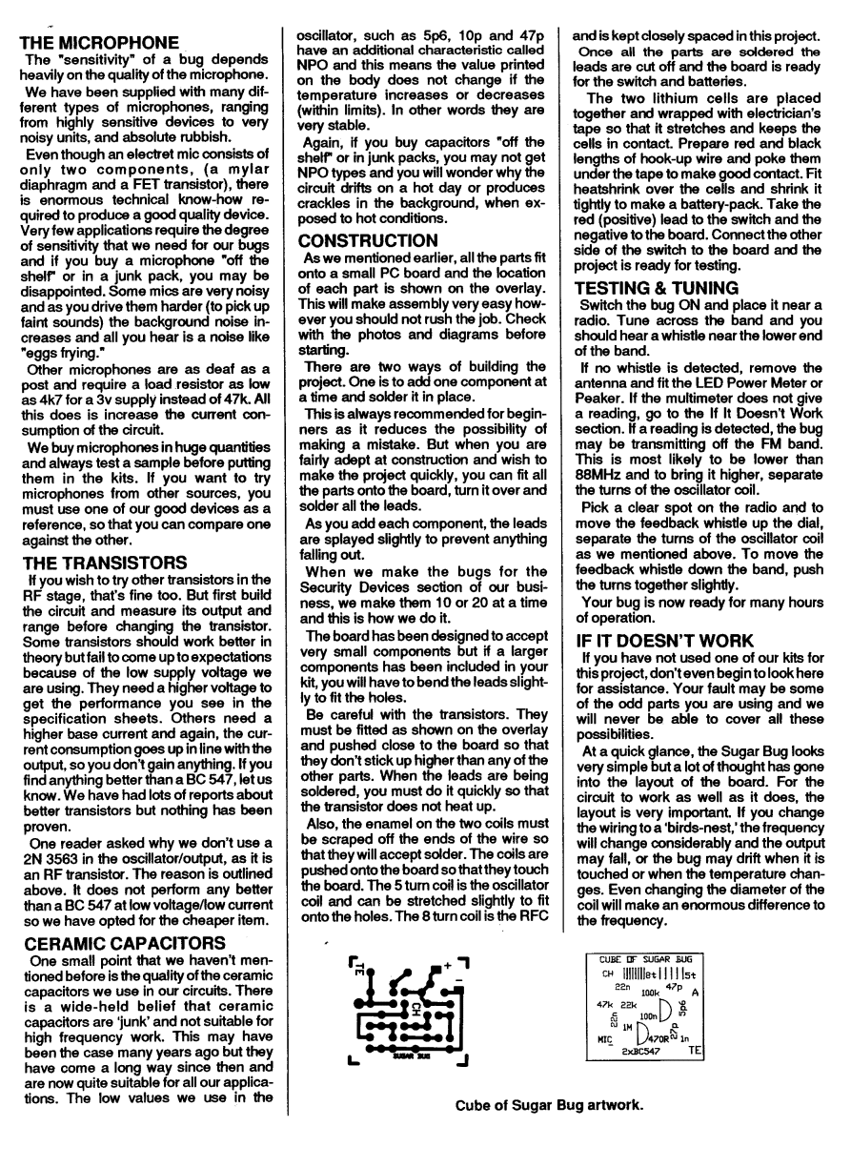

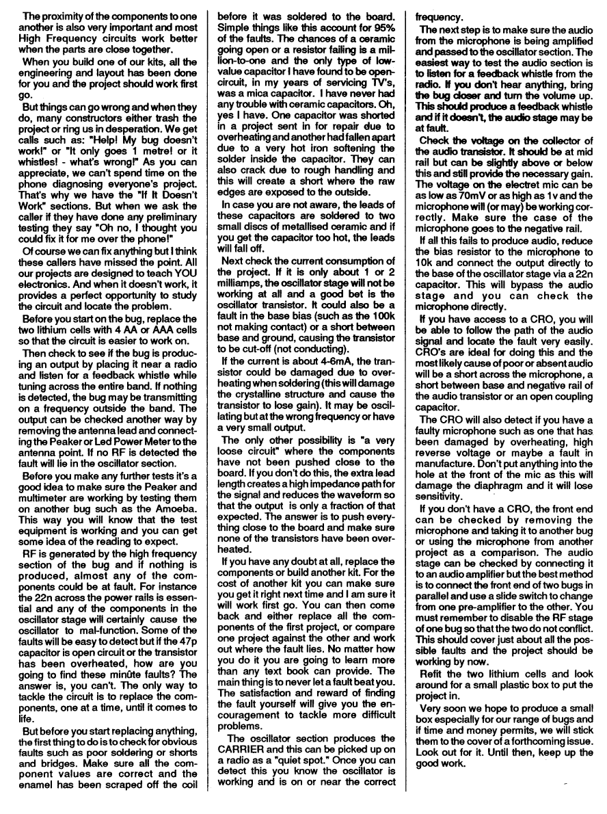

FM BUG
Kit of parts: $11.60 USD
Postage $4.50 USD
pay by PayPal
contact Colin Mitchell
email: talking@tpg.com.au
for details on paying for kit
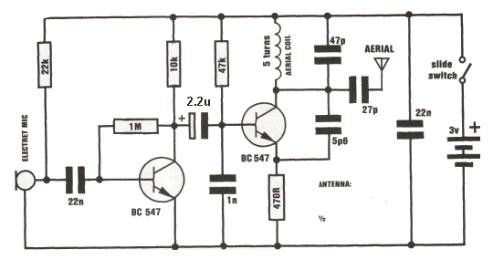
FM BUG Circuit
Corporate espionage is reaching new heights in sophistication. The latest information to be released shows the depths firms will go to pry into a rival firm's operations.
By using the latest in electronic bugging, they have stolen information, secrets and even formulas known only to the inventors themselves.
Take the example of one firm:
Leaks from Top Management level remained a mystery until, one day, a bug was discovered inside the Managing Director's office.
Sitting prominently on his desk was a gift box of imported cigars!
Cleverly concealed in the lower part of the box was a miniature FM transmitter . . all a gift from a phony sales rep.
This is just one of the many bugging devices available on the eaves-dropping market. The range includes pen and pencil holders, trophies, framed pictures and office furniture with false bottom drawers.
These products are readily sold to fledgling companies, eager to nestle into big brother's market.
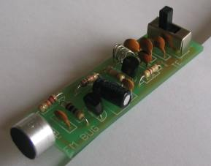
The Complete FM Bug
And for a while these bugging devices worked. Few firms knew of their existence, and even less on how to sniff them out.
But that has all changed now. If a corporation suspects a leak at any level, the first thing they order is an investigation into security. Not only personnel, but information and electronic security.
Debugging has grown into big business. Most large security organisations have a section concentrating on electronic surveillance including bugging and debugging.
They use scanners to detect hidden devices and can locate absolutely anything, anywhere, and on any frequency.
It was only after the firm above had commissioned a scan of the entire floor, that the cigar box was discovered. Its innocence had deceived everyone. And cost them a small fortune!
Bugging of this kind is completely illegal and we don't subscribe to this type of application at all.
But the uses for our SUPER-SNOOP FM WIRELESS MICROPHONE can be harmless, helpful and a lot of fun.
Our unit is both compact and very sensitive and can be used to pick up even the faintest of conversations or noises and transmit them 20 or so metres to any FM receiver.
When you build the FM BUG you will see why we consider the design to be very clever. We have used only low priced components and they are all easy to obtain.
No air trimmer capacitor is required as the coil is squeezed slightly to obtain the desired frequency. This has allowed us to fit the bug into a tooth-brush case so that it can be carried around or placed on a shelf.
If it is set between two books it will be hidden from view or as a supervision accessory it can be placed on a small child, etc. The transmitted signal will over-ride the background noise and the output will be clean. If the child wanders beyond the range of the transmitter, the background noise will come up and signal that the tot is out of range.
As an added bonus, you can listen to the chatterings and squabbles as the children amuse themselves in the back yard.
It is also great for picking up the first signs of a child awakening from his afternoon sleep or it can be used as an indicator from a bed-ridden patient.
The great advantage of the bug is the absence of wires. And since it draws only about 5-10 milliamps, the pair of AAA cells will last for many months.
The success of this FM BUG is the use of TWO transistors in the circuit. To create a good design, like this, each transistor should be required to perform only one task. In any type of transmitter, there is a minimum of two tasks.
One is to amplify the signal from the microphone and the other is to provide a high frequency oscillator.
The amplified microphone signal is injected into the oscillator to modify its frequency and thus produce a FREQUENCY MODULATED oscillator. If an aerial is connected to the output of the oscillator, some of the energy will be radiated into the atmosphere.
To increase the output of our design, an RF amplifier would be needed but this gets into legal technicalities with maximum transmitting power.
It may be of Interest to know that a record distance of 310 miles was achieved with a 350 micro-watt transmitter in the USA, some 15 years ago. This equates to an astounding ONE MILLION miles per watt!
In simple terms, an RF amplifier becomes a LINEAR amplifier.
We have opted for sensitivity and the first transistor is employed as a pre-amplifier. This will enable you to pick up very low-level sounds and transmit them about 20 to 50 metres.
MAKING THE OSCILLATOR COIL
The only critical component in the FM BUG is the oscillator coil. When I say critical, I am referring to its effect on the frequency. Its critical nature only means it must not be touched when the transmitter is in operation as this will detune the circuit completely.
It is the only component which needs to be adjusted or aligned and we will cover its winding and formation in detail.
The oscillator coil is made out of tinned copper wire and does not need any insulation. This is not normal practice but since the coil is small and rigid, the turns are unable to touch each other and short-out.
The coil is made by winding the tinned copper wire over a medium-size Philips screw-driver. The gauge of wire, the diameter of the coil and the spacing between turns is not extremely important and it will be adjusted in the alignment stage. However when the project is fully aligned, it must not be touched at all.
Don't be over-worried at this stage. Just follow the size and shape as shown in the diagram and everything will come out right in the end.
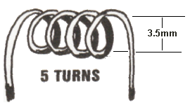
THE DETAILS:
The coil has 5 turns and is wound on a 3.5mm shaft. To be more specific, it has 5 loops of wire at the top and each end terminates at the PC board. The coil must be wound in a clock-wise direction to fit onto the board and if you make a mistake, rewind the coil in the opposite direction.
CONSTRUCTION
Construction is quite straight-forward as everything is mounted on the printed circuit board. The only point to watch is the height of some of the components. The electrolytic must be folded over so that the board will fit into the case.
Positioning of the parts is not as critical as you think as the final frequency is adjusted by squeezing the coil together or stretching it apart.
However it is important to keep the component leads as short as possible and the soldering neat due to the high frequencies involved. The components must be soldered firmly to the board so that they do not move when the transmitter is being carried.
Even the poorest of soldering will work but who wants to see poor soldering on a project?
The soldering may not affect the resulting frequency but poor layout of the components certainly will.
All the resistors must be pressed firmly against the PC board before soldering and the two transistors must be pushed so that they are as closes as possible to the board.
Some BC 547 transistors will not work in the circuit. Maybe the frequency is too high. SGS BC 547 transistors did not work at all. The other two types: f BC 547 and Philips BC 547 worked perfectly.
All the small-value capacitors are ceramic as they are not critical in value and do not need to be high stability. But you must be careful when identifying them. It would be a very simple mistake to buy a 56p instead of 5p6 because there is no difference in the size. 22n may be identified with 223 or 22n or .022. A capacitor marked 22k will be a 22p cap and will not be suitable. The 1n capacitor may be marked 1n or .001 or 102. These are all the same value. The value 101 or 103 is NOT 1n so be careful, the caps may be about the same size. The rule is: don't use a capacitor unless its markings are clear and you are sure of the value.

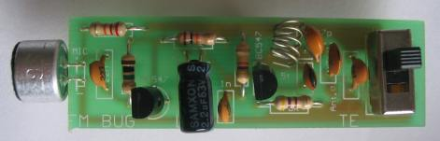
The complete FM BUG
The switch is mounted on the PC board with its three terminals fitted into the large holes.
The final items to add to the board are the two AAA cells. These come with the kit and we have chosen them for slenderness so that they can be fitted side-by-side.
It is very difficult to solder to the zinc case but if you roughen the surface with a file and use a large, HOT, soldering iron, the job can be done very quickly. Use a piece of tinned copper wire to join the positive of one to the negative of the other. At the other end, solder longer lengths of wire so that they can be connected directly to the PC board. Make sure the positive terminal connects to the plus on the PC board.
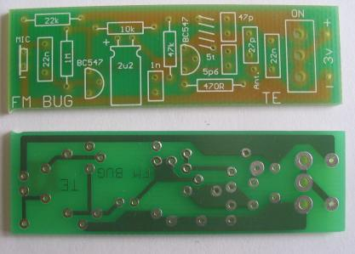
Top and bottom of the FM BUG PC board
AAA cells are also obtainable at photographic shops. The only alternative is an 'N' cell which is nearly as thin as an AAA cell but only half the length.
The terminal marked A on the board is the antenna output. For a frequency of 90MHz, the antenna should be 165cm long. This is classified as a half-wave antenna and provides one of the most effective radiators. If you find the antenna gets in the way you can opt for a quarter-wave antenna and this will be 83cm long. If you only require to transmit 10 to 20 metres the antenna can be as short as 42cm or even as low as 5 or 10 cm.
The most suitable length will depend on the sensitivity of the FM radio used to pick up the signal and the obstructions between the transmitter and receiver. It will be a good experiment for you to 'cut' your own antenna and determine which is the most suitable for your application.
HOW THE CIRCUIT WORKS
The circuit consists of two separate stages. The first is an audio pre-amplifier and the second is a 90MHz oscillator.
The first stage is very simple to explain. It is a self-biasing common-emitter amplifier capable of amplifying minute signals picked up by the electret microphone. It delivers these to the oscillator stage. The amplification of the first stage is about 70 and it only operates at audio frequencies. The 22n capacitor isolates the microphone from the base voltage of the transistor and allows only AC signals to pass through. The transistor is automatically biased via the 1M resistor which is fed from the voltage appearing at the collector. This is a simple yet very effective circuit. The output from the transistor passes through a 2.2u electrolytic. This value is not critical as its sole purpose is to couple the two stages.
The 47k, 1n, 470R and 22n components are not critical either. So, what are the critical components in this circuit?
The critical components are the coil and 47p capacitor. These determine the frequency at which the bug will transmit. In addition, the effective capacitance of the transistor plays a deciding factor in the resulting frequency.
This stage is basically a free-running 90MHz oscillator in which the feedback path is the 5p6 capacitor.
When the circuit is turned on, a pulse of electricity passes through the collector-emitter circuit and this also includes the parallel tuned circuit made up of the oscillator coil and the 47p capacitor. This pulse of electricity is due to the transistor being turned on via the 47k resistor in the base circuit.
When ever energy is injected into a tuned circuit, the energy is firstly absorbed by the capacitor. The electricity will then flow out to the coil where it is converted to magnetic flux. The magnetic flux will cut the turns of wire in the coil and produce current and voltage which will be passed to the capacitor.
In theory, this current will flow back and forth indefinitely, however in practice, there are a number of losses which will cause the oscillations to die down fairly quickly.
If a feedback circuit is provided for the stage, the natural RESONANT frequency of the coil/capacitor combination will be maintained. The 5p6 provides this feedback path and keeps the transistor oscillating.
The 5p6 feeds a small sample of the voltage appearing at the collector, to the emitter and modifies the emitter voltage. The transistor sees its base-to-emitter voltage altering in harmony with the resonant frequency of the tuned circuit and turns the collector on and off at the same frequency.
Thus there is a degree of stability in the oscillator frequency.
The actual frequency of the stage is dependent upon the total capacitance of the circuit and this includes all the other components to a minor extent.
Once the basic frequency of 90MHz is set, the variations in frequency are produced by the changes in effective capacitance of the transistor. This occurs when its base voltage is increased and reduced. The electret microphone picks up the sound waves which are amplified by the first transistor and the resulting frequency is passed to the base of Q2 via the 2.2u electrolytic.
This alters the gain of the transistor and changes its internal capacitance. This junction capacitance modifies the oscillator with a frequency equal to the sound entering the microphone thus FREQUENCY MODULATING the circuit. A short length of antenna wire is connected to the collector of the oscillator via a coupling capacitor and some of the energy of the circuit will be radiated to the surroundings.
Any FM receiver will pick up this energy and decode the audio portion of the signal.
SETTING UP THE TRANSMITTER
When the FM BUG is complete, checked and ready for insertion into its case, there is one slight adjustment which must be made to align it to the correct frequency.
As we have said, the only critical component is the oscillator coil. It is the only item which is adjustable.
Since we are working with a very high frequency, the proximity of your hand or even a metal screw-driver will tend to de-tune the oscillator appreciably.
For this reason you must use a plastic aligning stick to make the adjustment. Any piece of plastic will do. A knitting needle, pen barrel or plastic stirring stick can be used.
Place the bug about a metre from the FM radio and switch both units on. Tune the radio to an unused portion of the band and use the alignment stick to push the turns of the coil together. Make sure none of the turns touch each other as this will short out the operation of the oscillator.
All of a sudden you will hear the background noise diminish and you may even get feed back. This amount of adjustment is sufficient. Place the BUG in its case and tape up the two halves.
The fine tuning between radio and transmitter is done on the radio. Peak the reception and move the BUG further away. Peak the fine tune again and move the BUG into another part of the house and see how far it will transmit.
IF THE BUG FAILS
If the bug fails to operate, you have a problem. Simple digital tests will not fix it nor will ordinary audio procedures. The frequency at which the BUG operates is too high.
You have to use a new method called comparison.
This involves the comparing of a unit which works, with the faulty unit.
This means it is ideal for a group of constructors to build a number of units and compare one against the other.
This will not be possible with individual constructors and they will have to adapt this fault-finding section.
The first fact you have to establish is the correct operation of the FM receiver.
If you have another BUG and it is capable of transmitting through the radio you know the radio is tuned to the correct frequency. Otherwise you will have to double-check the tuning of the dial and make sure the radio is switched to the correct setting.
The next stage is to determine if the BUG is functioning AT ALL. The only voltage measurements you can make are across the collector-emitter terminals of the first transistor (1 v to 1.5v) and across the collector-emitter terminals of the second transistor (1.3v to 1.5v) These values won't tell you much, except that the battery voltage is reaching the component.
Tune the radio to about 90MHz and lay the radio antenna very close to the antenna of the BUG. Switch the BUG on and off via the slide switch. You should hear a click in the radio if the BUG is on a frequency NEAR 90MHz. Move the turns of the aerial coil together or apart with a plastic stick as you switch the unit ON and OFF.
If a click is heard but no feed-back, the oscillator will be operating but not the pre-amp stage. This could be due to the electret microphone being around the wrong way, the transistor around the wrong way, a missing component or an open 2.2u electro.
If the fault cannot be located, compare your unit with a friend's. You may have made a solder bridge, connected the batteries around the wrong way, made the coil too big or used the wrong value capacitor for one of the values.
If all this fails, put the unit aside and start again.
PARTS LIST
1 - 470R
1 - 10k
1 - 22k
1 - 47k
1 - 1M
1 - 5.6p ceramic = 5p6
1 - 22p ceramic or 27p or 33p
1 - 47p ceramic
1 - 1n ceramic = 1,000p or 102
1 - 22n ceramic = .022 or 223
1 - 2.2u 16v or 25v
2 - BC 547 transistors
1 - mini slide switch spdt.
1 - electret microphone (insert)
2 - AAA cells
10cm tinned copper wire
2 - metres aerial wire
1 - FM BUG PC board

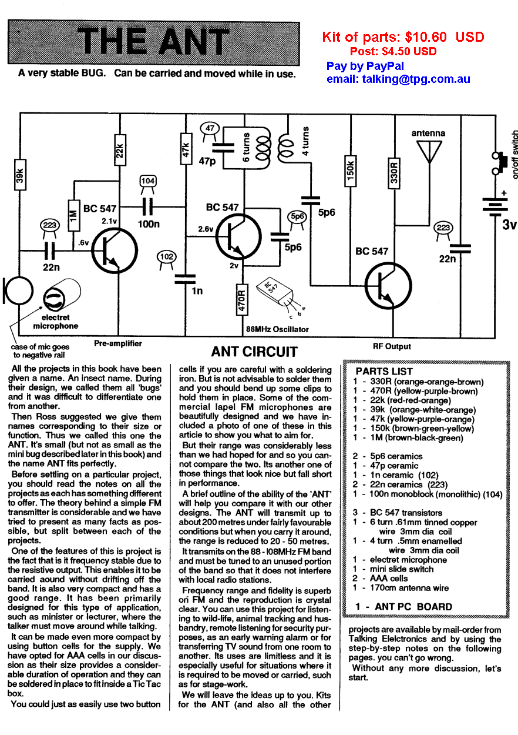
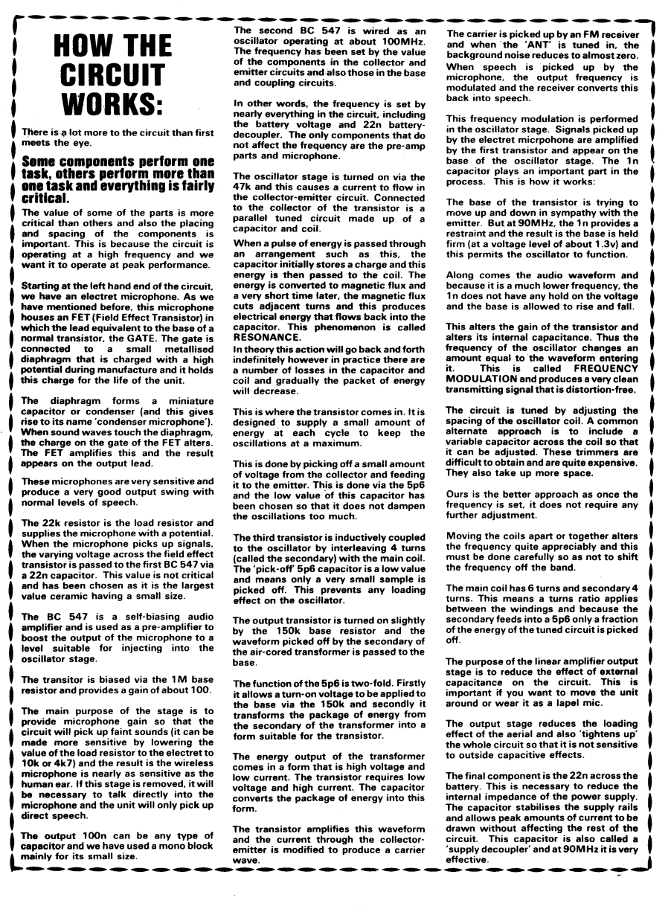
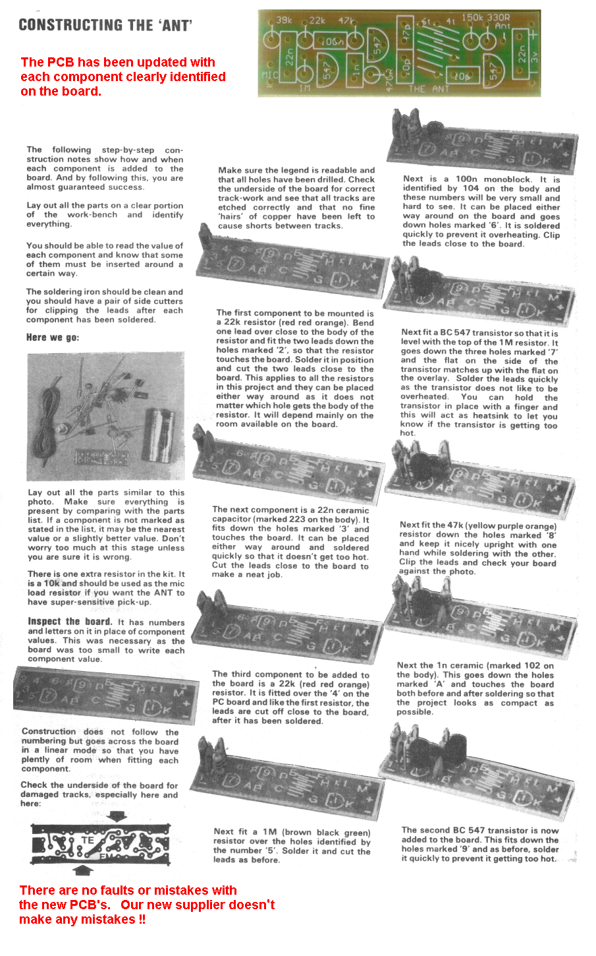
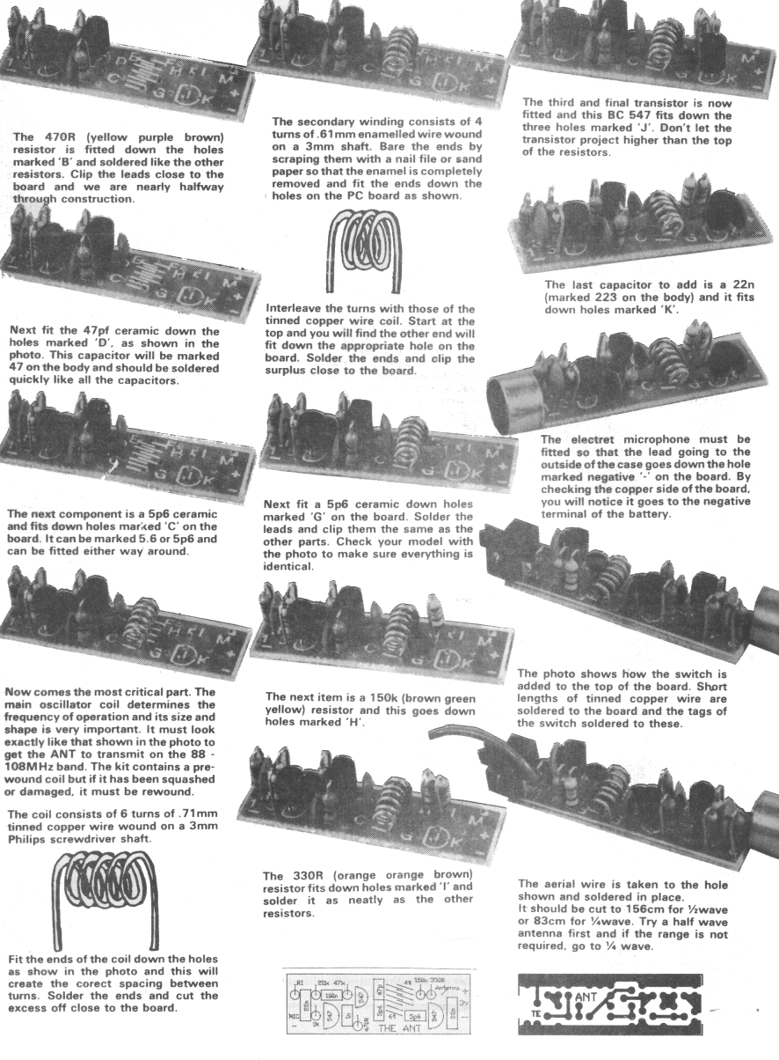
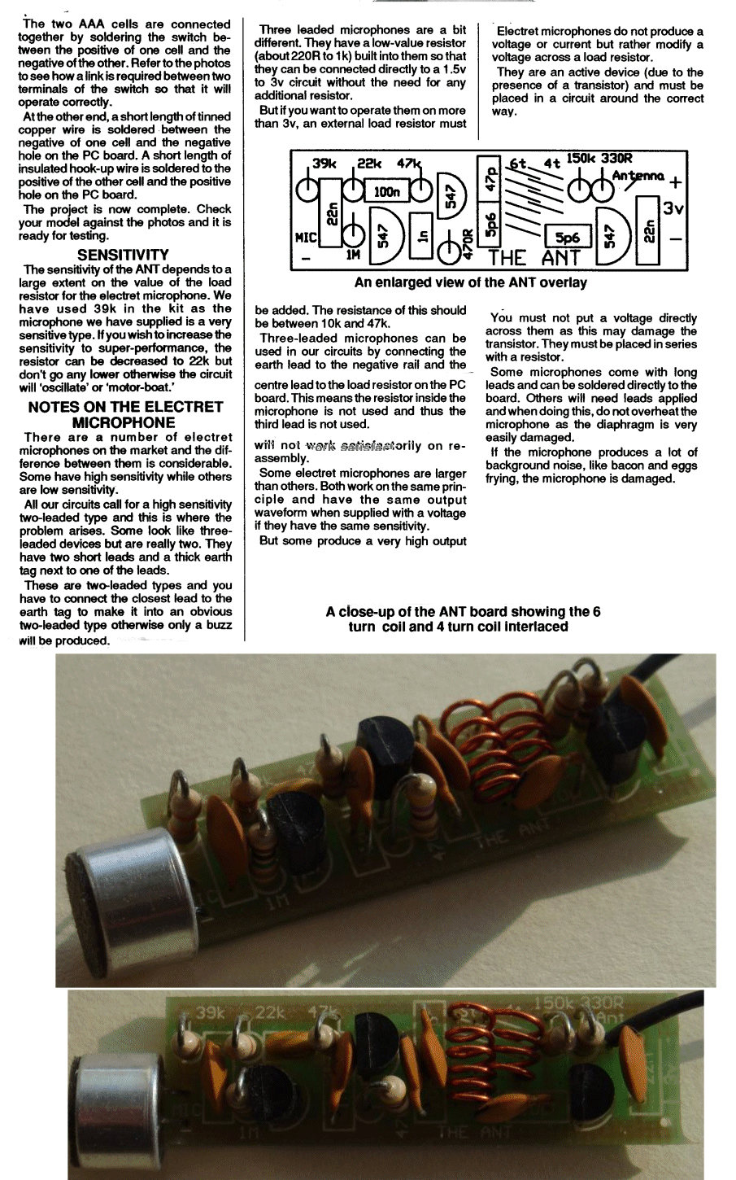
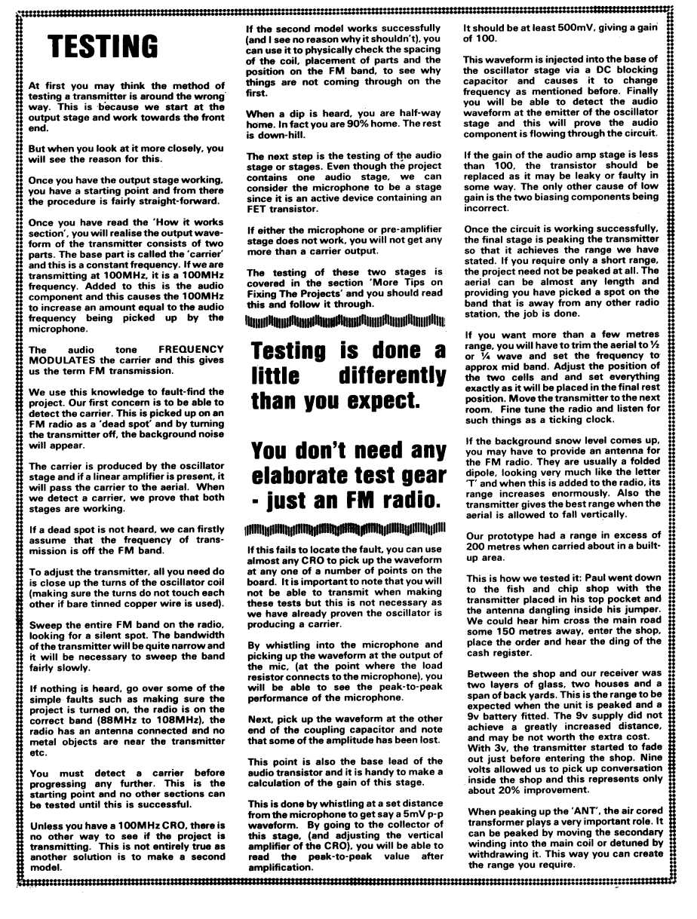
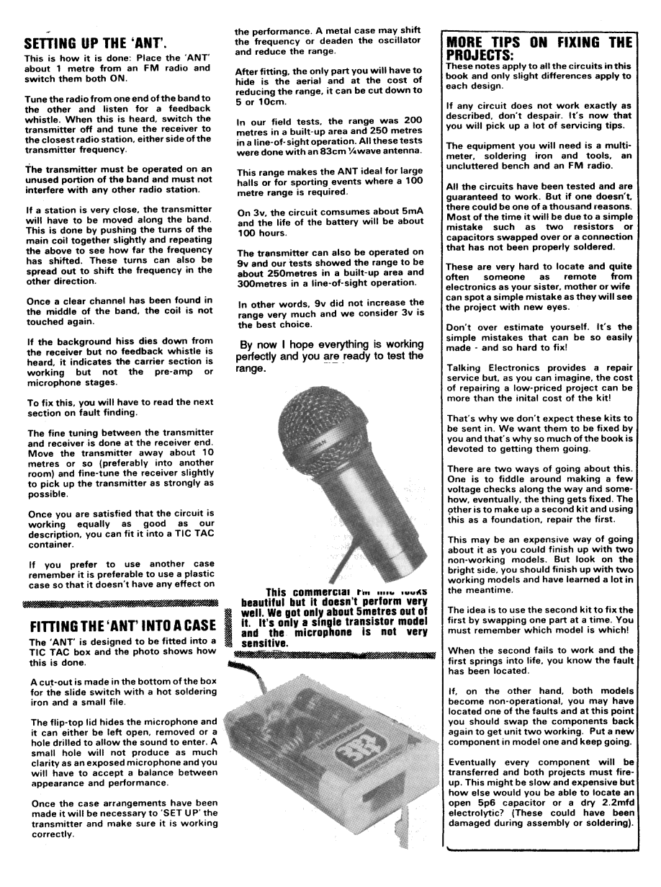
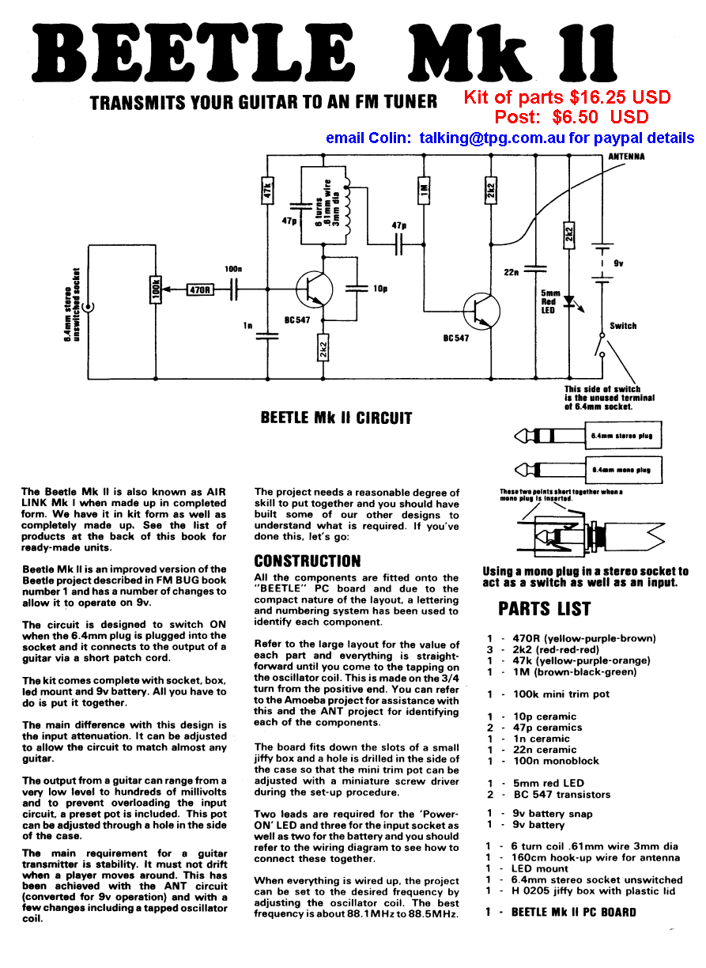
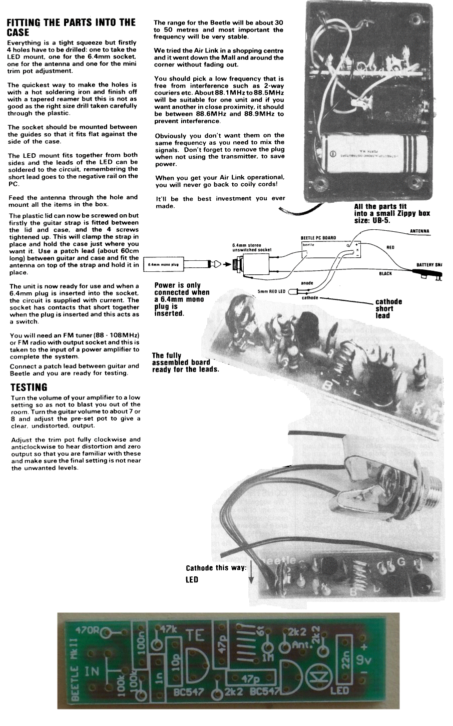
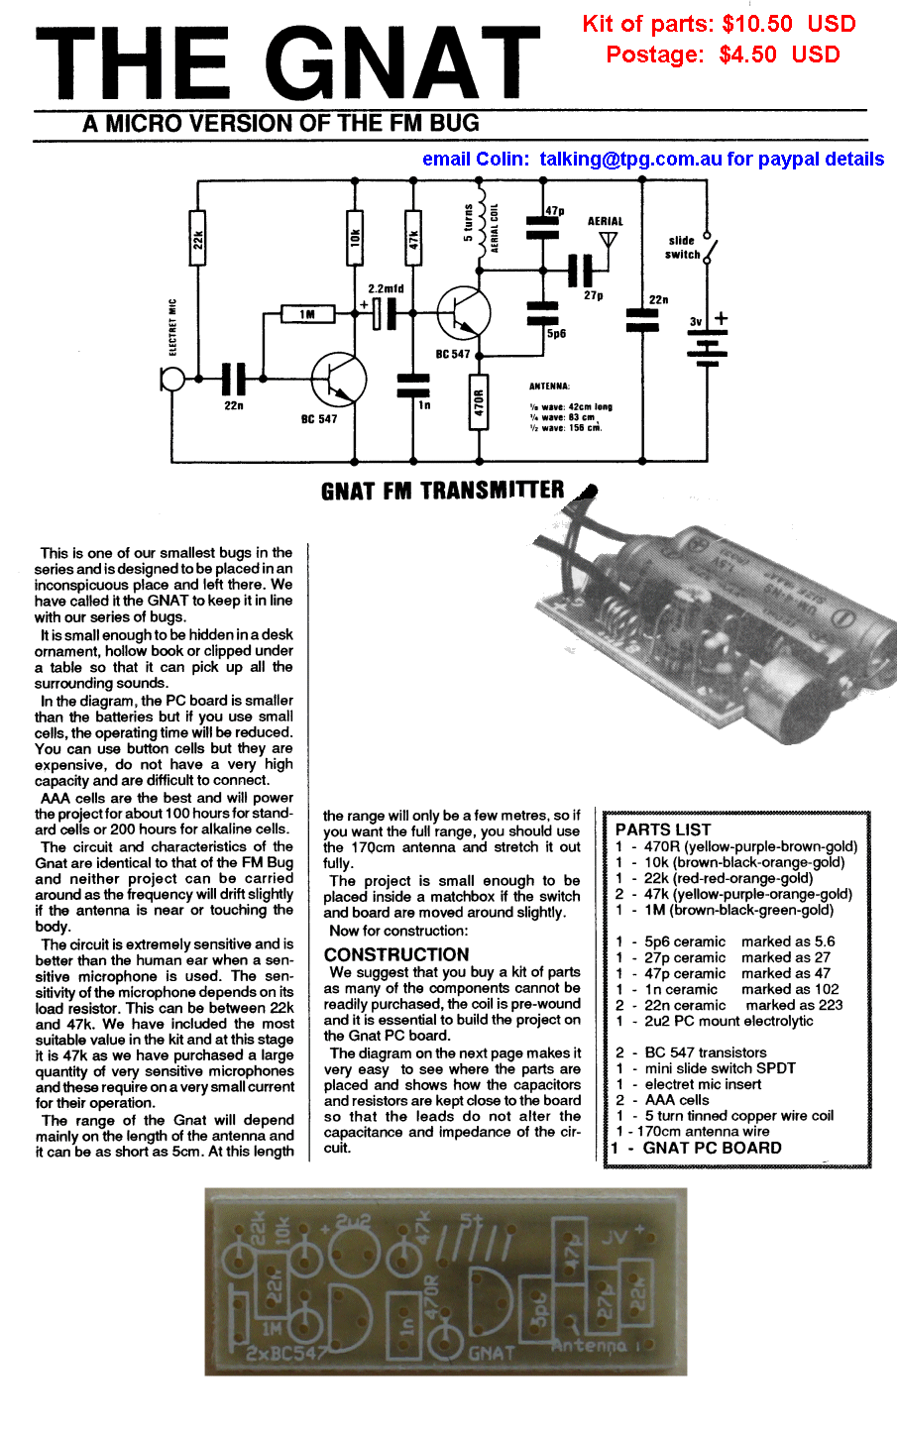
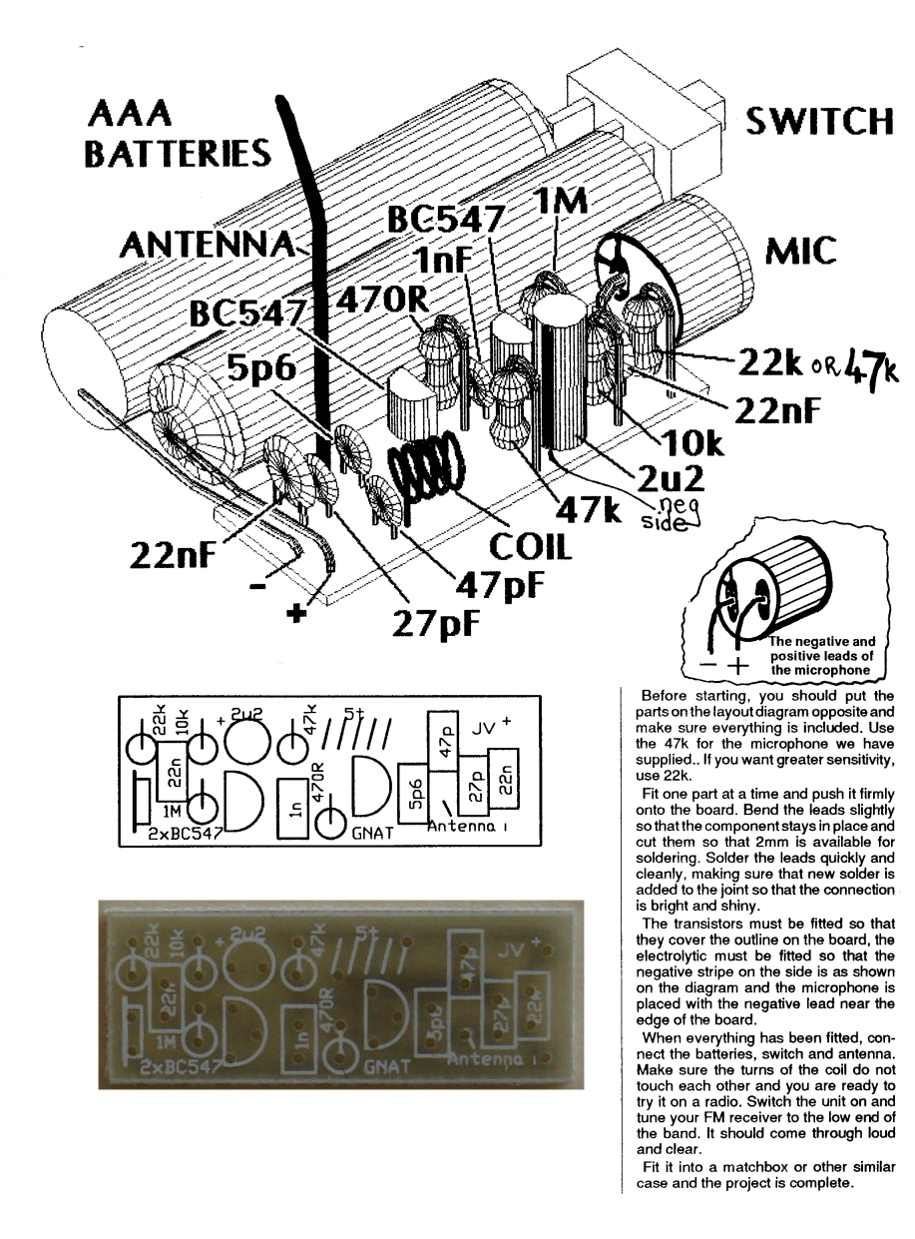
The 3D artwork above was designed and drawn by Ken Stone as a 3D side-elevation and rotated with the aid of a new program. It took 4 hours to produce the image we have used above. That’s how slow and inefficient computers were at the time. In fact, computers had just become available for less than $4,000. And the hard drive was 10 Meg !!
This image could be re-drawn now in less than 1/100th of a second.
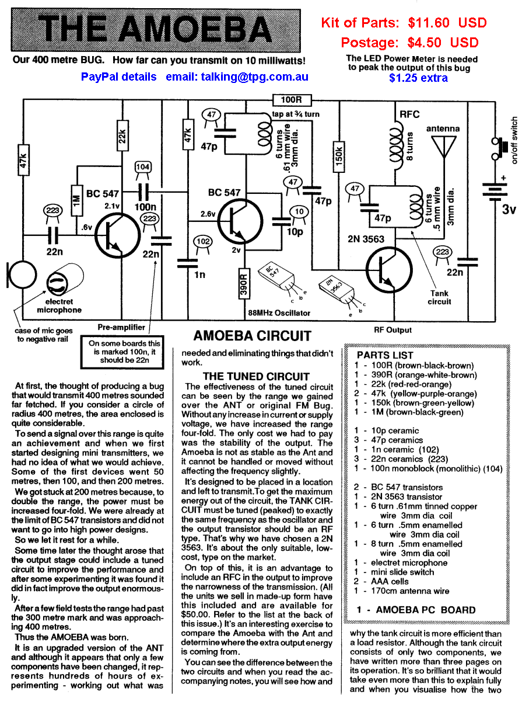
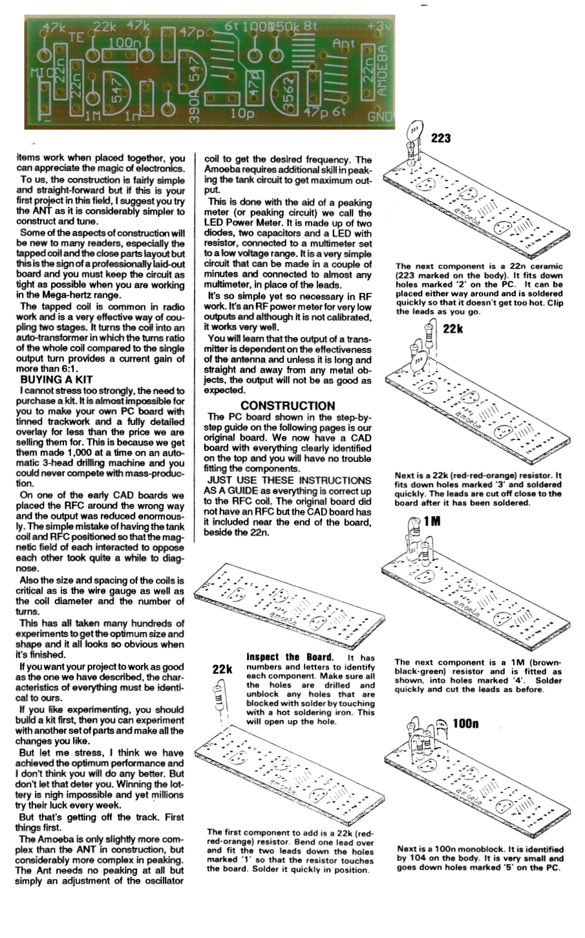
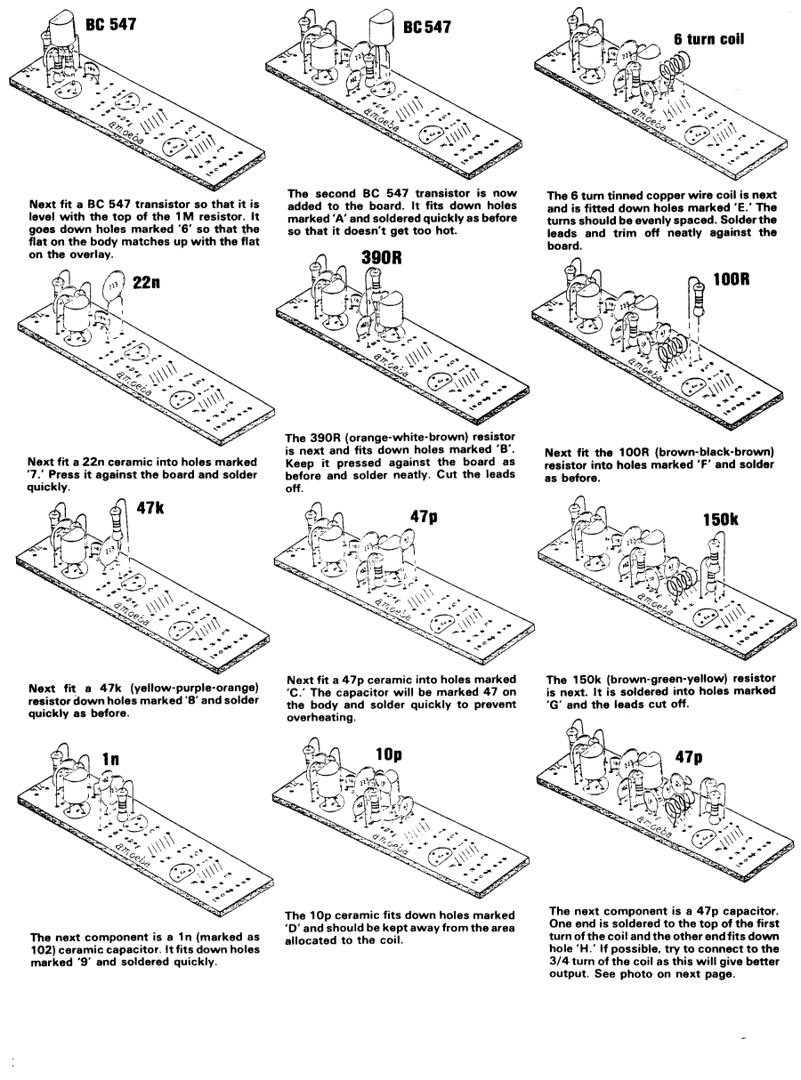
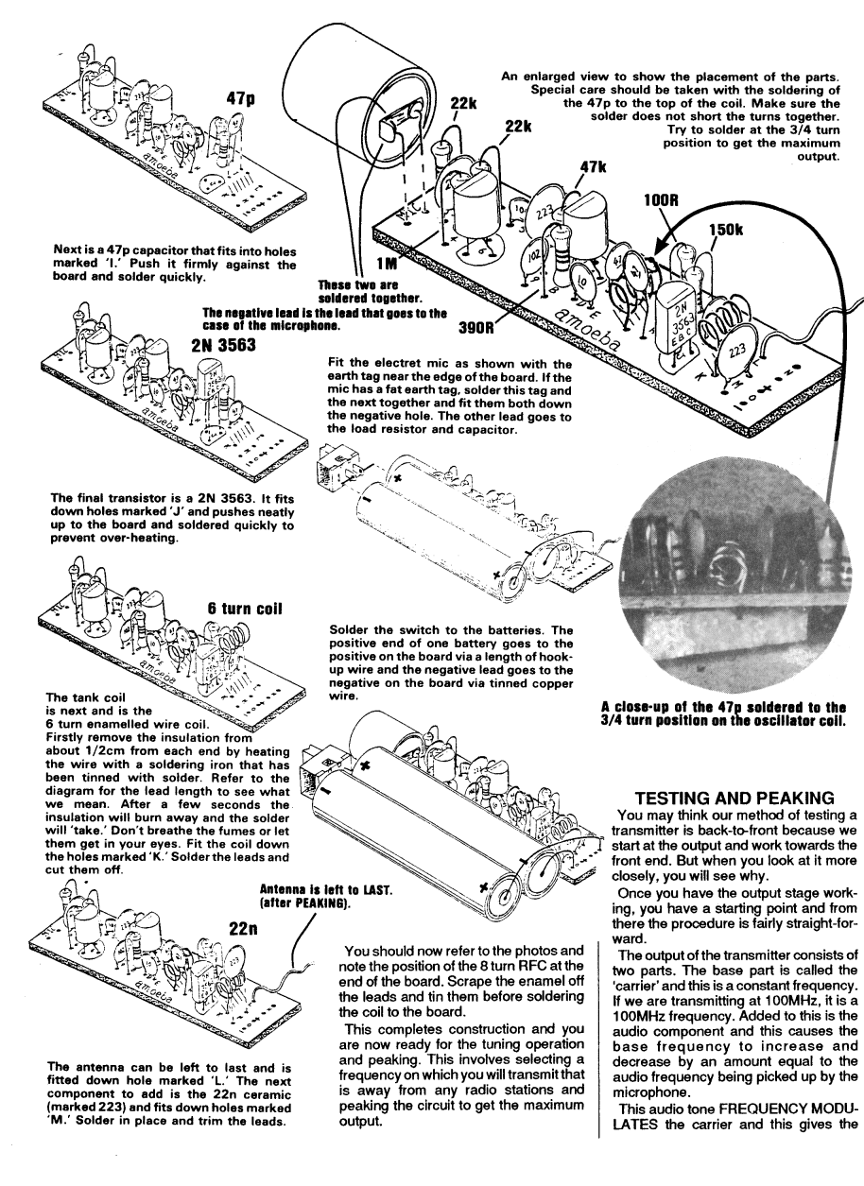
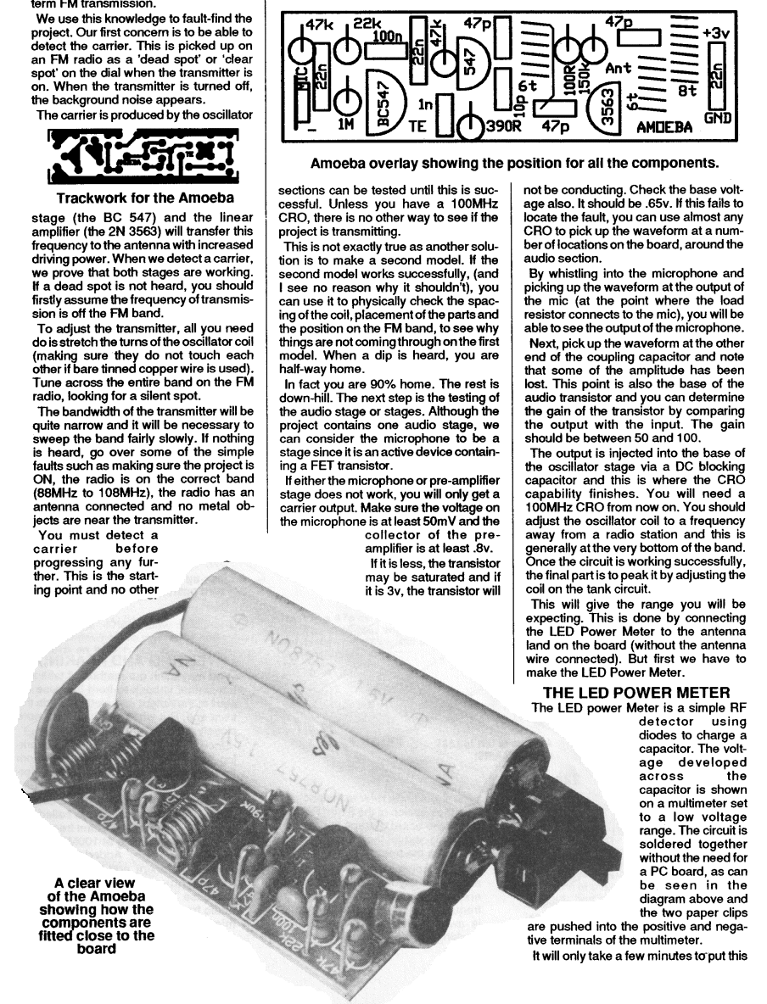
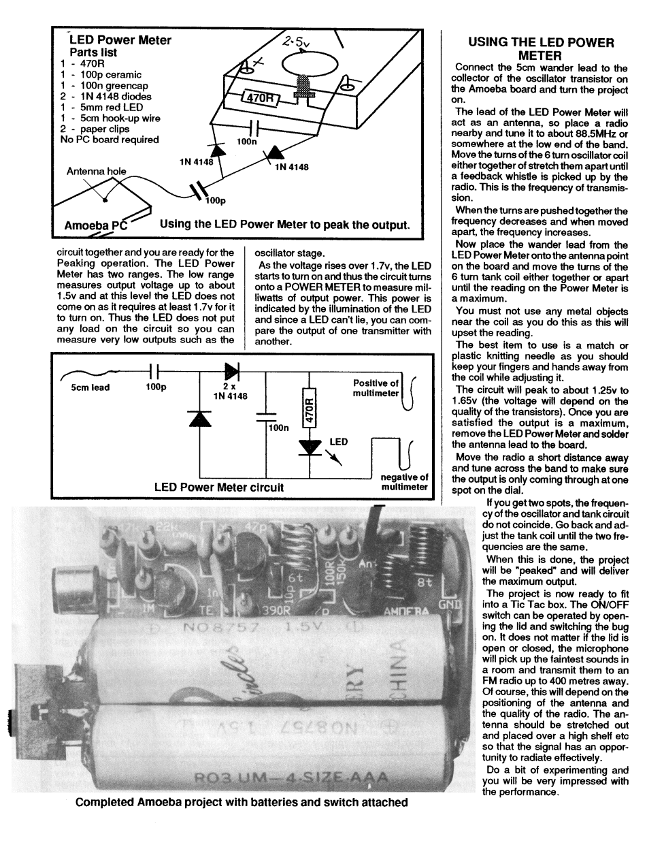
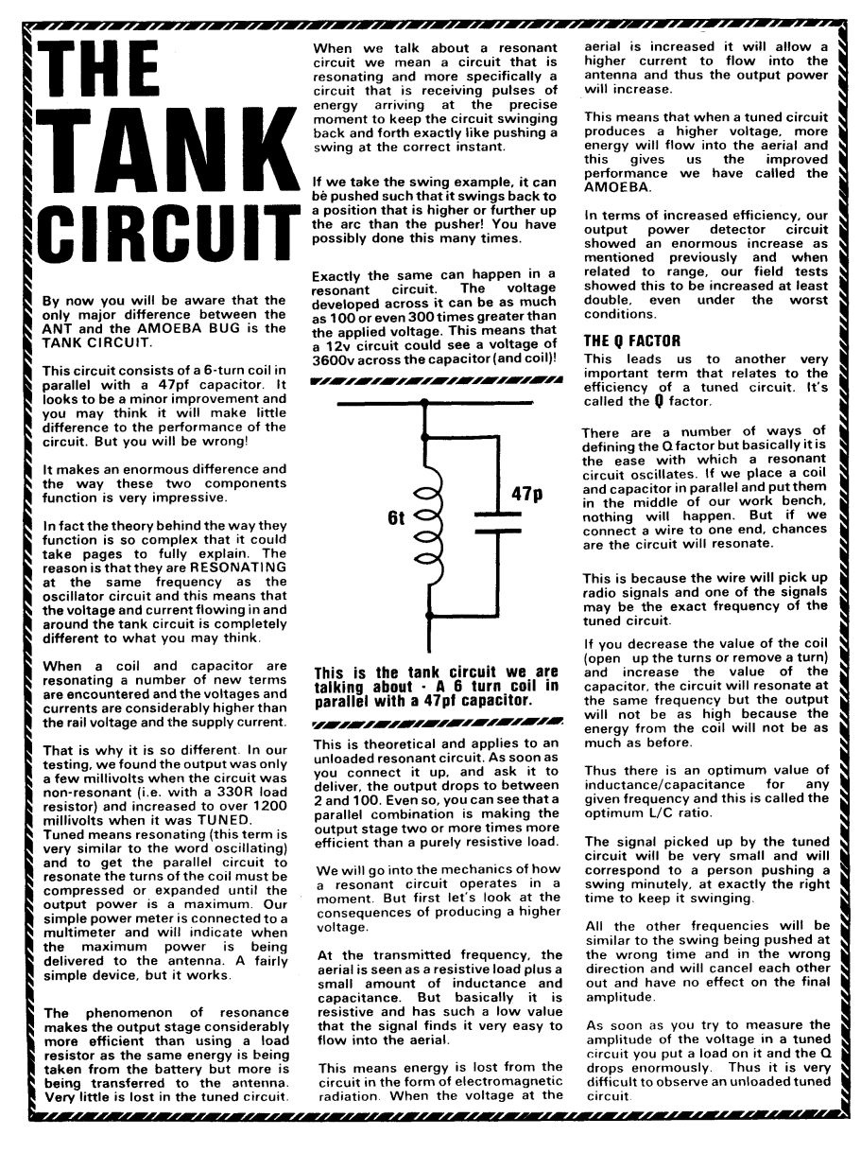

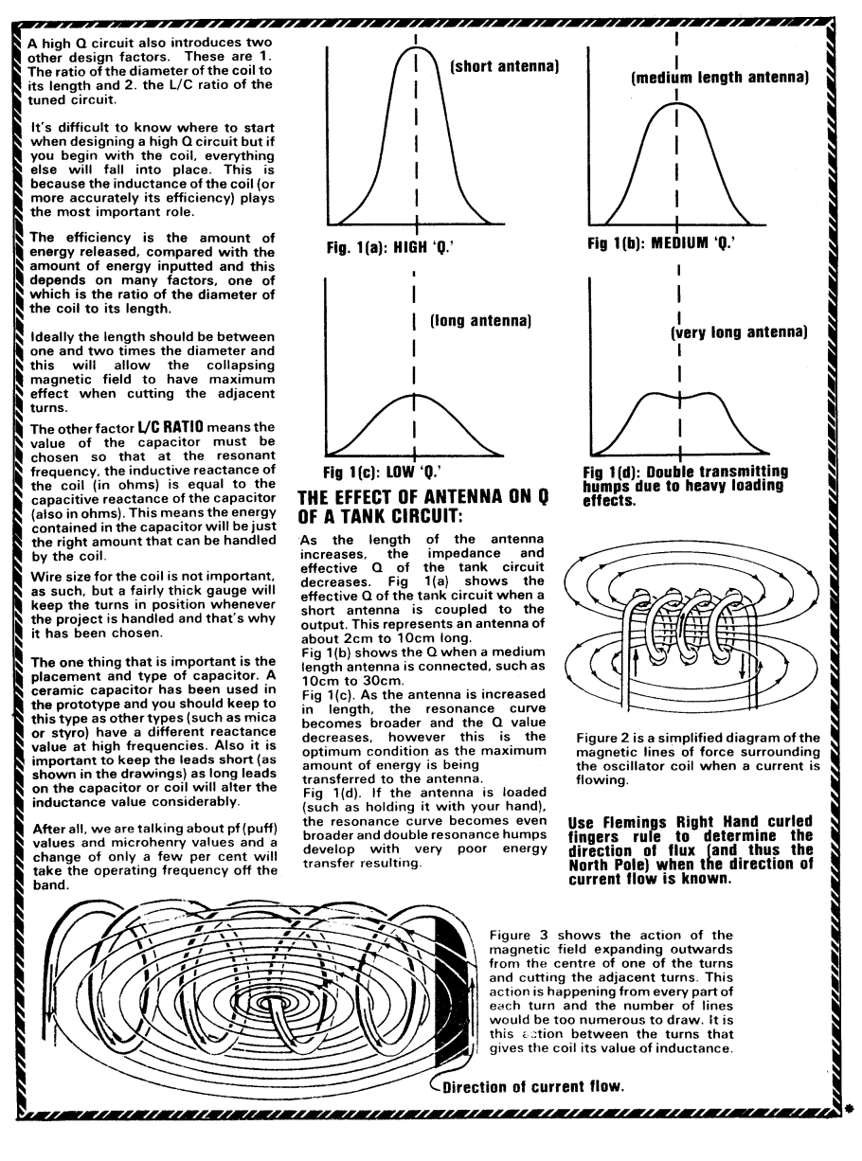
JOB INTERVIEW
I get asked all the time, what preparation should I do for a job interview?
If you intend entering the electronics field, you can consider taking a number of projects with you.
This will draw the attention of the interviewer and show you have an interest and understanding of electronics. Just about any projects are suitable.
It has worked in the past and I am sure it will work for you.

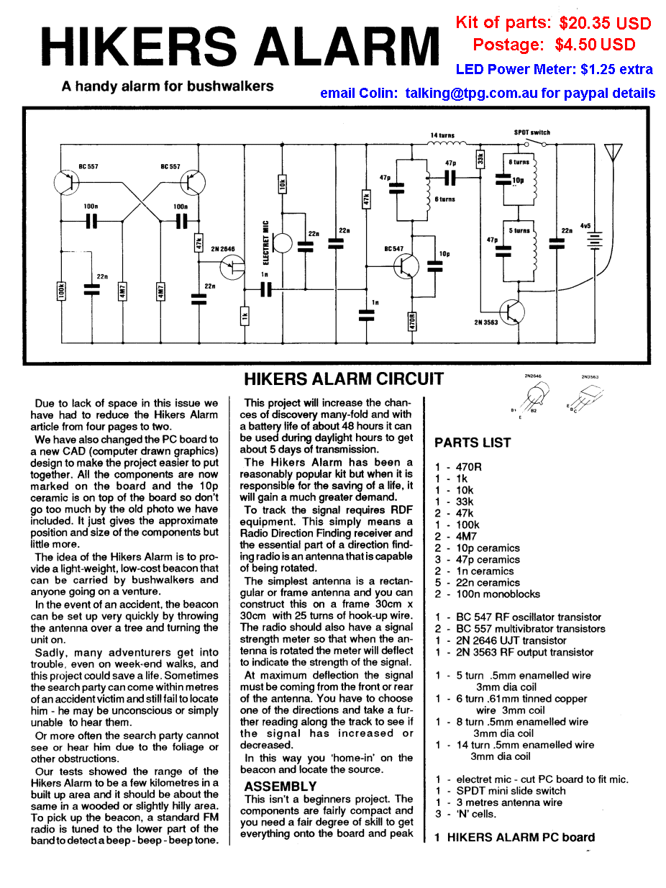
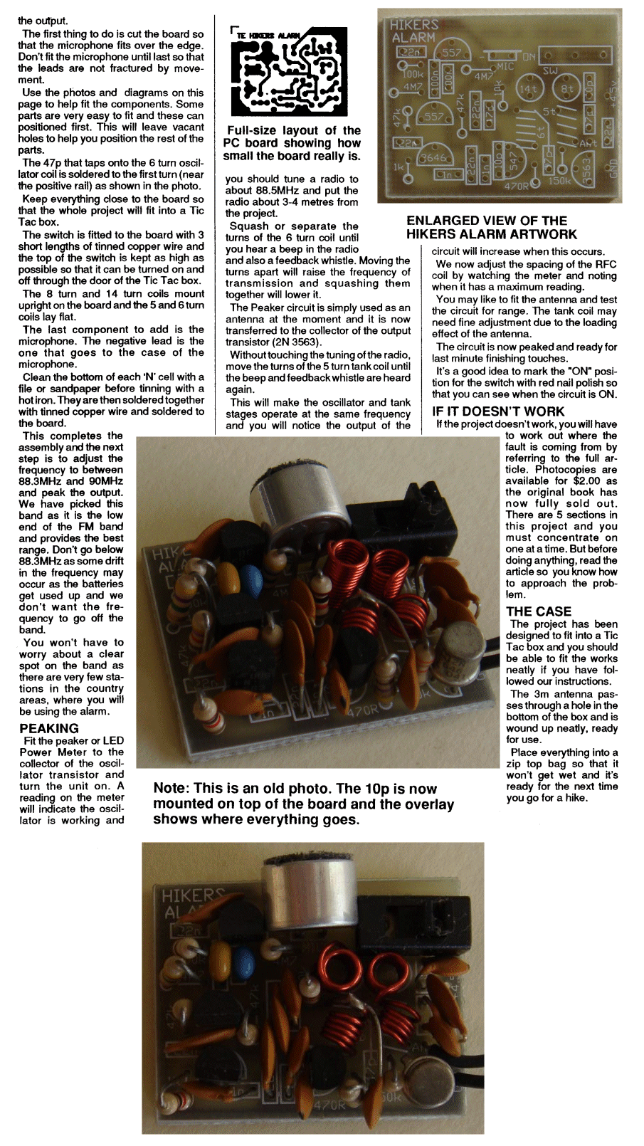
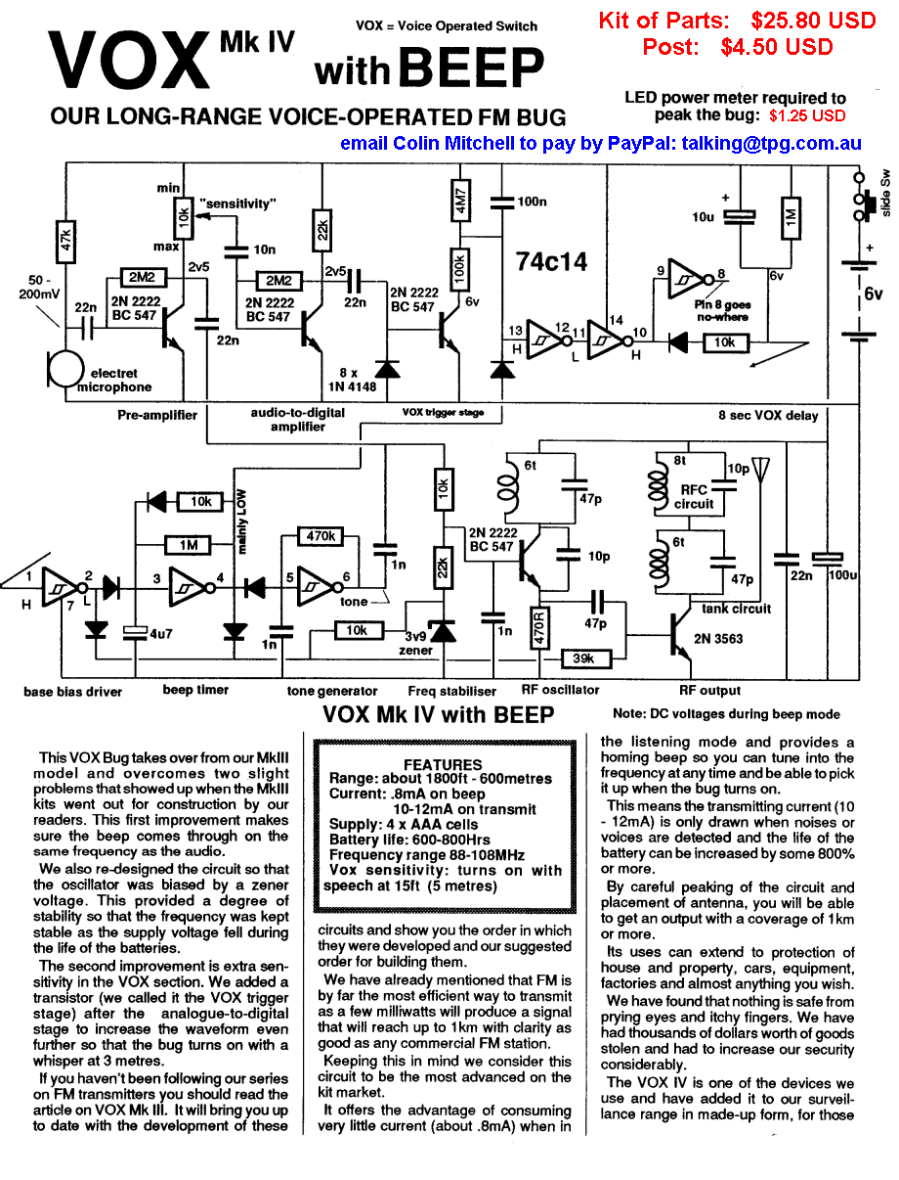
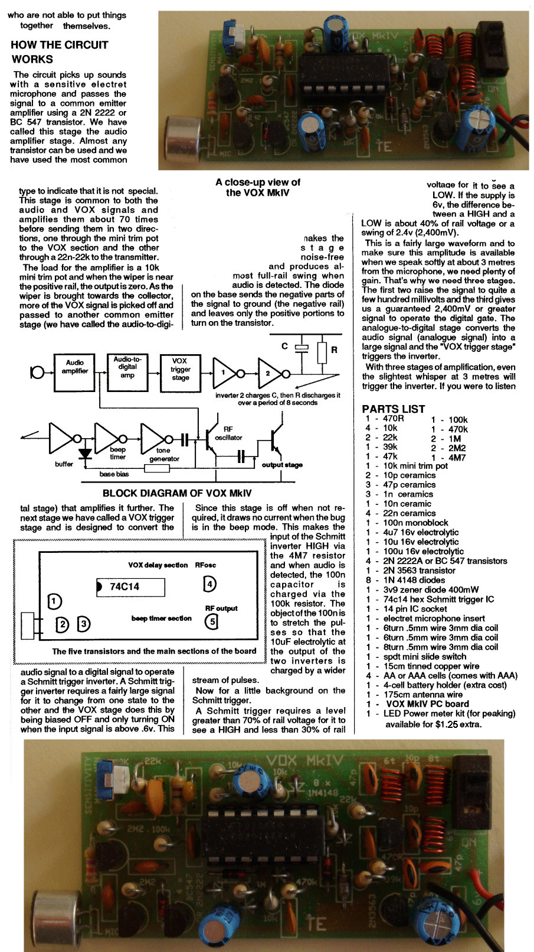
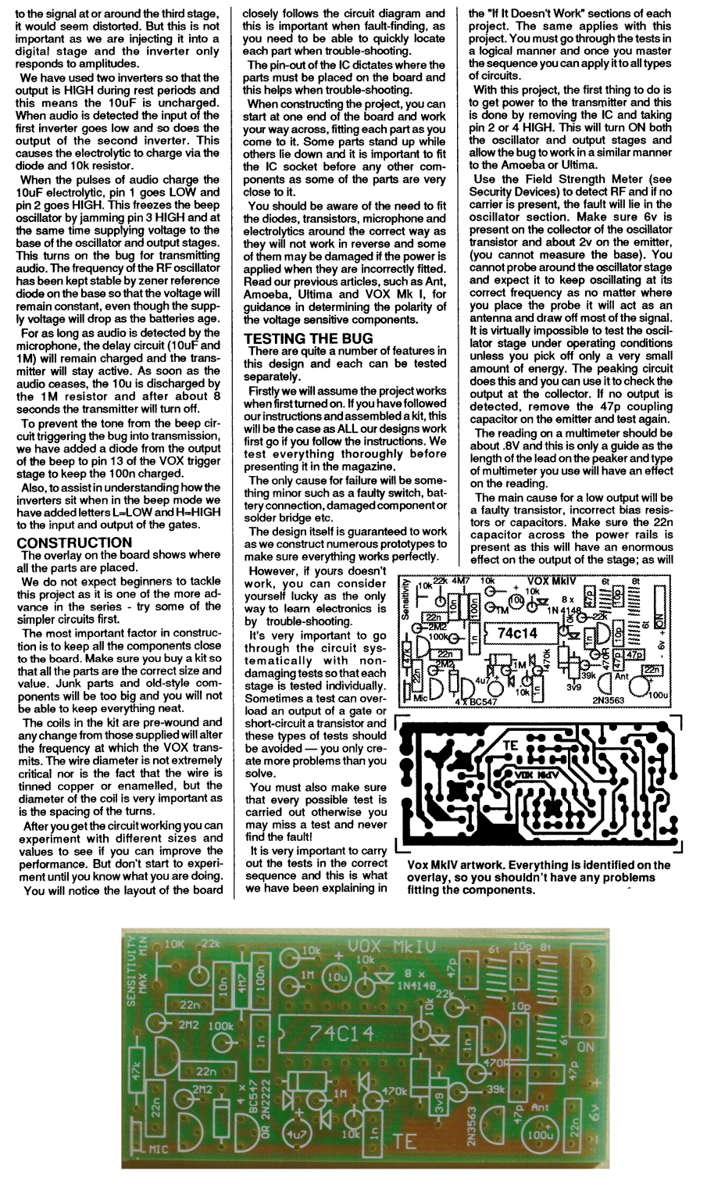
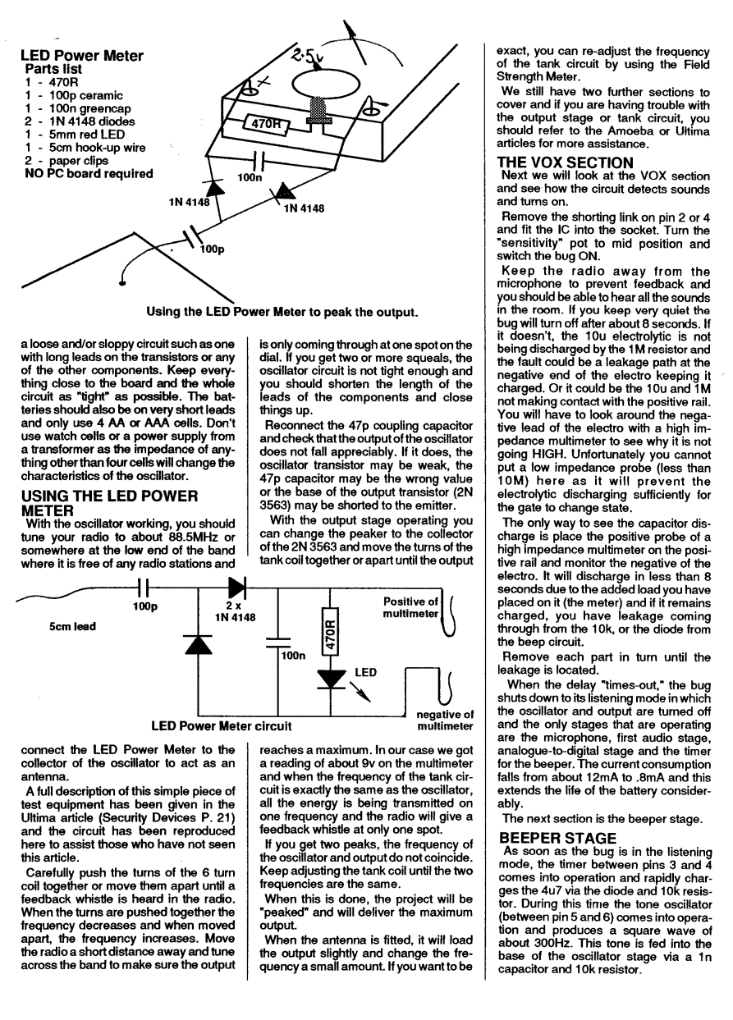
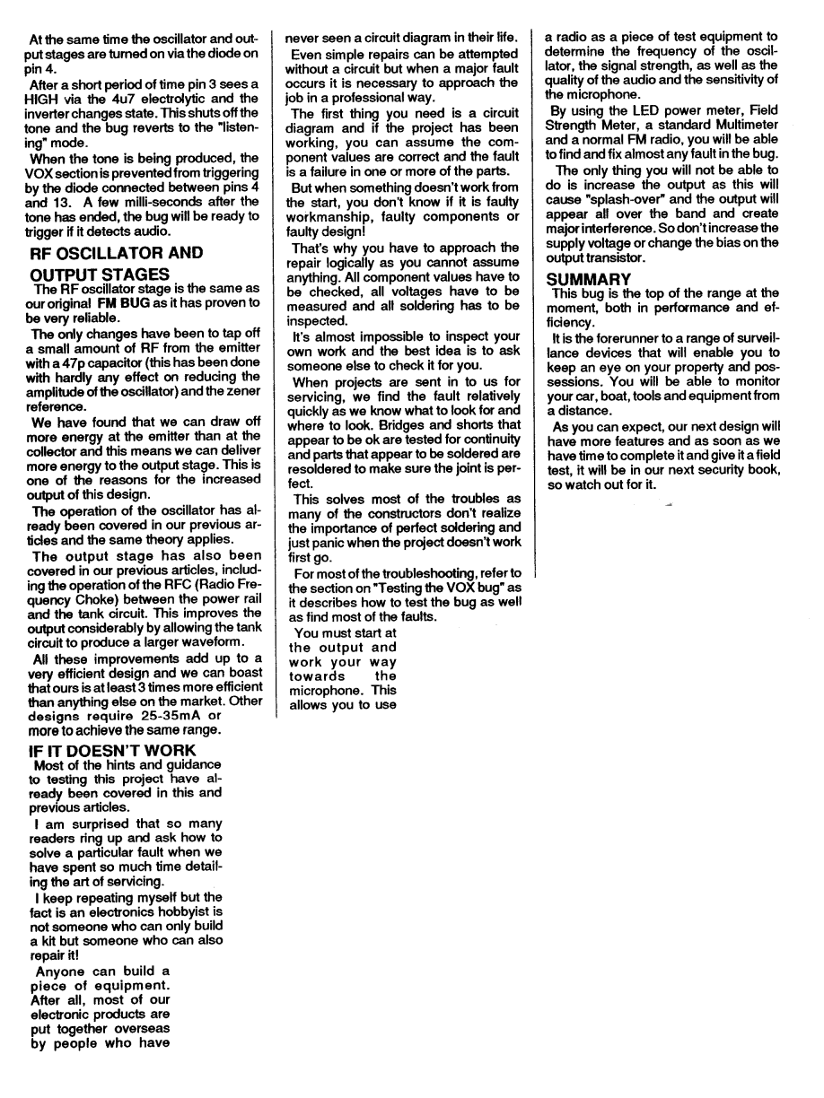
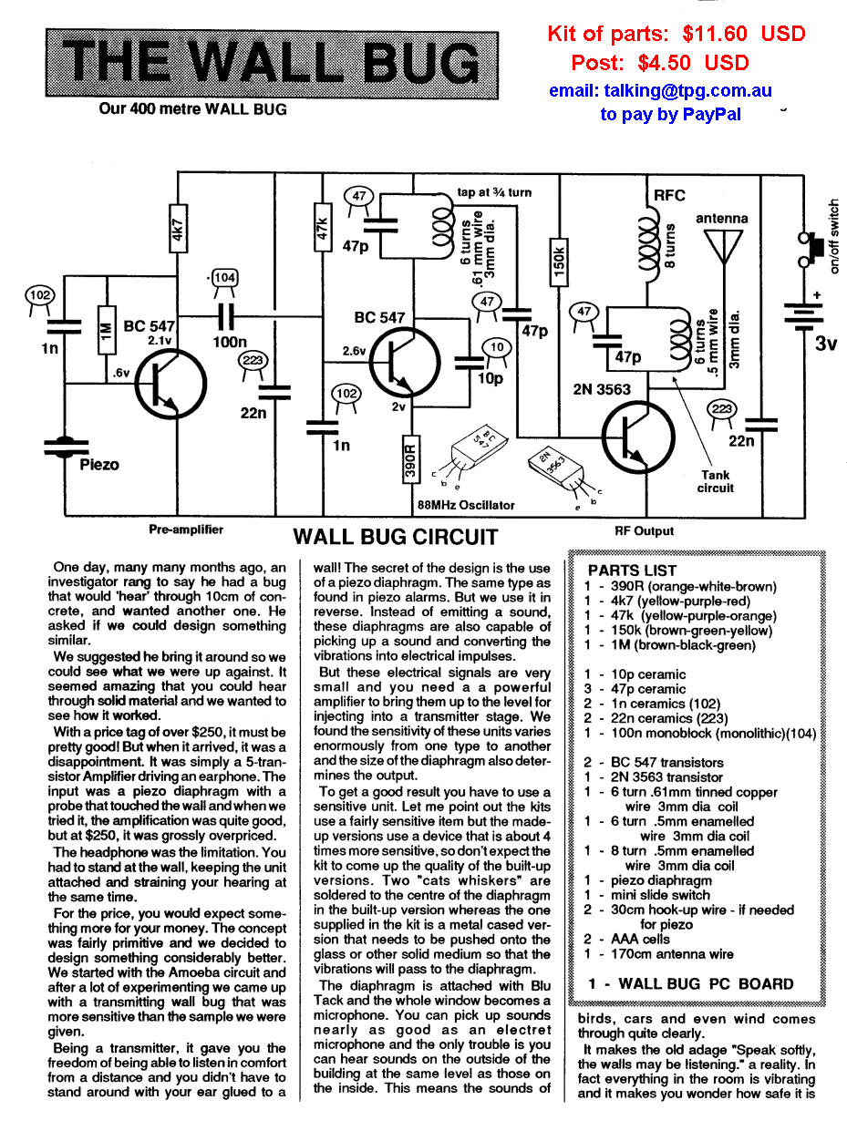
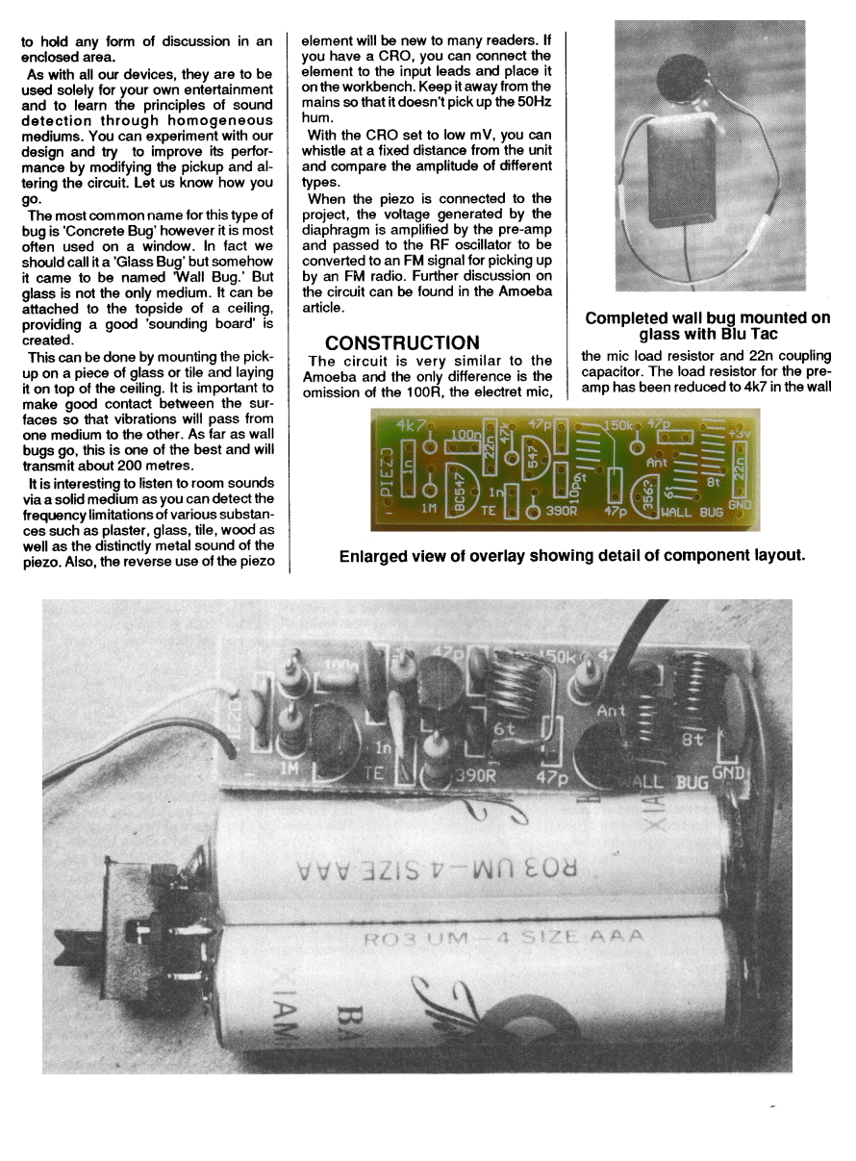
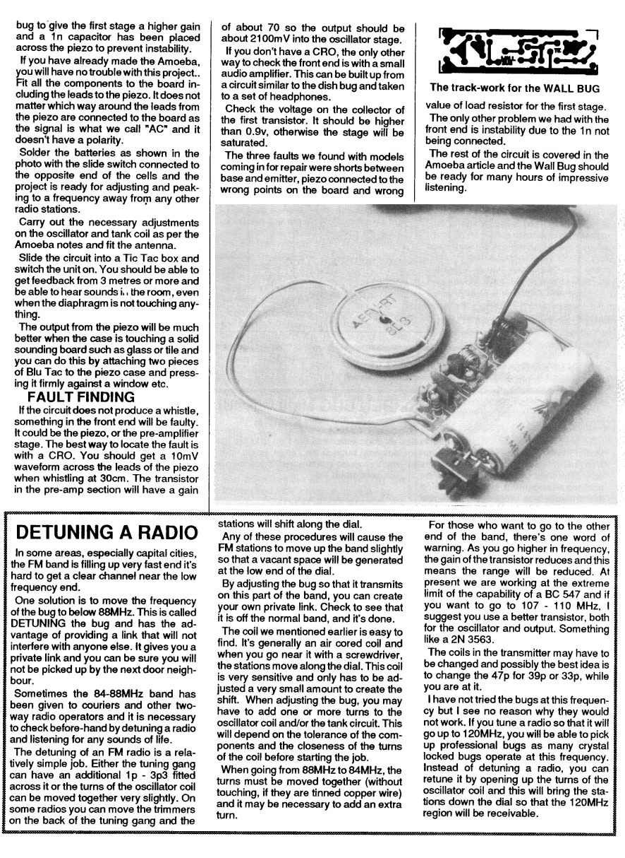
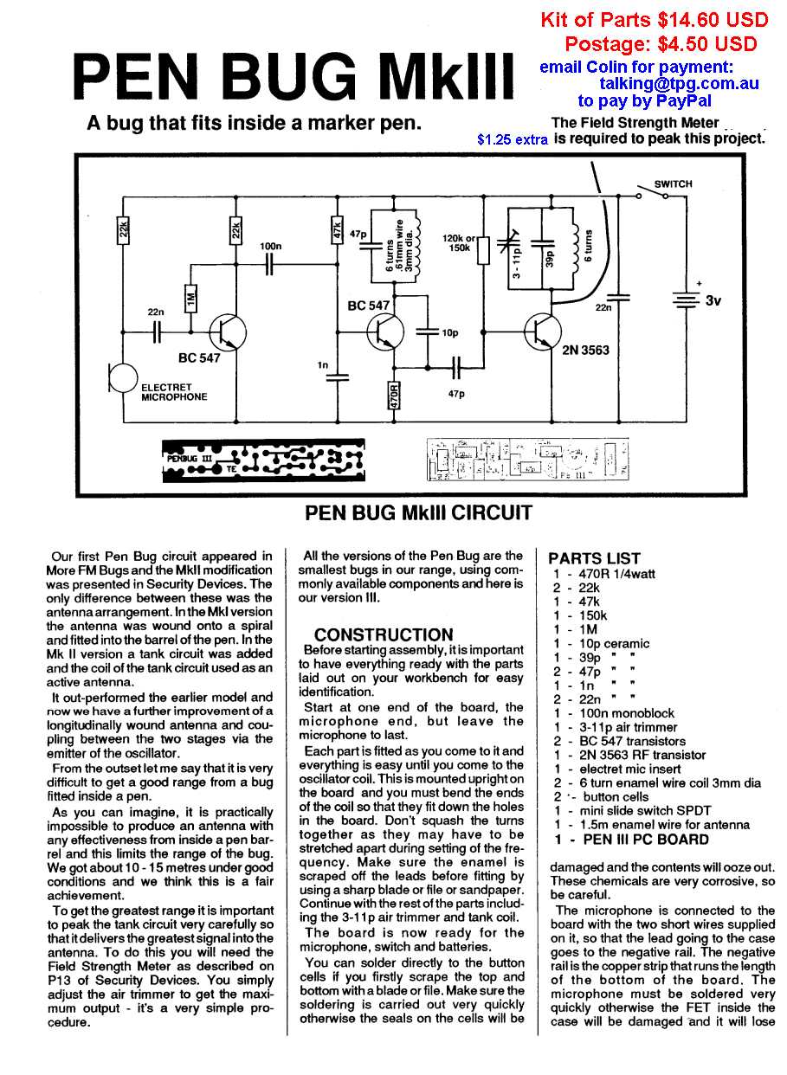
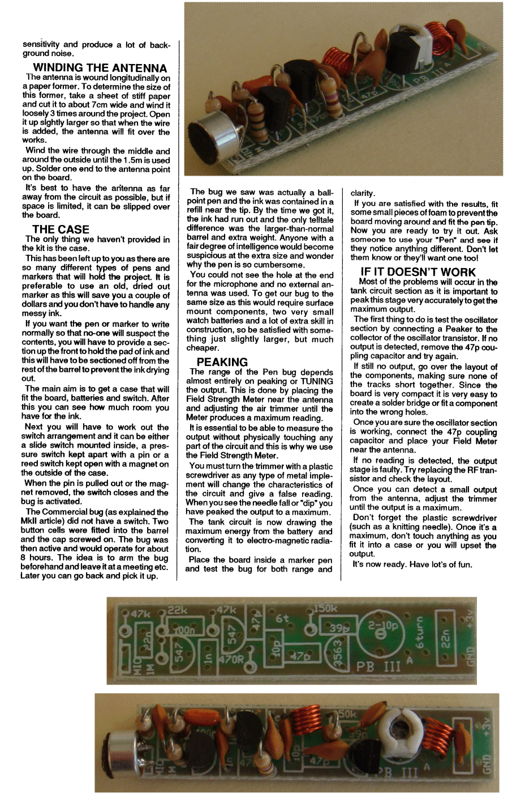

MICRO TRACKER
Our smallest FM Beeper Bug
Size: 0.8in x 0.6in
Fully surface mount
Range: 100m
$9.50 USD incl all parts and PCB
plus $4.50 USD postage to anywhere in the world
pay by PayPal
contact Colin Mitchell
email: talking@tpg.com.au
for details on paying for kit
This project uses the Micro Tracker PC board.
The component values are marked on the board.
The output produces a thump-thump-thump- squeal-squeal-thump-thump-thump . . . . . at approx 90MHz but the turns of the coil can be expanded to raise the frequency.

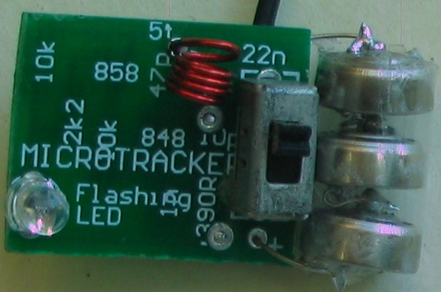
Micro Bug Tracker Circuit
HOW THE CIRCUIT WORKS
The circuit consists of two stages, a digital stage consisting of an ON-OFF waveform and an RF oscillator. The digital stage is a flashing LED and it has an in-built oscillator to turn red-blue and green LEDs on and off.
This action takes current from the supply when the LED is illuminated and almost no current when the LED is not illuminated.
The flashing LED is supplied via a 10k resistor and the flashing still occurs but the LEDs are much duller.
The flashing LED is no different to a transistor turning ON and OFF. The voltage across the LOAD resistor (10k) is detected by a buffer transistor and this transistor turns on and off.
The transistor supplies base current to the RF oscillator and when the oscillator turns ON it produces a carrier that removes the background noise in the receiving radio.
This is how you get the thump-thump-thump in the audio. It is just the difference between the silence and background noise.
The LED also produces a tone during part of the cycle when the LEDs are increasing or decreasing in brightness. This is heard as a squeal on the radio.
The Flashing LED cannot be put in the base of the oscillator stage as this a common-base design as the base voltage rises to nearly the supply voltage and the LED drops at least 1.7v when active and the oscillator stage would not work.
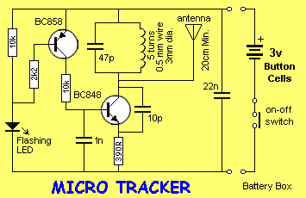
The RF oscillator is designed to operate at about 88MHz and the frequency is set by the inductance of the 5 turn coil together with the 47p capacitor. These two components make up a circuit called a parallel resonant circuit (tank circuit).
The frequency is also determined by the transistor, the 10p feedback capacitor and also to a lesser extent by the biasing components (47k, 100k and 390R resistors).
When the buffer transistor is tuned ON, the 1n base capacitor will charge via the 10k resistor and turn the oscillator transistor ON.
The base voltage will continue to rise and the 10p will have the effect of trying to prevent the emitter from moving. A point in time is reached when the energy from the capacitor is exhausted and it can no longer resist the movement of the emitter. The base-emitter voltage decreases and turns the transistor off. The current flow in the coil then ceases and the magnetic flux collapses.
This collapsing magnetic field produces a voltage in the opposite direction and whereas the collector voltage may have been 2.9v, it will now rise to over 3v and charge the 47p in the opposite direction. This voltage will have the effect of charging the 10p and the voltage drop across the 390R emitter resistor will be such that the transistor will be turned more firmly OFF.
As the 10p charges, the emitter voltage will drop to a point where the transistor will begin to turn ON and the current flow through the coil will oppose the collapsing magnetic field.
The voltage across the coil will reverse and the collector voltage will drop. This change will be passed to the emitter via the 10p and the result will be that the transistor will turn ON very hard and short out the 10p. After this the cycle begins again.
What we have is an oscillator that produces AC energy at 88MHz with the amplified audio signal fed into this stage via the 100n, varying the frequency of oscillation to produce the FM signals.
PARTS LIST
1 - 390R (marked 391)
1 - 2k2 marked 222)
2 - 10k (marked 103 )
2 - 4p7 surface mount
1 - 47p surface mount
1 - 1n surface mount
1 - 22n surface mount
1 - BC 848 transistor marked ‘1k’
1 - BC 858 transistor
1 - 3mm flashing LED
1 - 5 turn 3mm dia enamelled coil
3 - 1.5v button cells
1 - battery box
15cm very fine solder
1 - 80cm hook-up wire for antenna
1 - MICRO TRACKER PC board

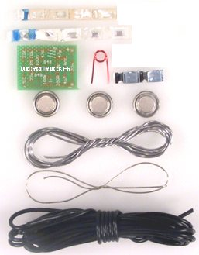
Micro Tracker components
Before starting, place a tiny piece of blu-tack on the top-side of the Micro-Bug Tracker PC board and push it onto your work-bench so it does not move - all the components are mounted on the "underside" of the board.
CONSTRUCTION
All the components for this project are surface-mount.
This includes the two transistors,
Let me warn you once again, the components are very tiny.
Before opening the kit of parts you must prepare a clean space on your workbench so the components can be taken out of the holding cells without being lost.
You will also need a soldering iron with a fine tip.
We use a soldering iron that is commonly called a SOLDERING PENCIL. It is a very small iron with a tip that is sharp enough to prick you!
If you do not have this type of soldering equipment, assembly will be much more difficult and the neatness will not be as good as our photos.
You will be amazed at the improvement you get by simply using the correct equipment and FINE SOLDER.
Now we can get down to assembly:
Use the photo above to identify the placement of the parts aas the board is designed to take two different circuits and the overlay is for the voice transmitter.
The oscillator section is the same for both projects but the LED and transistor are in different places for this project, plus 3 resistors.
Lay out a clean sheet of paper and place the strip of components so the black band is to the left.
The first components to fit onto the board are the resistors and these are in the strip in ascending order. This means the values are: 390R, 2k2, 10k, 10k and are clearly marked with a 3-digit or 4-digit code.
The next components to fit to the board are the 5 capacitors. Unfortunately they are not marked and so you will have to be very careful when removing them so that they are not mixed up.
The size of a capacitor chip is no indication of its value and so you have to take our word that we have placed them in ascending order.
Even the colour of the substrate is no indication of a value so please don't ring us up and say “I have a tiny pink capacitor and a tiny mauve capacitor and a tiny purple capacitor, which is the 1n!”
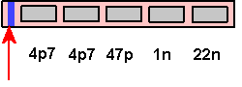
Blue/Black line
The surface-mount capacitors are housed in a carrier strip, with a black line at one end. The black line corresponds to the lowest value of capacitance.
The colours and size will change from one batch to another and from one manufacturer to another.
I know some people are going to plough into construction and lose a component or two so the replacement strips will be available for $2.00 for the set of capacitors $2.00 for the resistors and $2.00 for the transistors plus $3.00 for postage.
This is the best we can do so don't ask for individual components - you're lucky we have a service for replacement parts.
When fitting the components to the board, open up the strip from the black-band end and allow one chip at a time to fall out of its cell to a clean sheet of paper on the bench.
If the component is a resistor, it will have markings on it. Turn it over to reveal the numbers.
This is a three number or four number code to indicate the value in ohms. Make sure it is turned around so the numbers make sense. Sometimes you can hold a resistor around the wrong way and it will appear to be a different value!
The markings for each resistor have been supplied in the parts list so double-check the value before fitting it.
Pick up the resistor with a pair of tweezers or a paper clip that has a tiny piece of Blu-Tack placed on the end and carry the chip to the board.
Hold the chip in place with the paper clip but take the Blu-tack away so that it does not melt and contaminate the joint.
Bring up the soldering iron to one end of the chip and with your third hand, add a small amount of fine solder and make a connection.
The art of soldering surface-mount components will take a little time to master, but you will find they are easier and quicker to fit than conventional components.
We build hundreds of items for customers and the assembly workers have said surface-mount devices are easier and quicker to fit.
If you are using tweezers, you can add a small amount of solder to one end of the chip and when you place it on the board, it will be very quick to solder. Push on the tweezers to make sure the chip sits firmly on the board. Then solder the other end.
Everything takes time to get perfect and since electronics is going in the direction of surface-mount, now is a good time to get your hand in.
Every year, more and more of our consumer electronics are being converted to surface-mount technology.
Already more than 40% mount is surface-mount and the percentage is increasing all the time. The driving force is economics.
Even though surface mount components are slightly more expensive, the cost of insertion is much lower as they are placed on the board with a pick-and-place machine. These can fit components five-times faster than conventional components.
But the real saving is in the size of the board. This can be reduced by as much as 50% with components on one side or as much as 70% with components on both sides.
The board can be made of much thinner material or even flexible, so the scope for new produces is enormous.
Board for cameras, for instance, are made of paper-thin flexible material so it can fit around the body of the camera with flexible wiring to connect to the button, motor, battery and flash.
But the greatest advantage of surface-mount is the aesthetics. Surface-mount looks professional and makes your product stand out from the rest.
Now back to the topic.
When you get to the capacitors, you must look into the cell before letting it fall out so you can recognise it once it hits the paper.
Refer to the diagram of the strip for the value and then the enlarged diagram of the board for the position of the component.
It doesn't matter which way around the resistors or capacitors are placed and they can even be turned over but there is one thing you must not do.
When you have soldered one end of a component you must not try to straighten it up. This also applies to a component that is standing up slightly.
Any amount of force will fracture the substrate. Even slight pressure can separate the metallised end caps from their substrate and cause the component to go open circuit.
That's why it is important to hold the component in place with the tip of a paper clip while soldering the first end.
If the component shifts, you are in big trouble.
This is because YOU are going to take much longer to re-heat the end and realign it.
If this happens with a transistor, forget it. The transistor will be damaged.
It a component moves, leave it misaligned and try to solder the other end as best as possible. The damage you will cause in trying to straighten it will be a nightmare to fault-find.
Another problem you will find is some soldering irons are magnetic and the resistor will stick to the tip of the iron if you don't hold them down with something such as a pair of tweezers or paper clip.
Just before we go to the transistors, let me give one final hint.
To reduce the heat build-up in a component, it is best to solder one end then wait a few seconds for the component to cool down before soldering the other end.
This is very important when soldering the transistors.

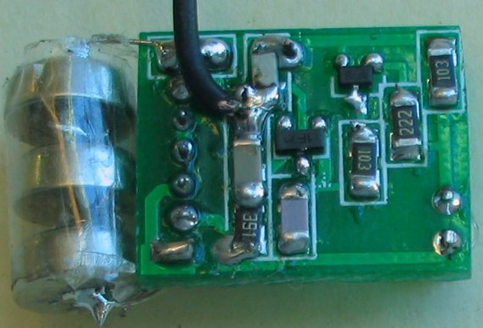
The Micro Bug Tracker from the bottom. Notice how the parts are positioned and soldered

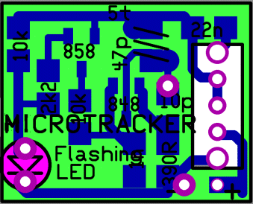
Micro Tracker PC Board

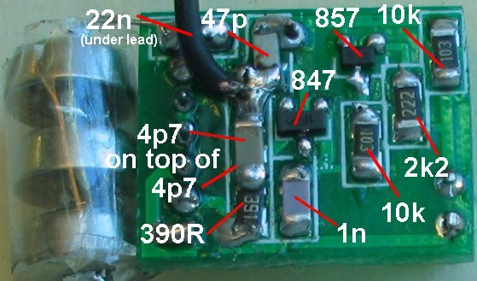
An enlarged view of the underside of the Micro Tracker PCB.
It shows the placement of the surface-mount components.
A 4p7 is placed on top of a 4p7 to make 10p capacitor.

THE MICRO BUG
Our smallest FM transmitter
Size: 0.8in x 0.6in
Fully surface mount
Range: 100m
$14.50 USD incl all parts and PCB
plus $4.50 USD postage to anywhere in the world
Contact Colin Mitchell:
talking@tpg.com.au
for Paypal details

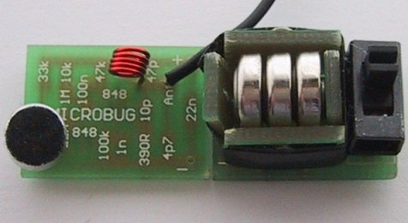
Micro Bug and Battery Box
Before I tell you about this amazing little project, let me say one thing. You have to be an expert at soldering to put it together.
The main difficulty is the surface-mount transistors. All the rest of the components are easy to fit, once you get over the shock of their size, but the transistors are not only microscopic, they are temperature sensitive. They must be soldered quickly with a DELICATE IRON at the RIGHT TEMPERATURE.
We will discuss this more in a moment. I want to get in first so that anyone who has not built at least four of our previous projects, including at least one of our surface-mount kits, do not get the idea that this bug is going to be easy to put together.
Something we have been asked on a number of occasions is: “Why do we keep producing so many FM transmitters projects?
Apart from the fact that they are always extremely popular, each of the designs either incorporates an improvement over a previous design or a new feature.
A reader wrote to us suggesting we design one enormous project incorporating the features of our VOX bugs, our Wall Bug and our long range bugs, with a switch to select a particular feature.
This would be wonderful idea if it were practical, but it would defeat the purpose of the designs as each demonstrates a different feature.
There is no circuit simpler than an FM transmitter. Nothing produces crystal clear audio from two or three stages and transmits to a tuner to give the equivalent of a high wattage amplifier. To make the circuit more complex by adding extra features would defeat the purpose of starting with something simple.
Each of the transmitter circuits we have designed incorporates a number of BUILDING BLOCKS and studying these will help you; not only to understand how the circuit works, but also with designing your own circuits.
Building FM transmitters is definitely a great place to start, as the cost is low and the experience you get is invaluable.
DESIGN IMPROVEMENTS
Many of the designs in our transmitter series are on their second or third improvement.
It would be wonderful to design a project that is perfect from the start, but unfortunately this is not reality. There are always improvements and additions that come along after we produce a project. Sometimes the improvements are only small and sometimes they are considerable.
No-one is perfect and we would be the last to admit we are perfect. However we can state our designs are by far the best we have seen, simply due to the fact that we update and improve them to get them to the stage of near perfection.
It's the “I help you, you help me” principle. I sell you something cheap and you buy it in enormous quantity. That's how we work. Everyone can afford our low-cost kits and that's how we stay in business. We help you with designs and you give us feedback and improvements.
This has been the case with all of our projects. When they go into the field we get feedback from constructors. We also have the advantage over other designers in that we sell made-up devices as well as kits and we get first-hand ideas on improvements. That's how we have got to the stage we are at.
And now for a really challenging project.
SMALLER AND SMALLER DEVICES
We are constantly asked for smaller and smaller bugs. Some constructors think it is easier to hide a smaller device.
But the problem with size is the antenna and the batteries.
It's no good having a micro-miniature bug if the antenna has to be 50-100cm long!
The other problem is the size of the battery. As the battery gets smaller and smaller, not only does the life of the bug reduce but the earth plane produced by the mass of the battery is also reduced and the output of the transmitter is reduced.
That's why really small bugs are placed in a metal case. It acts as a ground-plane.
It all boils down to the optimum size for a transmitter and this seems to be about the size of a matchbox.
This size gives us adequate room to fit two AAA cells, a switch and electret microphone as well as a board containing conventional components. But sometimes we have to pander to demand.
At the present, the demand is for a miniature bug.
That's why we have designed the MICROBUG. It is the smallest we can go using readily available surface-mount componentry - even then the components are not readily available, although some suppliers are listing packs of 10 of each component. We had to import the very tiny slide switch and microphone.
The circuit is our tried and proven two transistor design and has already been presented as the Earwig project.
Even though the circuit is very simple, no-one has been able to improve its performance and all we have done is use surface-mount components to reduce the size.
I am going over the operation of the circuit once again because every time I describe it, I include a few more details of how each component works.
HOW THE CIRCUIT WORKS
The circuit consists of three stages, an electret microphone, an audio amplifier and an RF oscillator.
The electret microphone consists of only two parts - a FET transistor and a plastic diaphragm. There is nothing else inside the case. The 3-leaded FET has an input, output and earth lead. The mylar diaphragm has been permanently charged with a static charge and this is one of the secrets of the operation of the microphone.
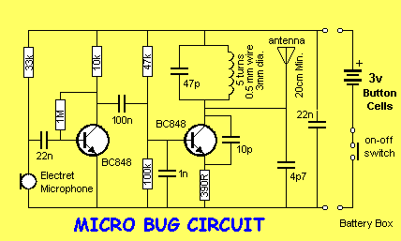
The FET transistor has a very high input impedance and because it is an active device, we call it a stage.
The gain of this device is extremely high because it is able to amplify the charges from a charged surface to produce an output in the millivolt range. When voice (or any sounds) are delivered to the microphone, the air vibrations are passed to the microphone through a tiny hole in the front of the case.
This causes the plastic diaphragm to move back and forth. It is situated very close to an earthed plate and if you have studied static electricity, you will know that charges on a charged surface redistribute when part of the surface is moved towards or away from an earthed surface.
This re-distribution causes charges to move in and out of a lead touching the centre of the diaphragm.
There are two factors that govern the sensitivity of the microphone. One is the manufacturing process and the quality of the charged mylar diaphragm. The other is the current flowing into the microphone via the load resistor. We cannot alter the charge on the diaphragm but the gain of the microphone can be increased or decreased by adjusting the current through the load resistor.
Further qualities such as the clarity of the pick-up is determined by the thickness (thinness) of the diaphragm and the electrostatic charge placed on it during manufacture. These factors cannot be changed by the user.
Creating a plastic that permanently holds an electrostatic charge has been a very difficult thing to do and that's why electret microphones are only a recent invention. Because we are down at the level of detecting individual charges, enormous amplification factors are required and unfortunately there is a wide variation in quality from one unit to another. For this reason they need to be tested and grouped according to sensitivity and for our project, we need the most sensitive type.
Poor quality units cannot be increased in sensitivity by reducing the load resistor as this will produce a lot of back-ground noise like bacon and eggs frying. One you have a good quality microphone, the output is passed to the first audio amplifier via a 22n capacitor.
This value can vary from 10n to 100n without any appreciable change in quality however it is always advisable to use the highest value capacitor to allow the low frequencies to pass through.
The audio amplifier has a gain of about 50 to 70 and passes the signal to the base of the RF oscillator stage.
The RF oscillator is designed to operate at about 88MHz and the frequency is set by the inductance of the 5 turn coil together with the 47p capacitor. These two components make up a circuit called a parallel resonant circuit (tank circuit).
The frequency is also determined by the transistor, the 10p feedback capacitor and also to a lesser extent by the biasing components (47k, 100k and 390R resistors).
When power is applied, the 1n base capacitor will gradually charge via the 47k resistor and turn the transistor on.
The base voltage will continue to rise and the 10p will have the effect of trying to prevent the emitter from moving. A point in time is reached when the energy from the capacitor is exhausted and it can no longer resist the movement of the emitter. The base-emitter voltage decreases and turns the transistor off. The current flow in the coil then ceases and the magnetic flux collapses.
This collapsing magnetic field produces a voltage in the opposite direction and whereas the collector voltage may have been 2.9v, it will now rise to over 3v and charge the 47p in the opposite direction. This voltage will have the effect of charging the 10p and the voltage drop across the 390R emitter resistor will be such that the transistor will be turned more firmly OFF.
As the 10p charges, the emitter voltage will drop to a point where the transistor will begin to turn ON and the current flow through the coil will oppose the collapsing magnetic field.
The voltage across the coil will reverse and the collector voltage will drop. This change will be passed to the emitter via the 10p and the result will be that the transistor will turn ON very hard and short out the 10p. After this the cycle begins again.
What we have is an oscillator that produces AC energy at 88MHz with the amplified audio signal fed into this stage via the 100n, varying the frequency of oscillation to produce the FM signals.
PARTS LIST
1 - 390R (marked 392 )
1 - 10k (marked 103 )
1 - 33k (marked 333 )
1 - 47k (marked 473 )
1 - 100k (marked 104 )
1 - 1M (marked 105 )
1 - 4p7 surface mount
1 - 10p surface mount
1 - 47p surface mount
1 - 1n surface mount
2 - 22n surface mount
1 - 100n surface mount
2 - BC 848 transistors marked ‘1k’
1 - 5 turn 3mm dia enamelled coil
1 - mini electret microphone
3 - 1.5v button cells
60cm very fine solder
1 - 80cm hook-up wire for antenna
1 - MICRO BUG PC board
See Battery Box $2.00 extra

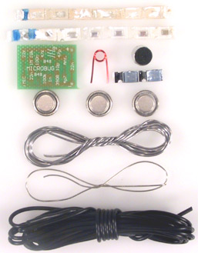
Micro Bug components
Before starting, place a tiny piece of blu-tack on the top-side of the Micro-Bug PC board and push it onto your work-bench so it does not move - all the components are mounted on the "underside" of the board.
CONSTRUCTION
All the components for this project are surface-mount.
This includes the two transistors,
Let me warn you once again, the components are very tiny.
Before opening the kit of parts you must prepare a clean space on your workbench so the components can be taken out of the holding cells without being lost.
You will also need a soldering iron with a fine tip.
We use a soldering iron that is commonly called a SOLDERING PENCIL. It is a very small iron with a tip that is sharp enough to prick you!
If you do not have this type of soldering equipment, assembly will be much more difficult and the neatness will not be as good as our photos.
You will be amazed at the improvement you get by simply using the correct equipment and FINE SOLDER.
Now we can get down to assembly:
Lay out a clean sheet of paper and place the strip of components so the black band is to the left.
The first components to fit onto the board are the resistors and these are in the strip in ascending order. This means the values are: 390R, 10k, 33k, 47k, 100k and 1M.
The next components to fit to the board are the capacitors. Unfortunately they are not marked and so you will have to be very careful when removing them so that they are not mixed up.
The size of a capacitor chip is no indication of its value and so you have to take our word that we have placed them in ascending order.
Even the colour of the substrate is no indication of a value so please don't ring us up and say “I have a tiny pink capacitor and a tiny mauve capacitor and a tiny purple capacitor, which is the 10p!”
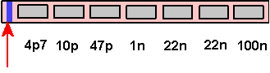
Blue/Black line
The surface-mount capacitors are housed in a carrier strip, with a black line at one end. The black line corresponds to the lowest value of capacitance.
The colors and size will change from one batch to another and from one manufacturer to another.
I know some people are going to plough into construction and lose a component or two so the replacement strips will be available for $8.00 for the set of capacitors $6.00 for the resistors and $4.00 for the transistors plus $2.00 for postage.
This is the best we can do so don't ask for individual components - you're lucky we have a service for replacement parts.
When fitting the components to the board, open up the strip from the black-band end and allow one chip at a time to fall out of its cell to a clean sheet of paper on the bench.
If the component is a resistor, it will have markings on it. Turn it over to reveal the numbers.
This is a three number code to indicate the value in ohms. Make sure it is turned around so the numbers make sense. Sometimes you can hold a resistor around the wrong way and it will appear to be a different value!
The markings for each resistor have been supplied in the parts list so double-check the value before fitting it.
Pick up the resistor with a pair of tweezers or a paper clip that has a tiny piece of Blu-Tack placed on the end and carry the chip to the board.
Hold the chip in place with the paper clip but take the Blu-tack away so that it does not melt and contaminate the joint.
Bring up the soldering iron to one end of the chip and with your third hand, add a small amount of fine solder and make a connection.
The art of soldering surface-mount components will take a little time to master, but you will find they are easier and quicker to fit than conventional components.
We build hundreds of items for customers and the assembly workers have said surface-mount devices are easier and quicker to fit.
Everything takes time to get perfect and since electronics is going in the direction of surface-mount, now is a good time to get your hand in.
Every year, more and more of our consumer electronics are being converted to surface-mount technology.
Already more than 40% mount is surface-mount and the percentage is increasing all the time. The driving force is economics.
Even though surface mount components are slightly more expensive, the cost of insertion is much lower as they are placed on the board with a pick-and-place machine. These can fit components five-times faster than conventional components.
But the real saving is in the size of the board. This can be reduced by as much as 50% with components on one side or as much as 70% with components on both sides.
The board can be made of much thinner material or even flexible, so the scope for new produces is enormous.
Board for cameras, for instance, are made of paper-thin flexible material so it can fit around the body of the camera with flexible wiring to connect to the button, motor, battery and flash.
But the greatest advantage of surface-mount is the aesthetics. Surface-mount looks professional and makes your product stand out from the rest.
Now back to the topic.
When you get to the capacitors, you must look into the cell before letting it fall out so you can recognise it once it hits the paper.
Refer to the diagram of the strip for the value and then the enlarged diagram of the board for the position of the component.
It doesn't matter which way around the resistors or capacitors are placed and they can even be turned over but there is one thing you must not do.
When you have soldered one end of a component you must not try to straighten it up. This also applies to a component that is standing up slightly.
Any amount of force will fracture the substrate. Even slight pressure can separate the metallised end caps from their substrate and cause the component to go open circuit.
That's why it is important to hold the component in place with the tip of a paper clip while soldering the first end.
If the component shifts, you are in big trouble.
This is because YOU are going to take much longer to re-heat the end and realign it.
If this happens with a transistor, forget it. The transistor will be damaged.
It a component moves, leave it misaligned and try to solder the other end as best as possible. The damage you will cause in trying to straighten it will be a nightmare to fault-find.
Another problem you will find is some soldering irons are magnetic and the resistor will stick to the tip of the iron if you don't hold them down with something such as a pair of tweezers or paper clip.
Just before we go to the transistors, let me give one final hint.
To reduce the heat build-up in a component, it is best to solder one end then wait a few seconds for the component to cool down before soldering the other end.
This is very important when soldering the transistors.
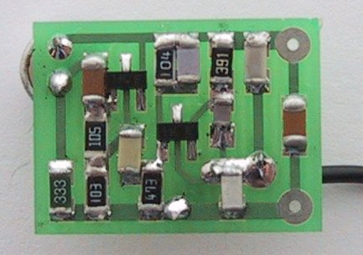
The Micro Bug from the bottom. Notice how neatly the parts are positioned and soldered
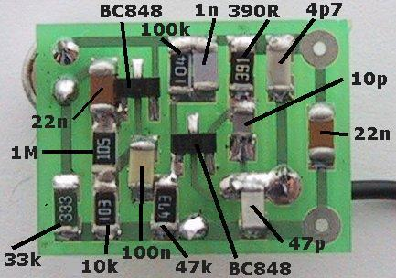
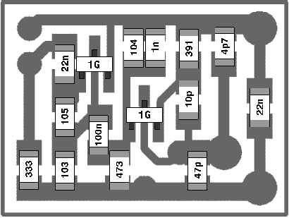
Another view of the underside of the Micro
Bug showing the placement of the
surface-mount components
Even though the transistors are designed to withstand 10 seconds of soldering in a wave-soldering machine, this does not mean you can take 10 seconds to solder with a soldering iron.
The reason is the wave-solder bath is maintained at a precise temperature and this is the exact temperature to complete the soldering process without overheating the components.
Most soldering irons are above this temperature and this means the soldering time must be reduced. For an iron 30°C above this temperature, the time must be reduced to 3 seconds and for 50°C above, the time must be less than 1/2 second.
Most hobbyist irons come into the 1/2 second category and on top of this, only one lead at a time must be soldered.
Once you know your soldering techniques are acceptable for surface-mount components, and none are being damaged, you can you can work as fast as our assembly section and fit the components about twice as fast as the through-hole types. 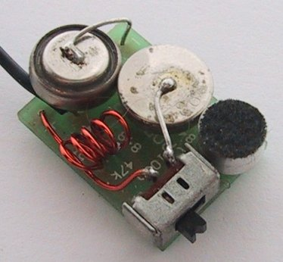
The Micro Bug with two button cells soldered to the top of the board with a miniature slide switch.
This is how the project will look with the components supplied in the kit

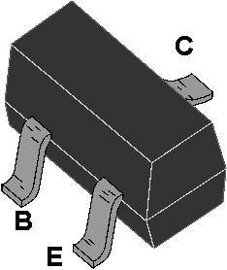
The pinout of the SM transistor we supply in the kit
THE SURFACE MOUNT TRANSISTOR
Now let's talk about the surface mount transistor.
When you open up your kit of parts you will get quite a shock.
The surface mount transistor is smaller than you think and in fact I think it is too small for manual insertion. But that’s what you’ll have to face.
Certainly the designers of surface mount transistors had no intention of them being inserted by hand as they are smaller than a surface mount resistor!
But any industrial prototypes have to be assembled by hand and this project will be a good experience for later.
Above you see the outline of the surface mount transistor. The top of the device is too small to fit the full type number and a silly code number has been allocated as follows: BC 847, BC848 (NPN) is marked 1k, but most importantly it is a three leaded package.
This is the same as BC 547. The tiny leads are so short that they just emerge from the case and this means any heat from the soldering iron will travel to the junction very quickly. You have only half a second to complete each solder joint. Any delay will damage the transistor totally and it will fail to amplify.
TESTING and GETTING THE CIRCUIT TO WORK
We are going to cover these two at the same time.
Testing the circuit and getting it to transmit on a particular frequency is a learning experience. If the circuit does not work, this is when you will start to learn REAL electronics.
I hope the circuit does not work and you have to fix it, but since our projects have been tried and tested thousands of times, the chances of it not working are very slim. The main fault will be overheating the components and damaging them by trying to move them while soldering.
As I have said, this transmitter is an advancement on a number of projects we have already presented and it has been suggested that you build some of the others to get you accustomed to the performance.
The first thing to do is see if the transmitter works (transmits).
Place it near an FM radio turned to medium volume and tune across the dial, listening for a feedback squeal.
If a squeal is heard, the transmitter is operating on the FM band. If you don't hear a squeal, don't worry as the circuit may be operating just below the band and in this case you will not be able to pick it up.
To find out, remove the antenna lead and fit the LED Power Meter.
It will only take 10 minutes or so to build this circuit and connect it to an ordinary multimeter set to low volts range.
Once you have built it, you can go on to the next stage:
THE LED POWER METER
The LED power Meter is a simple RF detector using diodes to charge a capacitor. The voltage developed across the capacitor is shown on a multimeter set to a low voltage range.
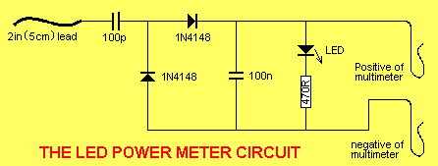
The circuit is soldered together without the need for a PC board, as can be seen in diagram below and paper clips are used for the positive and negative terminals of the multimeter.
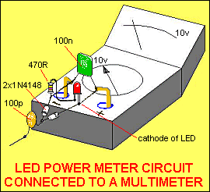
The output of the Micro Bug is very low and you will only get a very small indication on the meter and a very small glow from the LED.
The reading is not calibrated and does not represent milliwatts output. It is only a visual indication.
LED Power Meter Parts List
1 - 470R (yellow-purple-brown)
1 - 100p ceramic (marked 101)
1 - 0.1u (100n) ceramic (called monoblock) (104)
2 - 1N 4148 diodes
1 - 2in (5cm) hook-up wire
2 - paper clips
No PC board required
If the multimeter does not show a reading, the output stage is not working.
The two stages in this project are AC coupled (a capacitor separates them) and they can be tested separately.
The first place to go to is the oscillator section. This is called and RF oscillator as it is operating at approx 88MHz.
This is a difficult stage to test as it is operating at a very high frequency.
It is not possible to view the waveform on an ordinary 30MHz CR0 as the circuit is operating at 88MHz and the CR0 will not display the waveform on the screen. All it will show is a mass of lines
- if you are lucky. A 30MHz CR0 will also put such a load on the circuit that it will cease to oscillate.
This means all you can do is take a few voltage measurements and check the continuity of the trackwork.
Firstly check the voltage on the collector of the oscillator transistor. It should be 3v, indicating the coil is making contact through the board. Next measure the voltage on the emitter. It should be about 2v. If it is 0v, the transistor is not being turned on or the 390R is not making contact with the board (the voltage will be about 2.5v to 3v, in this case). The base voltage should be about 2.6v, and if it is much lower than this, the 47k resistor may be the wrong value or the transistor is pulling the voltage down (due to the emitter resistor being the wrong value and/or the base-emitter junction being a short circuit).
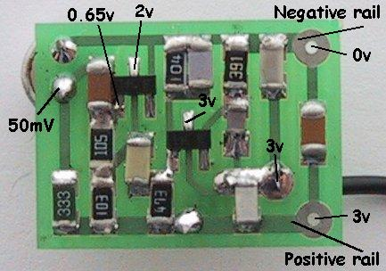
A guide to the voltages on the Micro Bug
When you are probing around this stage, the load produced by the leads of the multimeter will often prevent the circuit from operating, so don't expect to get an output on the LED Power Meter when probing the board.
The main reason for this is the leads become an antenna and they absorb the signal.
The LED Power Meter can be connected all the time. It puts a very small load on the circuit and will not affect the performance.
Two problems remain. You cannot test the 47p unless you remove it and test it on a Capacitance Meter. The same applies to the 10p. The cheapest and quickest thing to do is replace the two components (the surface mount components are available as spare parts).
The 1n is also very important and if it has been damaged during assembly (open circuit), the oscillator will not function. This should also be replaced.
Lastly the 22n across the power rails must be in place to get a good output from the oscillator. Try another 22n across it to see if the performance alters. The only other things I can suggest are a shorted or damaged 100n input capacitor and/or a damaged transistor.
Removing the transistor and testing it will be almost impossible as the heat required to desolder the leads will destroy the component.
The only real choice is to replace the transistor and make sure you solder it quickly.
Obviously you will have checked the freshness of the button cells, to make sure the voltage is not too low, and the operation of the switch.
Just in case you are not aware, you cannot connect this project to a power supply or to cells via long leads. The length of the leads will reduce the "tightness of the circuit” and prevent the oscillator from functioning properly.
This should get the oscillator functioning and you can now go to the antenna point and measure the RF via the LED Power Meter.
You must get a reading (a slight reading) on the antenna-point before continuing.
SETTING THE FREQUENCY
The next step is to set the frequency of operation.
This could be below the FM band or above it as the commercial section between 88 and 108MHz is rapidly filling up.
When we first started producing transmitters the band was almost totally empty, but as minority groups have begun to realize the power of voicing their view on the airwaves, every local community group has its own radio station.
The separation between radio stations is now less than 100kHz and you cannot get another transmission in between.
Just above or below the dial is sometimes the best solution and we have opted for below the band when we sell made-up devices, as the range is better.
Simply by adding one more turn to the oscillator coil we can tune below the band and adjust the turns to sit between courier companies and other users.
When thinking of transmitting above the band, you cannot operate between 120MHz and 130MHz as this has been allocated to the emergency band and aircraft traffic control.
With a reading on the LED power Meter you know the Micro Bug is transmitting but you don't know the frequency of transmission.
If you want to operate on the 88 -108MHz band, turn on an FM radio and tune across the band. When the radio is at the same frequency as the Micro Bug, it will produce a loud squeal.
If you want to operate below the band you will have to detune the radio so that it will go down to approx 86MHz.
This is done by moving the turns of the air-cored coil near the tuning gang so that the stations move up the scale. This will create an empty spot at the lower end of the band. You can also adjust the trimmers on the back of the tuning capacitor to shift the stations up or down the dial.
In most cases you cannot shift the band very much as the stations begin to "wrap around” the dial and the high stations appear at the lower end. Be satisfied with a small shift. You should now tune the radio to the bottom of the band if you have detuned the radio, or to the top of the band if you have moved the stations down.
For a detuned Micro Bug, you should have 7 turns in the oscillator coil. Move the turns of the coil so that you get a feedback whistle.
If you want to transmit above the commercial band, make sure you have 5 turns on the coil.
One of the main problems with this part of the operation is finding the frequency of transmission. The LED Power Meter will not give you this; it will only let you know when the oscillator is operating.
You need a frequency meter or our FIELD STRENGTH METER MklI (to be described in a future issue). It has a scale marked on the PC board, from 75MHz to 140MHz to let you know the frequency of the signal you are picking up and a set of 3 LEDs to indicate the relative strength of the signal.
If you get a reading on the LED Power Meter and an indication on the Field Strength Meter Mkll to indicate the frequency is say 90MHz, but the radio only produces a dead spot or quiet spot on the dial, it will indicate the audio from the first stage is not coming through.
This means the fault will lie in the audio amplifier stage and/or electret microphone. The first thing to do is take voltage tests and confirm your readings against those given on the circuit diagram. The collector of the audio transistor should be about half rail voltage (and the voltage on the microphone can be as low as 50 millivolts) and the microphone will still be working perfectly.
To test these stages more fully you need an audio oscillator or audio probe and we have provided an audio injector probe on the Combo-2 project.
Connect the earth clip of the Combo-2 project to the negative rail of the Micro Bug and inject a signal at the collector of the audio stage.
This will send a tone through the 100n coupling capacitor and produce a buzz from the radio.
If this does not happen, the fault will lie in the 100n monoblock or maybe the end of the capacitor that goes to the collector of the audio stage has a short under the board, taking it to one of the rails and thus shorting out the signal.
Once you get a signal at this point, move the probe to the base of the audio transistor. The buzz from the radio should be louder.
If it is weaker, the audio transistor may not be amplifying correctly. It may be damaged or open circuit.
Next, take the audio probe to the output of the microphone. If the output from the radio is reduced, the 22n coupling capacitor may be open circuit or one of the ends may be shorted to the negative rail.
If the output point of the electret microphone produces a loud buzz from the radio, but the microphone does not produce any audio, the most likely cause is a faulty microphone. Check around the microphone for shorts and solder bridges. As a last resort, replace the microphone.
CONCLUSION
This completes the project. It is about as small as you can get and if you have a fine-tipped soldering iron, it should be possible to get it working, provided you follow our instructions carefully.
You will be very pleased when you turn it on as it will pick up the ticking of a clock and anyone whispering nearby.
Surface-mount components are excellent for this type of project.
High-frequency projects like to be very compact as it improves the "Q-factor" (the overall output of the oscillator stage) and surface-mount components make the circuit very "tight."
Once you start working with surface-mount, you will realize it is the only way to go.
We will be presenting more surface-mount projects in the future, keep looking out for them.

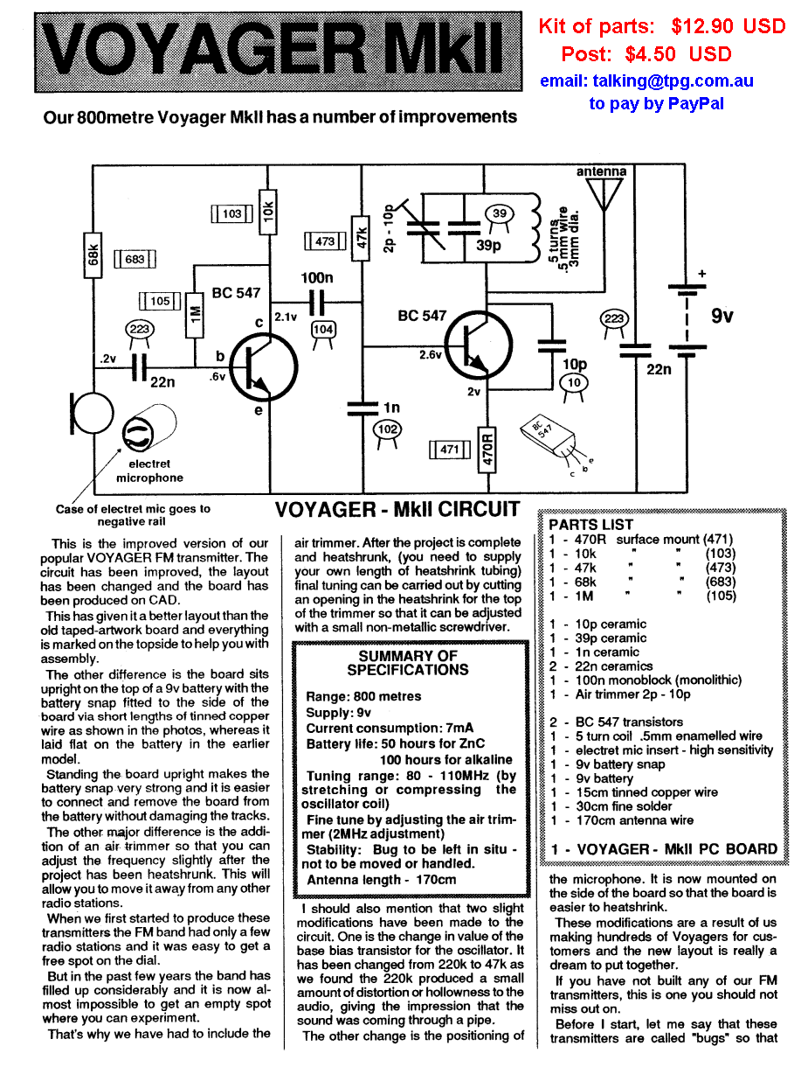
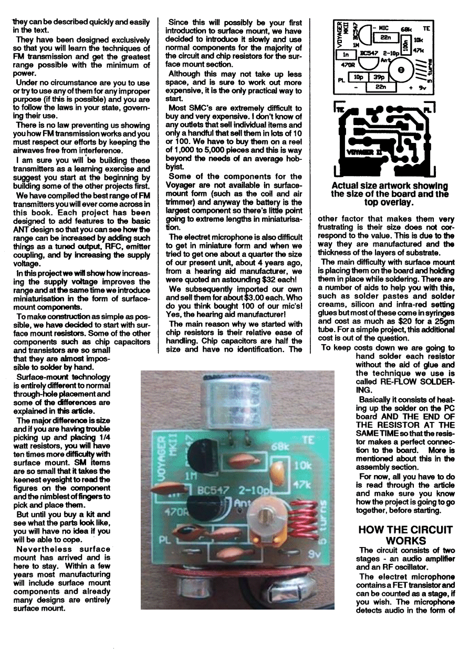
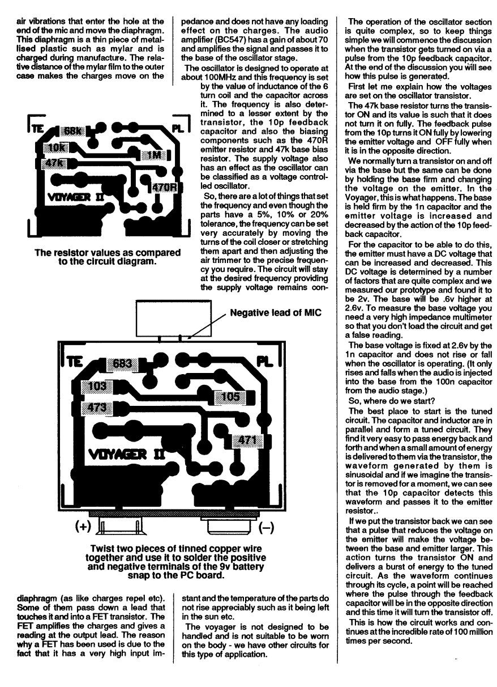
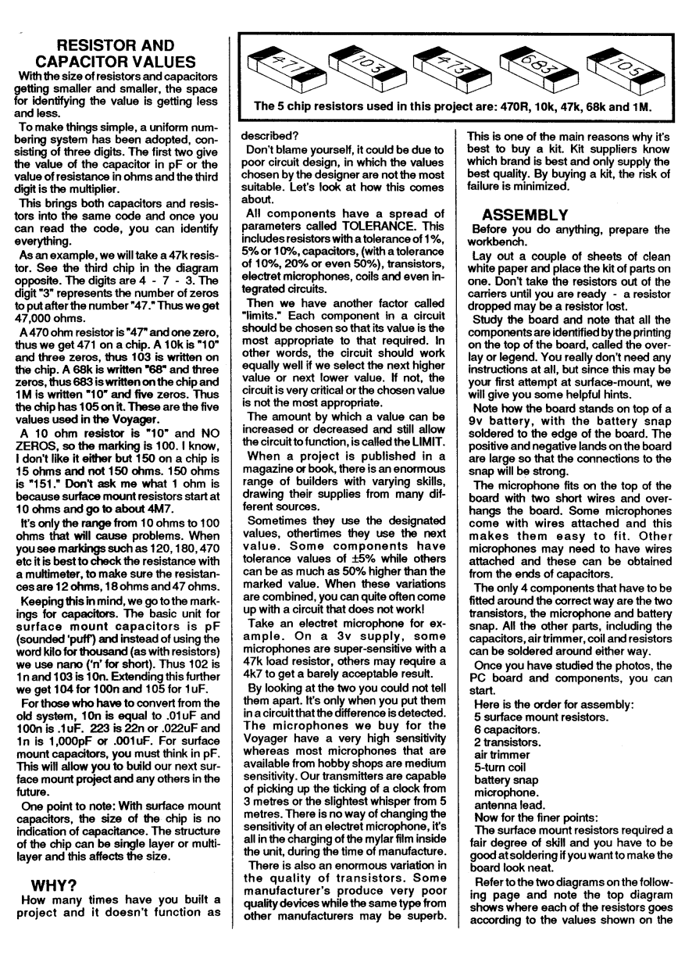
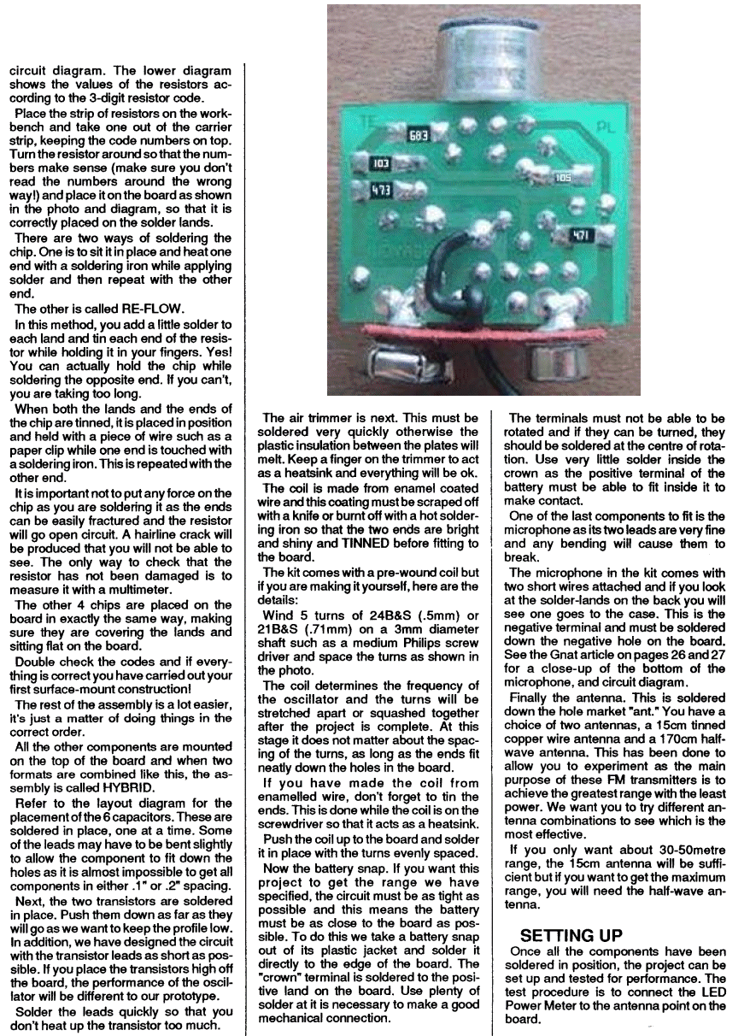

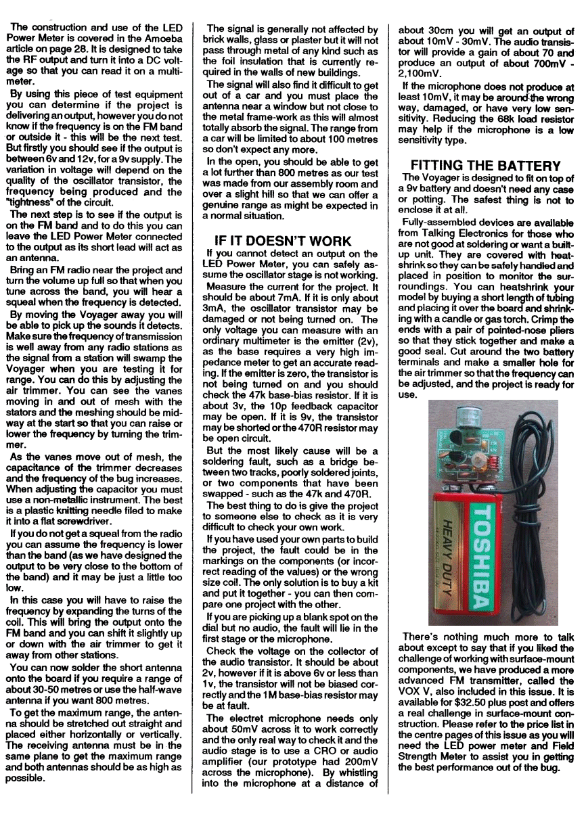
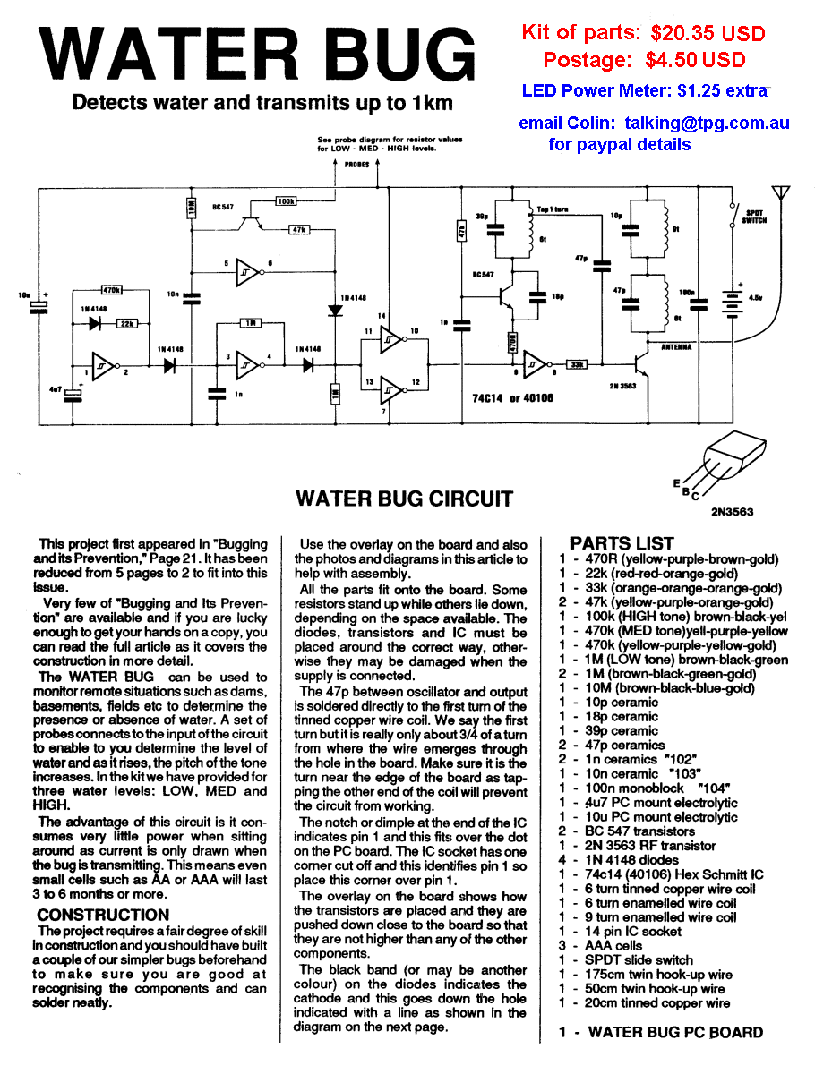
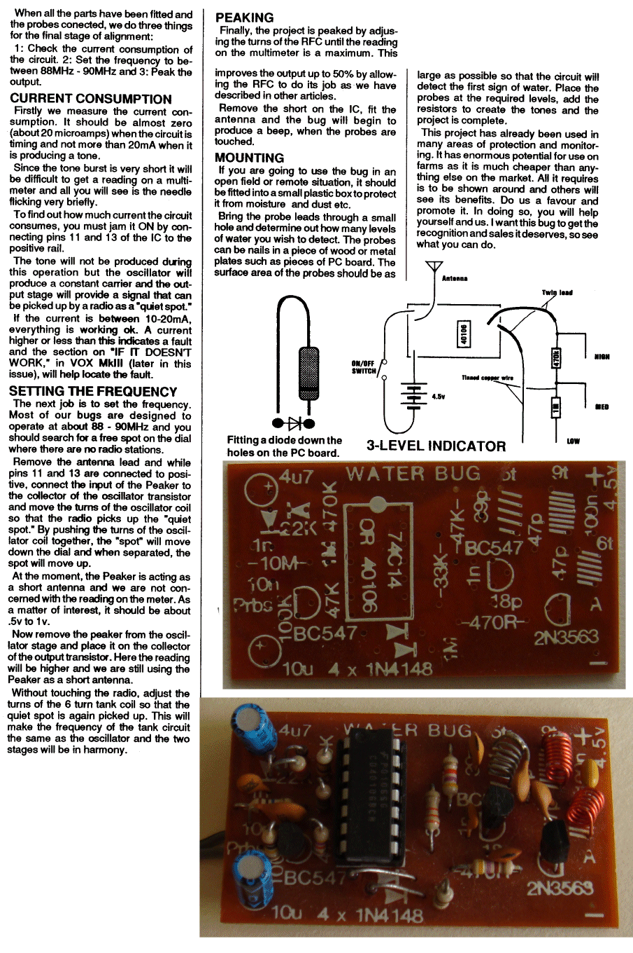

ULTIMA MkII
FM BUG
Home
Our 1km FM Transmitter
Kit of parts: $15.50 USD
Postage $4.50 USD
pay by PayPal
contact Colin Mitchell
email: talking@tpg.com.au
for details on paying for kit
The LED Power Meter can be used to detect the output.
$1.25 extra

Encouraged by the popularity of all our previous bugs, we have designed another FM transmitter, this time with a range of 1km.
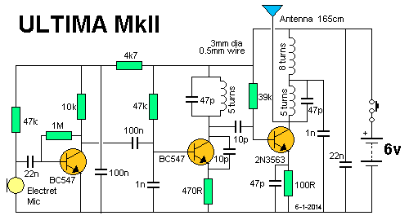
ULTIMA MkII circuit
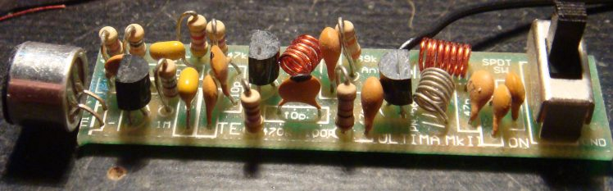
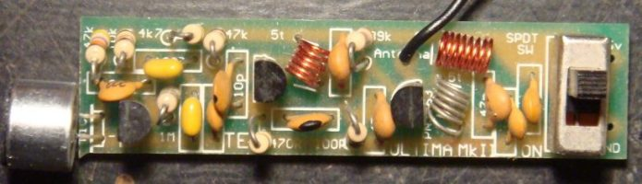
The components fitted to the ULTIMA
The efficiency of this design is slightly higher than our other designs as the power consumption is about double and yet the Effective Radiated Power (ERP) is about 4 times.
This is proved by the fact that the range is about twice, as it requires 4 times the power to double the range.
In this project we will cover some of the design features that make the circuit so efficient. Basically it is the higher voltage but there are also other contributing factors.
The way it works is this:
The minimum operating voltage for most transistor circuits is 1v, so a 1.5v supply will give a circuit about 100 metre range. At 3v it will reach about 400 metres and at 6v it will reach about 1km. You will recall the increased range of the Voyager was purely due to the 9v supply and this time the 6v supply, as well as the tuned output, will assist in providing the output power.
With any transmitting device, the primary requirement is range. To achieve this, an efficient antenna system must be used and although a dipole or loaded antenna provides a slight antenna gain, the usual purpose for which this project is intended, makes a special antenna impractical.
The main use for the Ultima is as an emergency beacon or signaling device and in such a situation, the user may only have the branch of a tree to throw the antenna over.
For this reason, and to keep the transmitter compact, a length of hook-up wire about 1metre long is provided.
The advantage of transmitting on the FM band should be obvious as most cars are now fitted with an FM receiver and they can be used to pick up the transmission without the need for any special receiving equipment.
If a frequency was set aside at the lower end of the FM band for such a purpose a safety channel could be set up at all types of outdoor centres where the transmissions would not interfere with any commercial operations as few if any FM stations are in remote areas.
Maybe something like this will be introduced in the near future. It's a "catch 22" situation where you would have to use it illegally, to get it approved nationally.
The Ultima project is built on a PC board 1.5cm x 7cm and can be fitted into a variety of cases. The most appropriate will depend on the intended use and if you want the project to be as small as possible, it can be heat-shrunk and made virtually watertight.
FM transmission is highly efficient and a few milliwatts can get you a long way. The clarity of FM, its lack of background noise and immunity to electrical interference makes it ideal for faithfully monitoring all types of sounds.
The impressive range of the UItima makes it ideal as a surveillance device, for monitoring remote sheds and buildings, where the slightest disturbance will be picked up and relayed to the monitoring point.
The Ultima is not intended as a hand-held microphone as frankly the microphone sensitivity is too high and the circuit is not "tight" enough to prevent the effect of stray capacitance of your body causing the frequency to drift. See our handheld transmitter, the ANT, for this.
HOW THE CIRCUIT WORKS
The main purpose of a transmitter is to get the greatest distance with the least current consumption.
To this end, the Ultima is the ultimate in design. It contains 3 novel features that have possibly never before been incorporated in the one design.
The front end is a simple common emitter stage with a gain of about 70-100, and decoupled from the battery via a 4k7 and 100n capacitor. These two components prevent motor-boating (instability) at low frequency.
There's another little known fact to be aware of, when designing the front end of a high gain amplifier such as this.
Since the electret microphone is an active device (it contains a FET), the gain of the FET must not be allowed to be too high, otherwise the front end will break into oscillation (sometimes called front-end squeal).
The gain is kept low by making the load resistor HIGH and that's why we have chosen 47k.
Coupling the audio to the RF oscillator is a 100n capacitor and this value is needed to pass the low audio frequencies.
The first of our "unusual" features is the 47k turn-on resistor on the base of the oscillator transistor.
After a great deal of experimenting we found a high value base resistor was sufficient to turn the transistor ON and produce a high amplitude waveform.
The oscillator circuit has been designed to oscillate at about 88MHz. The tuning capacitor in the oscillator is 47p and when the frequency is set, it remains set.
The Ultima is not a tunable bug and you should select a clear spot on the dial when setting it up, so that you don't interfere with any radio stations.
Apart from being illegal to transmit over a commercial station, you would have almost no chance of achieving any range if you were to do so.
The output of the oscillator is taken from the collector via a 10p.
The aim of the tapping is to pick off as much signal as possible without overloading the oscillator.
In technical terms we need a considerable amount of current to drive the output stage as gain is quite low (possibly about 5-20), depending on the quality of the transistor and the frequency of operation.
At 100MHz, the reactance of the 10p will be only about 200 ohms and that's why a small value such as this can be used.
The output stage has a number of features worth mentioning.
Firstly the emitter capacitor and resistor network may appear to be unnecessary as the stage is not a full bridge design. These components reduce the peak current and increase the input impedance of the output stage as seen by the oscillator stage. This improves and guarantees "start-up" of the circuit.
To get the greatest range from the Ultima, the output stage must be peaked and this is an essential part of the tuning and aligning. The tuned circuit in the output stage consists of a 5 turn coil and 47pF capacitor. The 8 turn coil is effectively an RFC (Radio Frequency Choke) to improve the matching of the output circuit to the antenna. The 1n capacitor on the RFC is designed to reduce harmonics and prevent interference on TV sets in the vicinity.
As output power is increased, the effect of harmonics becomes a real problem.
Shielding the project will have little effect as they are already appearing on the antenna and it's too late to suppress them once they get this far.
As we have said, one of the important stages in the construction is to peak the output. To do this, a simple POWER METER is required and its construction is also covered. The circuit attaches to a standard multimeter and uses the meter to give an indication of the signal strength. It also has a Light Emitting Diode that illuminates to give an indication of the relative power being emitted.
The illumination of the LED will give a valuable indication when peaking the circuit and will show how critical the values are at high frequency.
An on/off switch allows the project to be turned off when not required and the current consumption of our prototype was measured at 8mA, allowing a set of AA cells to last for about 150hours.
The 2N 3563 transistor in the output has been chosen as it gives the best performance at the least cost.
Surprisingly, a BC 547 will operate quite satisfactorily as an oscillator at 100MHz but provides very little gain at this frequency.
It only requires a gain greater than unity to function as an oscillator but in the output, a 2N 3563 provides a gain of between 5-20 and delivers the output we need.
No matter what other tricks you add to the output stage, you will not achieve better performance - for the same current.
The suggested maximum current for a 2N 3563 is 10-12-15mA (depending on the specification sheet you use), and only by decreasing the value of the bias resistor, does the output rise by a noticeable amount.
As you experiment with the circuit and peak it, you will see the changes in output power on the meter and/or the LED. But if range is increased at the expense of more current, you haven't improved the efficiency.
Our prototype produced 2v across the LED/resistor combination and the chip inside the LED could be seen to glow quite noticeably.
Not a great deal of weight can be put on this as a lot of RF energy is floating around the meter and will get into the movement to create a false reading.
But if you can see the LED glowing you know that energy MUST be present and that's why we have called it a LED POWER METER.
ASSEMBLY
A complete kit of components, including pre-wound coils and roll-tinned PC board is available from us and we hope you will buy more than one kit! Many readers buy two or more for their friends and some keep coming back for more!
The PC board is shown below.
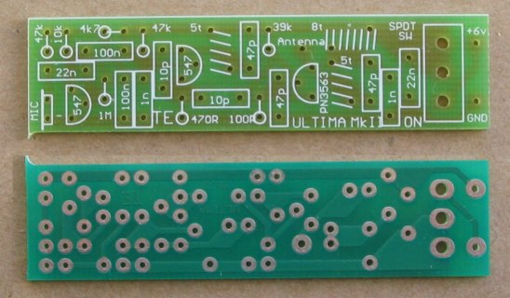
Without exaggeration, it has taken hundreds of hours of experimenting and at least 100 trips "around the block" to see how effective each modification has been.
Sometimes an improvement via the power meter did not co-relate to an improvement in range. You must always make a "field test" - it's the only proof.
Although the circuit is not critical as such, a lot of work has gone into the selection of each component and the layout of the board.
If you want your model to perform as good as ours, it is important to use the exact same components and the same layout. That's why I suggest you buy a kit.
It you are a seasoned hobbyist, and know what you are doing, you will know the type of components to use. But if you are unsure or missing one or two of the critical parts, don't take the chance, buy a kit.
I am not going to go through the finer points of placing the parts on the board as we expect you will have made some of our other designs already.
The coil winding details are below for those who wish to wind their own. You can use slightly different gauge wire but the coil diameter and spacing is critical.
All the parts for the Ultima fit onto the board almost exactly as they appear in the circuit diagram. This makes the circuit very easy to follow and is one of the factors to good layout.
The coils are enamel coated and the enamel must be scraped off or burn off before fitting them to the board. It is not satisfactory to expect the enameling to burn off at the time when the coil is being soldered in place.
All the components should be pressed firmly up to the board before soldering. This also applies to the transistors. They should be pushed down to the same height as the resistors as can be seen in the photograph.
The PC board contains a legend and the accompanying photos will show where everything goes.
The next stage is tuning and peaking but before this can be carried out, you will need to make up the LED POWER METER.
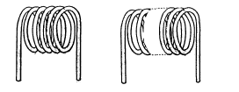
COIL WINDING DETAILS:
1 - 5 turn tinned copper coil (.6mm wire) wound on a 3mm
diam screwdriver.
1 - 5 turn enamelled wire coil (.5mm wire) wound on a 3mm
diam screwdriver.
1 - 8 turn enamelled wire coil (.5mm wire) wound on a 3mm
diam screwdriver.
The turns are counted at the top of each loop. Five loops at the top indicates a five turn coil etc.
THE LED POWER METER
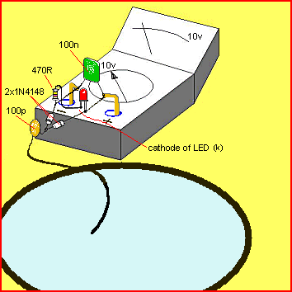
The LED Power Meter
The LED power Meter is a simple RF detector using diodes to charge a capacitor. The voltage developed across the capacitor is indicated by a multimeter set to a low voltage range. The circuit is soldered together without the need for a PC board, as can be seen in the diagram above and paper clips are used for the positive and negative terminals of the multimeter.
It will only take a few minutes to put this circuit together. The power from the output of the Ultima is indicated by the illumination of a LED and the voltage reading on the multimeter gives a further indication of the output.
The reading is not calibrated and does not represent milliwatts output. It is only a visual indication.
LED Power Meter Parts
1 - 470R
1 - 100p ceramic
1 - 100n ceramic
2 - 1N 4148 diodes
1 - 5mm Red LED
1 - 2in (5cm) hook-up wire
2 - paper clips
No PC board required
USING THE LED POWER METER
To get the best performance out of this transmitter, an RF power meter is used to maximize the output.
Since the output is very low, a conventional RF power meter cannot be used. We need an RF milliwatt meter.
The circuit described in this section is very simple and uses a standard multimeter to show the reading.
Across the input is a LED and resistor and the degree of brightness of the LED, together with the voltage reading on the meter, gives an indication of the energy level.
A digital multimeter may be used but the presence of RF may produce a false reading.
Likewise, the radiated energy may upset some analogue meters and you may get full scale deflection on the 15v range as well as the 250v range. But the LED won't lie. It will accurately indicate the RF and you can see the change in brightness as you adjust the coils in the output stage.
Build the circuit for the LED Power Meter exactly as shown in the photo and make sure the input lead is exactly 5mn long. If you keep to the same layout as shown, your readings will closely coincide with ours.
When dealing with RF, lead length is very important and if the input lead is longer, the meter will produce a lower reading.
The type of multimeter will also affect the reading and this is why we cannot give a quantitative value for the output.
We don't have any means of providing a "standard" as we don't have any bench-mark or reference point.
As soon as you build the power meter you will be able to test the transmitter.
Connect the input lead to the antenna point on the Ultima board (don't fit the antenna lead yet) and switch on. Switch the multimeter to the 2v (or 2.5v or 5v) range.
Keep the transmitter away from the meter to prevent the movement being influenced by the RF and you should get a reading of about 2v.
The LED will glow quite noticeably and you can see the output on the LED before the circuit is peaked.
Tune the radio across the band and there may be a number of spots where a signal is detected and it is important to pick the fundamental.
The weaker side-tones have no range and this is where a tuning indicator comes in. It will quickly indicate the fundamental frequency.
Move the radio away to confirm that the fundamental is being detected.
Or you cantune it to about 88.5MHz or somewhere at the low end of the band and move the turns of the 5 turn oscillator coil either together or stretch them apart until a feedback whistle is picked up by the radio. This is the frequency of transmission.
When the turns are pushed together the frequency decreases and when moved apart, the frequency increases.
You must not use any metal objects near the coil when moving the turns. If you do, the reading will be upset.
The best item to use is a match or plastic knitting needle as you should keep your fingers and hands away from the coil while adjusting it.
Now stretch or compress the 5 turns of the output TANK CIRCUIT so that the reading on the POWER METER increases.
The multimeter will show a reading of about 2v and this voltage will depend on getting the two sections of the circuit to operate at the same frequency. Once you are satisfied the project is working, remove the LED Power Meter and solder the antenna lead to the board.
Move the radio a short distance away and tune across the band to make sure the output is coming through and to see if you have picked up the main frequency of transmission.
Carry out some experiments yourself and you will be very impressed with the performance.
By moving the Ultima further away you will be able to pick up the sounds it detects. Make sure the frequency of transmission is well away from any radio stations as the signal from a station will swamp the Ultima when you are testing it for range. If you want to change the frequency, you will have to set the frequency of the oscillator section then adjust the output stage again, by using Power Meter
If you do not get a squeal from the radio you can assume the frequency is lower than the band (we have designed the output to be very close to the bottom of the band) and it may be just a little too low.
In this case you will have to raise the frequency by expanding the turns of the coil. This will bring the output onto the FM band.
To get the maximum range the antenna should be stretched out straight and placed either horizontally or vertically. The receiving antenna must be in the same plane to get the maximum range and both antennas should be as high as possible.
The signal is generally not affected by brick walls, glass or plaster but it will not pass through metal of any kind such as aluminium foil or metal cladding. Trees can also have an effect due to the amount of moisture they contain.
The signal will also find it difficult to get out of a car and you must place the antenna near a window but away from the metal frame-work as this will almost totally absorb the signal. The range from a car will be a lot less than the 800m we stated at the beginning.
IF IT DOESN'T WORK
If you cannot detect an output on the LED Power Meter, you can safely assume the oscillator stage is not working.
Measure the current for the project. It should be about 7mA. If it is only about 3mA, the oscillator transistor may be damaged or not being turned on.
You cannot measure any of the voltages around the oscillator transistor and expect to get an accurate reading as the leads of a multimeter will upset the operation of the circuit.
However if you measure the voltage on the emitter of the second transistor and find it is zero, it is not being turned on and you should check the 47k base-bias resistor. If it is 6v, the transistor may be shorted or the 470R resistor may be open circuit.
But the most likely cause of the project not working will be a soldering fault, such as a bridge between two tracks, poorly soldered joints, or two components that have been swapped - such as the 47k and 470R.
The best thing to do is give the project to someone else to check as it is very difficult to check your own work.
If you are picking up a blank spot (called the carrier) on the dial but no audio, the fault will lie in the first stage or the microphone.
Check the voltage on the collector of the audio transistor. It should be about 2.4v, however if it is above 5v or less than 1v, the transistor will not be biased correctly and the 1M base-bias resistor may be at fault.
The electret microphone needs only about 50mV across it to work and the only real way to check it and the audio stage is to use a CRO or audio amplifier (our prototype had 200mV DC across the microphone). By whistling into the microphone at a distance of about one foot (30cm), you will get an output of about 10 - 30mV. The audio transistor will provide a gain of about 70 and produce an output of about 700mV - 2,100mV, as mentioned previously.
If the microphone does not produce at least 10mV, it may be around the wrong way, damaged, or have very low sensitivity. Reducing the 68k load resistor may help if the microphone is a low sensitivity type.
MODS
If you want to detune the transmitter to below 88MHz or run it at the top end of the band, you will have to change the oscillator section as well as the output section as they both determine the frequency.
To detune the transmitter to say 85-87MHz, you will need to add one turn to both the oscillator coil and the tank coil, making them 6 turns.
To operate at 10BMHz, you will need to change both the 47p's in the oscillator stage and tank circuit to 39p and follow the peaking procedure described above.
IF IT DOESN'T WORK
Before you get involved in any technical problems, have someone check the construction for dry joints, parts placement, shorts, and the like. Nine times out of ten it's something simple.
Next check the current. It should be 8-10mA and any value outside this will indicate a fault is present. Also check the voltage across the power rails and the voltage across the front end (about 5v).
Next you must determine if the fault is in the audio section or the RF section.
If the carrier is being produced you will get a blank spot on the dial and the power LED will light up.
In this case the fault lies in the front end and can be due to the microphone being around the wrong way, the audio transistor being faulty, the 100n capacitor not passing the signal or one of a number of faults.
Firstly check the voltage across the electret microphone. If it is between .0.1v and 1v, the mic is drawing current and if you want to see the output signal, you will need a CRO or mini amplifier.
A voltage of 2-3v on the collector of the audio transistor will indicate it is biased correctly and any value outside this may mean the transistor is faulty or has a gain above or below that expected.
In a self-biasing stage such as this, the gain of the transistor sets the collector voltage and maximum amplification is achieved when the collector is sitting at mid rail.
Two other components affecting the audio are the 22n and 100n capacitors.
They may be damaged due to soldering and the only way to check them is by bridging another capacitor across each or using a mini amplifier to detect the audio.
If you have access to a CRO, you can observe the signal at each point in the circuit and almost no fault will escape you. (Only the audio section).
Replacing all the components is a last resort but may be necessary if simple tests do not reveal the fault.
On the other hand, if no carrier is produced, the oscillator or output stage will be at fault.
Firstly check the oscillator stage by removing the 47p capacitor from the oscillator coil and connecting the input lead of the LED POWER METER to the collector of the BC 547.
The meter should deflect slightly but the LED will not come on as it requires at least 1.7v to be present before the LED will start to illuminate.
The LED and resistor do not have to be removed as they do not impose any load on the circuit until the voltage rises to above 1.7v.
If the meter does not deflect, the fault will lie in the oscillator stage. The first component to change is the transistor, then the 10p feedback capacitor.
Make sure the 39k turn-on resistor is providing a voltage to the base of the oscillator transistor. It will be difficult to measure this voltage accurately as the stage is producing RF and will upset the meter reading.
Make sure the 470R has a voltage across it and this will indicate the transistor is turned-on.
If the 47p capacitor has shorted the circuit will not oscillate. If these tests fail to locate the fault, you should assemble another kit and come back to this one later.
Reconnect the 47p and take the LED Power Meter to the antenna connection.
NO deflection of the LED POWER METER can only mean one thing. The output stage is not operating.
Firstly test the output transistor and make sure the voltages are correct.
The enamel on the coils must be removed before soldering as it does not conduct electricity at all.
Make sure the 39k provides a turn-on voltage and you can try shorting across the 100R if you think this resistor is open.
A low RF output can be due to an open 22n capacitor across the battery, the coils in the collector being spread too far apart or a faulty RF transistor.
The only other possible explanation is damage to some of the components during soldering.
For the cost of another kit, the quickest and easiest way is to start again. You will take more care with the next construction and hopefully things will work out successfully.
MOUNTING
The project can be mounted in a jiffy box that is large enough to take the PC board and a battery holder. This will give it protection from the weather etc if used in an outdoor situation.
If you want the project to be as small as possible, the PC board can be heat-shrunk but you must be careful that the heat-shrinking does not move the coils and change their frequency. Do not use a voltage higher than 6v as the circuit is not designed for it and harmonics will be produced that will interfere with TV reception.
I hope you find this project as interesting as we did. The range is most impressive and it is incredible that such a low output will reach 1km.
ULTIMA MkII
Parts List
Cost: $15.50 USD
plus $4.50 USD postage

1 - 100R (all resistors 1/4 watt)
1 - 470R
1 - 4k7
1 - 10k
1 - 39k
2 - 47k
1 - 1M
2 - 10p
3 - 47p
2 - In
2 - 22n
2 - 100n monoblocks
2 - BC 547 transistors
1 - 2N 3563 RF transistor
1 - 5 turn tinned copper wire coil
1 - 5 turn enamelled wire coil
1 - 8 turn enamelled wire coil
1 - electret microphone insert
4 - AAA or AA cells
1 - mini slide switch SPDT
1 - length hook-up wire for antenna (1.6m long)
1 - "ULTIMA" PC BOARD
(You can specify AA cells or AAA cells)

Field Strength Meter MkI
Essential for checking the output of our FM transmitters

Kit of parts: $10.80 USD
Postage $4.50 USD
pay by PayPal
contact Colin Mitchell
email: talking@tpg.com.au
for details on paying for kit
This Field Strength Meter has been specially designed for our FM bugs. It is capable of detecting very low power transmitters and will assist enormously in peaking many of our FM transmitters that have a coil in the output stage that can be adjusted for optimum output.
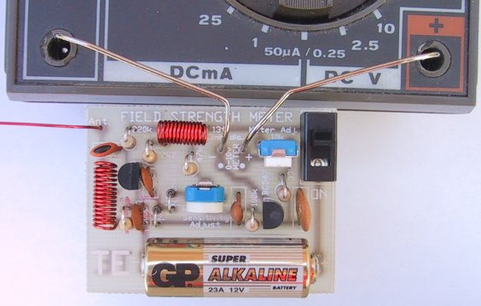
A close-up of the Field Strength Meter MkI connected to a multimeter
with paper clips fitted to the multimeter terminals
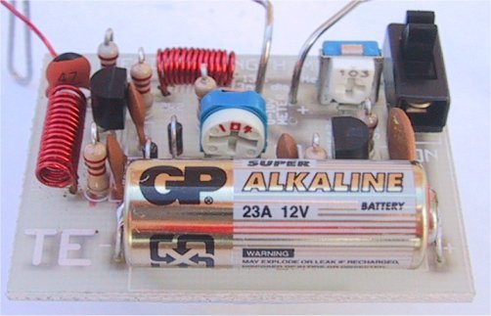
A close-up of the circuit Board showing the the position of the components
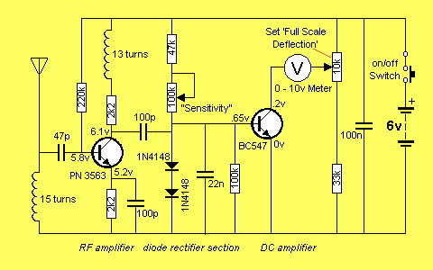
Field Strength Meter MkI Circuit. A 2N2222A transistor can be used in either/both locations
Up to now, field strength meters have only been able to detect transmitters with an output of 100 milliwatts or higher, and for an output such as this, a simple circuit such as a meter and a coil is sufficient. But when it comes to a low power device, a simple circuit, with no amplification, is not suitable.
We spent more than 5 days building all the circuits we could find - that purported to be suitable for low-power transmitters, hoping to find one that would work.
Unfortunately none came anywhere near good enough so we had to design our own.
The circuit we came up with is shown above and it incorporates an RF amplifier, diode rectification, and a DC amplifier so that a movement from a multimeter (a movement is the 'meter' part of a multimeter) could be used as the readout. The heart of the design is a pair of diodes that are partially turned on via a resistor (the 100k sensitivity control) and this overcomes some of the .6v threshold of a diode.
You may not think .6v is very much but when you are talking in millivolt terms, it is 600 millivolts. The signal we are attempting to pick up produces one or two millivolts on the receiving antenna and if you need 600 millivolts to turn a diode ON, the field strength meter becomes very insensitive.
Our design overcomes this problem and produces a reading up to 10cm from a bug. This means you can adjust and peak a bug with the antenna fitted and get an accurate indication of the power it is producing.
Up to now you have had to rely on the "LED Power Meter” as described in a previous article and although it gives a good indication of the RF energy, it does not take into account the loading effect of the antenna.
The antenna loads the output stage of any transmitter and when you have a low power device, the antenna tends to detune the frequency slightly so that a slight re-peaking is necessary if you want to get maximum performance. The field strength meter will allow you to do this and get back the extra performance you may have lost.
HOW THE CIRCUIT WORKS
The circuit consists basically of an RF amplifier, diode rectifier and a DC amplifier. The first feature that may be new to you is the inductor in the antenna circuit. You may think it produces a short-circuit between the antenna and earth but the inductance of the 15 turn coil creates a voltage across it when the antenna picks up a signal. This voltage is fed to the base of the first transistor via a 47p capacitor and since the transistor is turned on via a 220k resistor, any signal from the 47p will be amplified by the transistor.
The RF amplifier has been designed to only have a gain at high frequencies. In our case this is at about 100MHz to 300MHz. The 300MHz is the upper limit due to the response of the RF transistor and the lower frequency is governed by the 100p bypass capacitor on the emitter.
It's impedance at 100MHz is 16 ohms and this gives the stage a gain of about 12. At 10MHz the reactance of the capacitor is 160 ohms and the gain of the stage drops to about 2.
This prevents low frequencies from being amplified and up-setting the reading.
By increasing the value of the emitter bypass capacitor, the gain of the stage will be increased but this is not desirable as it may cause excessive gain causing the front end to self-oscillate.
The inductor in the collector circuit separates the output signal from the power rail and increases the output amplitude slightly.
The low value coupling capacitor (100p) between the RF stage and diode pair is sufficient to transfer the energy as, don't forget, we are dealing with very high frequencies. The two diodes in the diode stage simply work as a rectifier and are partially forward biased via a 47k and 100k sensitivity control from the positive rail. But they are not turned on fully due to the base emitter junction of the DC amplifier transistor only allowing .6v to appear across them.
When a signal is passed into the diode pair, the negative excursions reduce the voltage across them and this begins to turn off the DC amplifier transistor and thus the needle on the meter drops. It requires about 300mV signal to start the process and with a gain of about 12 on the RF transistor, we need about 30 millivolts developed on the antenna circuit to start the detecting process.
This makes the Field Strength Meter only sensitive to nearby signals and prevents weaker signals from upsetting the reading.
The 10k pot connected to one end of the voltmeter sets the full-scale deflection for a 0-10v range on the multimeter.
The circuit consumes about 3.5mA and with a lighter battery (50mAHr cells) the circuit will operate for more than 12 hours. A switch is provided to conserve the battery when not required and the board attaches to any multimeter via leads and paper clips that have been bent to suit the banana sockets on the meter.
Any old meter will do and it can have a sensitivity from 1k ohms per volt to 50k ohms per volt. The range we used in our prototype is 10v DC on a 30k ohms per volt meter however 12v, 15v or even 25v scale will be ok and the 25v range simply means the needle will not deflect as much, for the same RF detected.
You can even use an old, broken, multimeter providing the movement is not damaged. We have about 5 of these field strength meters, one for each worker, as everyone needs one to peak the devices we are making
We turned 5 broken multimeters into active service. It's one good way of using damaged equipment. It's amazing how the staff can blow up things, with the ohms range not working and the milliamp range burnt out.
I remember one firm had the same problem. They made all the staff spend every Friday afternoon repairing the test equipment but with the tight economics of today, we couldn't afford the luxury of providing half a day's holiday like this each week.
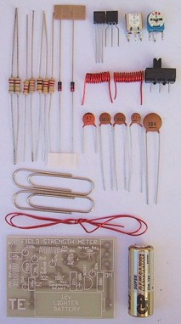
Field Strength Meter Mk I Kit

PARTS LIST
2 - 2k2
1 - 33k
1 - 47k
1 - 100k
1 - 220k
1 - 47p ceramic
2 - 100pceramics (101)
1 - 22n ceramic (223)
1 - 100n ceramic (104)
1 - 10k mini trim-pot
1 - 100k mini trim-pot
1 - BC 547 transistor
1 - PN 3563 RF transistor
2 - 1N4148 diodes
1 - 13t enamelled wire 3mrn dia coil
1 - 15t enamelled wire 3mm dia coil
1 - 12v lighter battery
1 - 25cm enamelled wire
1 - SPDT mini slide switch
2 - paper clips
1 - FIELD STRENGTH METER PCB
Extras:
1 - multimeter (0v -10v range)
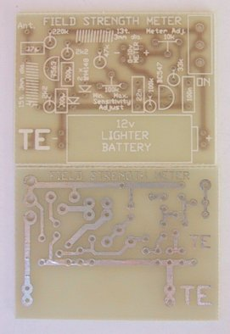
Field Strength Meter MkI PCB
CONSTRUCTION
All the components, including the 12volt lighter battery and switch, mount on the PC board. The legend on the board shows where each part is placed arid we have found it important to avoid over-heating the diodes and transistors as they lose their peak performance and cause the circuit to become very insensitive. Follow the overlay on the PC board to see where everything is placed. The coils are pre-wound in the kit and are wound on a 3mm diameter Philips screwdriver (if you are making your own) and the wire size is not critical as they simply form a broad-band trap.
The antenna wire is enamelled to prevent it touching the active components of the bug you are testing.
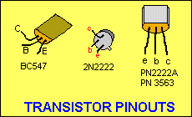
We needn’t say any more about construction as you will obviously know how to put the kit together.
SETTING UP
Solder the paper clips to the board as shown in the photo and bend them to suit the sockets on the multimeter. Turn the "sensitivity" control (100k pot) to minimum resistance and switch the circuit ON. Turn the "Set full scale deflection" pot (10k) to give full deflection on the meter. Now turn the sensitivity pot until the needle just starts to "dip."
At this point the circuit is the most sensitive as the DC amplifier transistor is just turned on and any signal appearing on the diodes will reduce the voltage appearing on the top of them and turn the transistor off - the needle on the meter will begin to drop. The Field Strength Meter is now ready for use.
USING THE FIELD STRENGTH METER
This project will help you get the best silt of any transmitter. It will give an accurate readout because it does not connect to the transmitter but registers the strength of the field AT A DISTANCE.
The way it is used is to set up the antenna of the Field Strength Meter in the same plane as the transmitting antenna (to get the best pick-up) and at a distance that just causes the needle on the meter to deflect.
The meter is wired as a "DIP" meter and the needle deflects towards zero as the field strength increases. Place the bug to be peaked on the test bench, with the antenna out-stretched and bring the receiving antenna so that the needle just starts to dip.
Peak the circuit a small amount and take your hands away so that they don't upset the reading, and watch the needle. As the output increases, the needle dips further. By maintaining the exact same distance between bug and meter, you can compare one bug with another.
It's the fastest way of determining the output without doing a "field test."
IF IT DOESN'T WORK
As with all our projects, they work be cause we have actually built them and checked their performance. If yours doesn't work, the first thing to do is check the value of the components against the overlay on the board.
Two components in the wrong place can make a huge difference and a circuit like this is fairly critical as the biasing must be correct.
Secondly, make sure all the parts are fitted and nothing has been missed. Also make sure all the parts have been soldered neatly and cleanly.
We still get projects sent to us for repair where one or more leads have not been soldered and obviously the project could never work.
Next you can make a few voltage readings. Although they don't tell you too much, it is a fast way of determining if a stage has the correct DC conditions.
The voltages:
RF Stage:
Collector: 6.1v
Base: 5.8v
Emitter: 5.2v
DC stage:
Collector: 0.2v
Base: 0.65v
Emitter: 0v
If these check out ok, you should make a few further DC tests. If the meter swings full scale at power-up, you should short between base and emitter of the BC 547 to see the needle falls to zero. This will show the transistor is working ok. If not, the transistor may be shorted.
Next remove the 47k on the diode pair. This will also cause the needle to move down-scale and show the biasing network is working. It is more difficult to test the RF stage and merely probing around the stage with a meter or CR0, will pick up hum and cause the needle to deflect.
Of course we have assumed you have bought a kit and PC board for the project. The frequency of operation of this circuit makes it important that it is built on the correct PC board.
We cannot guarantee "breadboard" jobs or circuits made with your own components as so many variables creep in.
Things like different markings on capacitors, different RF transistors or signal diodes could make the difference between success and failure.
If you know what you are doing, that's fine - you can use your own components. But if you intend to learn from our projects, don't take any chances. It's cheaper in the long run to get all the projects in kit form and build them exactly as specified.
If you get really stuck, don't hesitate to buy another kit and start again. You can come back to the faulty one later. This project is so important that we don't want you to miss out. With a field strength meter you can carry out experiments that would take a chapter of a book to explain. Here's one:
EXPERIMENTING
Take the Voyager project and connect 30cm of tinned copper wire to the antenna point on the PC board. Hold the Field Strength Meter in your hand (keep away from the actual circuit by holding the multimeter) and bring the receiving antenna near the Voyager antenna, without touching it. As you move up and down the Voyager antenna, watch the needle.
It will show that energy is not radiated uniformly from the antenna but has a maximum and minimum value. It is for you to see where these occur. Measure the length of the antenna and plot the results. Cut 2cm off the antenna and repeat the tests. Fit a 175cm antenna to the bug and repeat the tests.
This will give you a good understanding of the phenomenon of electromagnetic radiation.
There are lots of other things you can test with this project.
The Field Strength Meter Mkll is presented in the next article and has the advantage of a tuned front end and 3-LED readout. This will enable you to not only peak transmitters but also find the frequency on which they are operating.
It detects in the range 75MHz to 140MHz enabling you to design and build transmitters capable of transmitting off the normal broadcast band.
But don't put off building this project as you will need both of them as they have different capabilities. And you also need the LED Power Meter.
Test equipment is very important when working with RF so don't put it off any longer, start now and build up your range of gear.

FIELD STRENGTH METER Mk II
Kit of parts: $16.45 USD
Postage $4.50 USD
pay by PayPal
contact Colin Mitchell
email: talking@tpg.com.au
for details on paying for kit
A Field Strength Meter is essential when designing and building transmitters. It provides signal strength values and allows us to compare and estimate the efficiency of a transmitter and its expected range.
SUMMARY
• Checks the output of low-power
transmitters
• 3 LED readout
• Detects from 75MHz to 140MHz

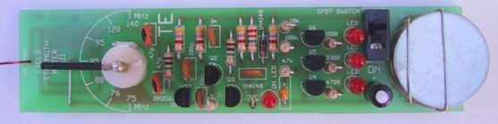
Note: the pointer is not soldered to the trimmer correctly. When the plates are fully disengaged, the pointer should point to 75MHz.
Note: The bottom 3v lithium cell should be insulated from the holding wires so that the cells do not "short-circuit." Put tape around the bottom of each wire. 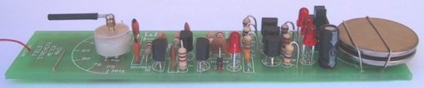
Field Strength Meter Mk II
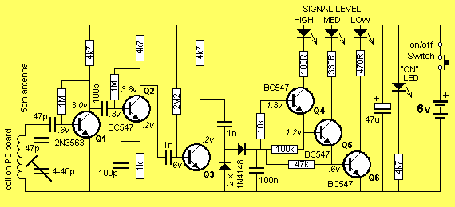
Field Strength Meter MkII circuit

This project has 3 features.
1. It's a Field Strength Meter,
2. A Frequency Meter and,
3. An aid for testing detuned transmitters.
Its uses will become clear in a moment but firstly let's go over the background of a Field Strength Meter.
A Field Strength Meter is essential when designing and building transmitters. It provides signal strength values and allows us to compare and estimate the efficiency of a transmitter and its expected range.
Obviously the most accurate way of getting these results is to make a field test but this sometimes requires travelling long distances, so the next best thing is to get results on the bench by using a piece of test equipment such as an RF POWER METER.
An RF power meter is similar to a field strength meter, however the two are used slightly differently.
An RF Power Meter is generally connected directly to the antenna of a transmitter whereas a Field Strength Meter is placed NEAR the antenna without physically touching it.
When you only have 5 - 50 milliwatts available, it is very difficult to place a measuring device (such as a Power Meter) in the antenna circuit without it absorbing and upsetting the energy being radiated.
When you are dealing with frequencies in the 100MHz range, the signal flows over and through any device you place in the antenna circuit. Some of the signal is absorbed in the measuring device so that the reading may not be a true indication of the output. At the same time the performance of the transmitter is reduced so you don't know how to interpret the results.
A much more accurate way of detecting the energy is to place a device NEAR the radiating source (the antenna) so that it does not interfere with the transmission.
This is the advantage of our FSM. It is placed near the radiating source and detects the energy AT A DISTANCE so that the output is not upset.
This project differs from our Field Strength Meter MkI in that it is a stand-alone unit and does not require connection to a multimeter.
It contains a set of 3 LEDs, wired in a staircase arrangement, so that they light up progressively as the strength of the signal increases.
A trimmer capacitor at the front end tunes the exact frequency of the transmission and as the FSM is brought closer to the antenna of the transmitter, more LEDs will turn on.
We have already commented on the effectiveness of FM transmission in our many transmitter articles and shown that the range is a result of good design. The efficiency of a transmitter has a lot to do with the design of the output stage and this can be improved by adding features such as a TANK CIRCUIT and a RADIO FREQUENCY CHOKE. These are truly amazing additions as they increase the range of the transmitter without consuming any more current because they concentrate the signal into a narrow band.
One of the most-often asked questions is "How much power is a particular transmitter producing?" This is very difficult to answer but a simple rule of thumb is to allow 30% of consumption from the supply as the output power.
One of our designs consumes 7mA @ 3v has an output of about 7 milliwatts. Another design
has the same consumption and yet the range is only one quarter, so you can see that efficiency plays a big part in getting the range.
Its output would be less than 1 milliwatt and this is shown by the fact that the output is barely detectable on the LEDs.
The output difference between our highest and lowest transmitter is more than 100:1 and this has made it difficult for us to produce a project that will cover the whole range.
To measure the output of the weakest transmitter you will have to wind up the antenna and push the probe into the centre of the coil.
All the other transmitters have sufficient output to detect the radiation when the antenna is outstretched.
With some of the transmitters, the tank circuit must be adjusted so that the output is a maximum.
If you have a radio with a signal strength meter, you won't need this project, but if you don't, it's what you need.
Most Field Strength Meters are designed for connection to transmitters with an output of 1 to 1000 watts and are not capable of detecting outputs in the milliwatt range.
For low outputs we need a Field Strength Meter that will detect 1 - 50 milliwatts and that's why we designed this project.
As we have said, it is an adaptation of Field Strength Meter MkI and in place of the meter in the output we have used a series of 3 LEDs. This makes it self-contained and "frees-up" your multimeter for other uses.
The third feature mentioned in the introduction enables you to determine the frequency of detuned transmitters. It is able to detect frequencies as low as 75MHz.
This is very handy when designing transmitters for operation below the 88MHz band.
When working with a transmitter in this range it is important to keep the frequency just below 88MHz as many radios can only be detuned a few MHz before the stations at the top of the dial start to appear at the bottom.
If a bug is below this limit it will be impossible to find, even on a detuned radio.
There are two methods of detuning a radio.
One is to move the turns of the air coil near the tuning gang and see if the stations move up or down the dial.
To produce a space at the bottom of the band, the stations must be moved up and if you squash the turns too much, the top stations will wrap around and appear at the bottom.
The other method is to adjust the trimmers on the back of the tuning gang. This has proven to be the easiest and best method. Simply turn the trimmers until a space is created at the bottom of the dial and your transmitter can be fitted into the space thus created.
When you try to pick up the transmitter on a normal radio, it will be invisible!
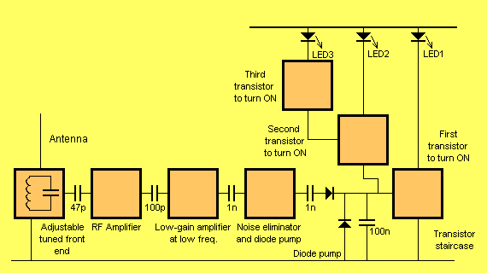
Field Strength Meter MkII block diagram
HOW THE CIRCUIT WORKS
The circuit consists of a tuned front end, an RF amplifier, two further stages of amplification, a diode pump and a transistor staircase.
The circuit picks up RF energy on its 5cm antenna and passes it to a tuned circuit where all the frequencies, EXCEPT ONE are lost in the coil:capacitor combination. The only frequency to appear at the output (the top) of the tuned circuit is the one that is equal to the natural resonant frequency of the tuned circuit.
This signal is passed to the RF amplifier stage where it is amplified.
The coil for the tuned circuit has been etched on the PC board so that it is a known and fixed value of inductance. This allows us to use a trimmer capacitor and put a scale around it on the PC board so that you can read the frequency.
Even though the coil does not have a very good "Q" factor it will be ok in this case as the Q is not important.
In other words the tuning will be fairly broad and you will have to find the "centre spot" to get the exact frequency. Even then, the frequency will not be exact as the scale has not been individually calibrated. It's only designed to give you an approximate value.
Back to the tuned circuit:
The way in which the tuned circuit works is quite amazing. All the signals from radio stations, taxis, bugs, TV stations, cellular phones etc are picked up by the antenna and passed to the tuned circuit where they try to set it into operation.
It's a bit like hundreds of people trying to push a person on a swing - most of them will get in the way of each other. For example, a signal at 150MHz will try to push the swing when it is coming towards the pusher and the energy will be applied at the wrong time.
All the other signals will be pushing at the wrong time too and the only signal that pushes at exactly the correct instant will be the one marked on the scale. Its energy will not be lost in the tuned circuit but appear on the output. This signal is passed to the RF stage via a 47p capacitor for amplification.
The RF stage is able to amplify signals in the 100MHz range as we have used a high frequency transistor and the output appears at the collector.
Two further stages of amplification are needed to increase the signal so that it is large enough to be fed into a diode pump. Q2 is biased in a standard self-bias configuration while Q3 is biased in an unusual way. It is biased ON so that small signals on the input do not appear at the collector. This means the noise generated by the first two stages is prevented from appearing on the diode pump. Only signals above a certain threshold on the base of Q3 appear on the collector. This signal is rectified by a signal diode and fed into a 100n reservoir capacitor.
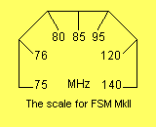
The other diode (between the 1n capacitor and negative rail) removes the negative portions of the waveform and thus discharges the 1n capacitor so that it can supply positive pulses for the charging process.
The first transistor in the staircase (Q4) starts to turn on when .6v is present on the reservoir capacitor. As the voltage rises to .65v the LED connected to the collector of 04 gets brighter and brighter. Due to the slight voltage drop across the 47k base bias resistor, the voltage on the reservoir capacitor needs to be slightly higher than .65v and once the first transistor in the staircase is turned on fully, the next transistor (Q5) will begin to turn on as the voltage on the reservoir capacitor (100n) rises slightly above 1.3v (.65v + .65v).
This process continues with the middle LED getting brighter and brighter until it is fully turned on.
As the voltage on the reservoir capacitor increases, the top LED will come ON and illuminate fully.
The 3 LEDs will give plenty of range as you can read values such as a LED fully turned on or partially turned on.
It is important to know that the lower transistor (Q4), turns on FIRST and as the voltage on the reservoir capacitor increases, Q5 then Q6 turns on. Without this, you will not be able to understand how the circuit works.
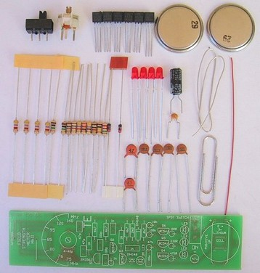
Field Strength Meter Mk II Kit

PARTS LIST
1 - 100R
1 - 330R
1 - 470R
1 - 1k
4 - 4k7
1 - 10k
1 - 47k
1 - 100k
2 - 1M
1 - 2M2
2 - 47p ceramics
2 - 100p ceramics
2 - 1n ceramics
1 - 100n mono-block capacitor
1 - 4 - 40p air trimmer
1 - 47u 16v PC mount electrolytic
2 - 1N 4148 diodes
5 - BC 547 transistors
1 - PN 3563 transistor
4 - 3mm red LEDs
1 - SPDT slide switch
1 - paper clip for pointer on trimmer
1 - 5cm enamelled wire for antenna
1 - 10cm tinned wire for batteries
2 - 3v lithium cells
1 - FSM MkIl PC board
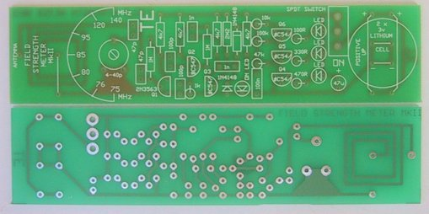
Field Strength Meter MkII PC board
CONSTRUCTION
All the components fit on the board, with the two lithium cells at the end.
The overlay shows where the parts are placed and it's a simple matter to fit everything close to the board. If the leads of any of the components are left too long, the circuit will give a different gain to our prototype and not work properly, so keep everything neat.
The transistors, diodes and LEDs must be placed around the correct way and not overheated, otherwise the transistors will lose their gain and the LEDs will lose their brightness.
Bend the paper clip into an "L" shape. Do not cut it with side cutters as the metal is very hard and will damage your cutters.
The air trimmer (pointer) is now a ceramic air trimmer and the following photos show how it is soldered to the board and the the pointer soldered to the top when the air trimmer is turned so the moving vane is on top of the stationary vane. This position gives the air trimmer the maximum capacitance and now the pointer can be soldered as shown in the images.
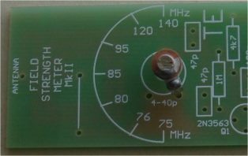
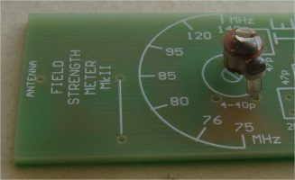
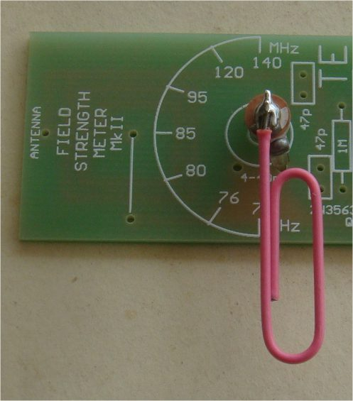

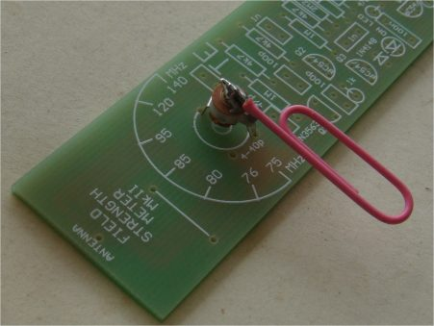
The pointer is now in the correct position for the 75MHz frequency.
Don't forget the link at the front, near the etched coil.
Mark the ON position for the switch with nail polish and place electricians tape around the two lithium cells before fitting them to the board, with straps of tinned copper wire.
The rest of the assembly should be straight-forward.
IF IT DOESN'T WORK
The first thing to do is check the components against the overlay on the board.
All the parts must be around the right way and as close to the board as possible so that everything will be the same as our prototype.
Check the underside of the board for any leads that are bent over and touching other tracks.
Don't forget to check the soldering for shorts and make sure the tracks are not damaged in any way.
Next check the current by measuring across the switch. In the quiescent state, when only the power LED is illuminated, the circuit should consume about 3mA. When 1 LED is illuminated, the circuit should consume about 10mA, for 2 LEDs the circuit should take about 18mA and when the 3 LEDs are illuminated it should be about 26mA.
If this is not the case, and the LEDs don't come on correctly, you will need to look into the circuit more thoroughly.
The circuit can be separated into two sections at the point where the 1n capacitor meets the two diodes.
The left half the diagram is classified as AC coupled and the right half is DC coupled.
The letters AC, stand for "Alternating Current" however we really mean each stage is CAPACITOR COUPLED so that the DC voltages on one stage are not transferred to the next - a capacitor separates the stages.
The only thing that passes from one stage to the next in an AC coupled circuit is the AC waveform and although you may think this can be called an ALTERNATING CURRENT waveform, we do not use this term. We only say "AC coupled."
I know this is confusing however you have to learn the correct terminology if you want to discuss electronics.
To repeat myself, we say the left-hand half of the circuit is AC coupled. We don't say Alternating Current coupled. We just say "it's AC coupled" and only the AC voltages are passed from one stage to the next.
In other words, each stage is self-contained and the biasing comes from within the stage itself. If we view the waveforms on a CRO we call them AC waveforms and yet they are really alternating voltage waveforms.
The right-hand half of the circuit is much easier to explain as it is DC coupled (yes, Direct Current coupled). You can also say "Directly Coupled."
The easiest half to work on is the DC coupled section so we will start with it and this means covering transistors Q4, Q5, Q6, and their associated components.
The quickest way to check if this section is working is to take a jumper lead from the join of the two diodes to the positive rail.
This will put full rail voltage on the reservoir capacitor and make all the LEDs come on.
If this doesn't work, take the jumper lead from the collector of Q4 (the bottom of the 470R) to the negative rail. This will turn on the lower LED. If not, the LED may be around the wrong way.
Next, connect the bottom of the 330R to the negative rail (for the middle LED) and finally the bottom of the 100R for the top LED.
This proves the 3 LEDs (and current limiting resistors) are working.
Shorting between the collector and emitter of the middle transistor (Q5) will turn on the two lower LEDs and show that the lower transistor is functioning. Shorting between the collector and emitter of the top transistor (Q6) will turn on the 3 LEDs and show that the middle transistor is operating.
This is the extent of the simple DC tests for the staircase and the only other thing you can do is take voltage readings on the base of each transistor when the reservoir capacitor is fully charged. These values are shown on the circuit diagram.
The 3 RF stages are much more difficult to test and the only thing you can do is measure the voltage on the collector of each transistor and assume it is biased correctly and the coupling capacitors are passing a waveform (the AC). If you have a CR0 you can see the amplitude of the waveform increase as it passes from one stage to the next and by bringing a bug such as a Voyager near the antenna, the LEDs will gradually light up.
If you have a working model of the FSM you can use it to test a non-working model. Use the antenna of the good unit as a probe to see if a signal is being amplified through each stage of the non-working model. If you don't have a FSM you will need something like a 100MHz CRO - but these cost between $1,000 - $4,000!
Now you can see why a FSM is so valuable. It's a very low-cost way of measuring the characteristics of transmitters in the 100MHz range.
If you are building our transmitters, a Field Strength Meter is an essential piece of equipment.
USING THE FIELD STRENGTH METER
We are assuming the project works correctly and has been checked as per the "If it Doesn't Work Section."
To check the output of an FM transmitter, place it on the work-bench with the antenna in a horizontal plane, away from any metal objects.
Switch it on and place the antenna of the Field Strength Meter about 20cm away, with both antennas in the same plane.
Gradually turn the trimmer by moving the paper clip with your finger, while keeping away from the coil on the underside of the board until the maximum readout is detected on the LEDs.
The pointer will then give you the frequency at which the transmitter is operating.
As you move the FSM away, the LEDs will dim and as it is brought closer, more LEDs will come on.
If you wish to compare one transmitter with another, simply put the second in exactly the same place on the bench with the antenna at the same distance. You may have to re-tune the FSM to pick up the frequency; however you should get the same reading on the LEDs if both have the same output.
When working with detuned transmitters, you can use the scale around the trimmer to give readings from 75MHz.
If you have a transmitter tuned to a band above 108MHz, the FSM will detect frequencies up to 140MHz.
When using the FSM, it is important to keep your hands away from the board, especially the front end, as the loading of your body may affect the readings slightly.

QUESTIONS FOR ADVANCED CONSTRUCTORS:
1. What is the purpose of the 47p in series with the 4 - 40p trimmer?
2. Why is the coil etched on the PC board?
3. What is the purpose of the 100p and 1k in the emitter of Q2?
4. Why is Q3 biased fully ON?
5. For the diode pump, does the transistor or the 4k7 collector resistor charge the 100n?
ANSWERS:
1. The 47p in series with the trimmer adjusts the effective value of the trimmer to 3p5 - 20p. The easy way to remember this is: two equal-value capacitors in series produces a value of half the smaller value. Thus 40p and 40p produces 20p. For the smaller value, the ratio is about 10:1 or 4p:47p. We use the same reasoning and see that the 47p will alter the 4p very little. This is the way to see things without using mathematics.
2. The coil is etched or fixed on the board so that we can generate a scale around the trimmer that will be the same for all models.
3. For low frequencies, (1 MHz etc) the 100p will have a high reactance and thus the gain of the stage will be the ratio of the 4k7 to 1 k or about 5. Thus the stage will not amplify all the hash and noise of the low frequencies.
4. Q4 is biased fully ON to further reduce the noise and hash produced by a self-biased stage and also to give the diode pump full voltage swing.
5. The charging current for the diode pump is supplied by the 4k7. The transistor merely pulls the 1n low to discharge it through the lower diode.
THE END
This is not the end.
Talking Electronics has over 200 more projects and you can only learn if you start to put things together.
Reading a book is only part of the experience. The other 90% is gained from ACTUAL CONSTRUCTION.
All the prices in this publication have not increased since the year 2000. That’s because Talking Electronic is now a SERVICE COMPANY and supplies everything at cost because no-one wants to pay the real price.
All the kits are now packed “in-house” and this has reduced our costs.
All the kits cost LESS than buying the components separately and some of the items are not available from electronics wholesalers, so you need the kit.
But the real issue is this: You have to build things to get the knowledge. The author still builds and designs and gets PCB’s from China and there is a back-log of more than 10 projects waiting to be finalised.
That’s the only way to operate. Keep yourself busy.
You can be fully engrossed in electronics your whole life and one project will spark another and after a few years your whole workshop will be filled with projects.
If you look at the range of Talking Electronics projects, you will see lots for the Model Railroad enthusiast and lots for the hobbyist wanting to learn about microcontrollers.
The whole point of having a hobby is to keep your mind active and even sharing your ideas with others on ELECTRONICS FORUMS.
That’s where the internet comes in. It is absolutely filled with electronics data, circuits and helpful advice and you can access Talking Electronics website at any time and join the other 7,000 visitors who click on the site every day.
PRICE LIST
All prices are USD plus $4.50 USD postage for a single kit.
2 kits to 5 kits – add $6.50 USD
Use PayPal. It is the quickest and most reliable way to pay.
Use your Paypal account and send to
TALKING ELECTRONICS.com by using Talking Electronics PayPal account: talking@tpg.com.au
Colin Mitchell
(Australian customers – email me first, before buying)
Payment is AUD for the kit and AUD for postage.


MICRO BUG $14.50 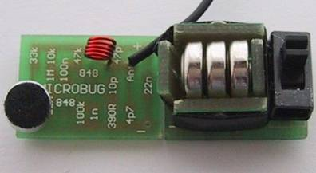
VOYAGER MkII $12.90 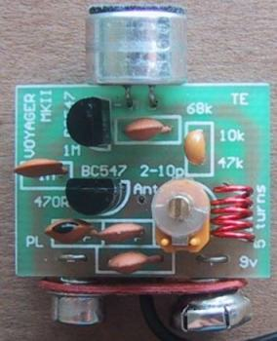
WATER BUG $20.35 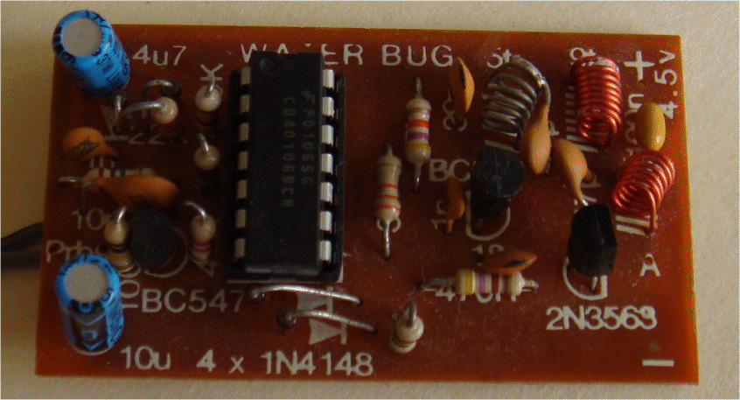
ULTIMA MkII $15.50
FIELD STRENGTH METER MkI $10.80
FIELD STRENGTH METER MkII $16.45

